Gironde Estuary, Nouvelle-Aquitaine, France
Europe's largest estuary winds through some of France's most legendary wine country. Whether your ship docks at Pauillac amid the Médoc vines, Le Verdon at the estuary mouth, or historic Blaye, the Gironde delivers châteaux, oysters, and 18th-century grandeur.
⚓ Pier (Pauillac, Le Verdon, Blaye) · 🕒 Typical call: 8–10 hrs · 💶 Currency: Euro (€) · 🗣️ Language: French · 🍷 Wine country
✍️ MY DAY IN PORT (FILL IN)
Ship / Date
In port | arrive ______ · all aboard ______
Booked excursion
Notes / meeting point
GETTING ASHORE
- Docking: Pauillac pier (up to 320 m); Le Verdon deep-water pier (any size); Blaye waterfront; Bordeaux city quay (ships ≤255 m)
- Walk to center: Pauillac: 10 min to promenade; Blaye: 5 min to Citadel; Le Verdon: not walkable — bus required
- Best For: Wine lovers, history buffs, UNESCO sites, gourmet dining
- Don't Miss: Médoc Grand Cru châteaux, Blaye Citadel, Cordouan Lighthouse, Bordeaux Miroir d'Eau
GETTING AROUND
- 🚕 Taxi: €10–€20 — Ships docking at Quai des Chartrons in Bordeaux are already near the city center — a short taxi ride (5–10 min) costs €1
- 📱 Rideshare: ✅ Uber, Bolt
- 🚌 Hop-on hop-off: ✅
TOP THINGS TO DO
- Médoc Grand Cru Wine Châteaux — Visit storied estates like Château Mouton Rothschild, Château Lafite Rothschild, or Château Latour in the Pauillac appellation.
- Blaye Citadel & Vauban Fortifications — The 17th-century Citadel of Blaye, designed by Louis XIV's master engineer Vauban, is a UNESCO World Heritage site.
- Bordeaux City Day — Even if your ship docks in Pauillac or Le Verdon, Bordeaux is worth the coach ride.
- Cordouan Lighthouse Boat Trip — The 'Versailles of the Sea' is the oldest active lighthouse in France and a UNESCO World Heritage site, standing alone in the…
- Oysters & Wine on the Estuary — The Gironde's brackish waters produce exceptional oysters, traditionally served raw with rye bread and a crépinette sausage…
BEST WALKS
- Pauillac Waterfront & Bages Village: 2–3 hrs · Easy · 3 km round-trip — From the Trompeloup pier, walk north along the Gironde to Pauillac's promenade and the Lafayette…
- Blaye Citadel Loop: 1.5–2 hrs · Easy · 2 km — Step off at Blaye quay and walk straight up to the Citadel entrance.
WEATHER · DAYLIGHT · MONEY
Month | High °F | Low °F | Rainy days
May | 69 | 53 | 11
Jul | 79 | 63 | 7
Sep | 75 | 59 | 8
Daylight: May 6:33AM–9:25PM · Jul 6:30AM–9:47PM · Sep 7:41AM–8:13PM
cruiseports.org/gironde-estuary · Confirm terminal & all-aboard time with your ship

Gironde Estuary, Nouvelle-Aquitaine, France — Port Map
Red = walkable sights · Amber = excursions farther out · P = cruise terminal
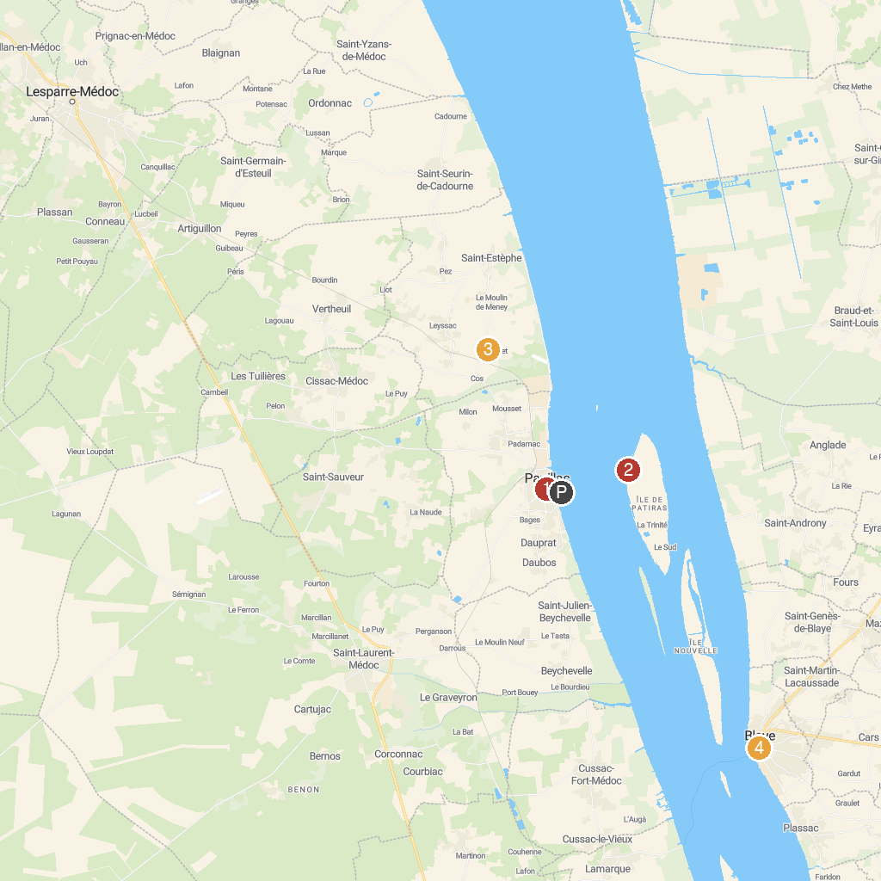
MAP KEY
1. Église Saint-Martin | 4. Villa Gallo Romaine de Plassac
2. Lighthouse Patiras | 5. Pole-nature Vitrezay
3. Château Le Crock | 6. Tourist Office of Blaye
P. Cruise port / terminal
Map © MapTiler © OpenStreetMap contributors · cruiseports.org

