Gijón, Asturias, Spain
Northern Spain's Celtic soul — bagpipes, cider poured from above, a crescent beach, and a medieval hilltop quarter all within easy reach of the port shuttle.
⚓ Pier (El Musel — shuttle required) · 🕒 Typical call: 6–9 hrs · 💶 Euro · 🗣️ Spanish (Asturian dialect)
✍️ MY DAY IN PORT (FILL IN)
Ship / Date
In port | arrive ______ · all aboard ______
Booked excursion
Notes / meeting point
GETTING ASHORE
- Docking: Pier at El Musel, ~6 km from city center — shuttle or taxi required
- Walk to Center: Not walkable — industrial port; shuttle ~10–15 min, taxi ~€12
- Best For: Old quarter, Roman baths, San Lorenzo Beach, Asturian cider & food
- Don't Miss: Elogio del Horizonte sculpture on Cerro de Santa Catalina
GETTING AROUND
- 🚕 Taxi: €11–15 — El Musel port is ~7 km from city center; a metered taxi takes about 15 minutes and costs roughly €11–15. Taxis queue at
- 🚌 Hop-on hop-off: ✅
TOP THINGS TO DO
- Cimavilla Old Quarter & Cerro de Santa Catalina — Wander the cobblestone streets of Gijón's historic fisherman's quarter, climb to Eduardo Chillida's Elogio del Horizonte…
- Termas Romanas de Campo Valdés — Underground 1st-century Roman public baths at the foot of Playa de San Lorenzo — one of Spain's best-preserved urban Roman sites.
- Playa de San Lorenzo Promenade — Stroll El Muro, the broad seafront promenade alongside Gijón's 1.5 km crescent beach.
- La Laboral Ciudad de la Cultura — Spain's largest building — a vast mid-20th-century complex with a 117-metre tower, church dome, and courtyard.
- Asturian Cider House Lunch — Join locals in a sidrería for the full ritual: escanciado pouring from height, a culín of sharp sidra, and plates of cachopo…
BEST WALKS
- Marina to Cimavilla to San Lorenzo Loop: 3–4 km · 1.5–2 hrs · Easy–Moderate — Start at the Marina's red Gijón letters, walk north into Cimavilla's old quarter, climb Cerro de…
- Marina & Poniente Beach Stroll: 1–2 km · 45 min · Easy — A relaxed flat walk along the sheltered Poniente Beach from the Marina to the Aquarium — good for…
WEATHER · DAYLIGHT · MONEY
Month | High °F | Low °F | Rainy days
May | 64 | 53 | 14
Jul | 72 | 62 | 10
Sep | 71 | 59 | 12
Daylight: May 6:58AM–9:40PM · Jul 6:55AM–10:01PM · Sep 8:02AM–8:32PM
cruiseports.org/gijon · Confirm terminal & all-aboard time with your ship

Gijón, Asturias, Spain — Port Map
Red = walkable sights · Amber = excursions farther out · P = cruise terminal
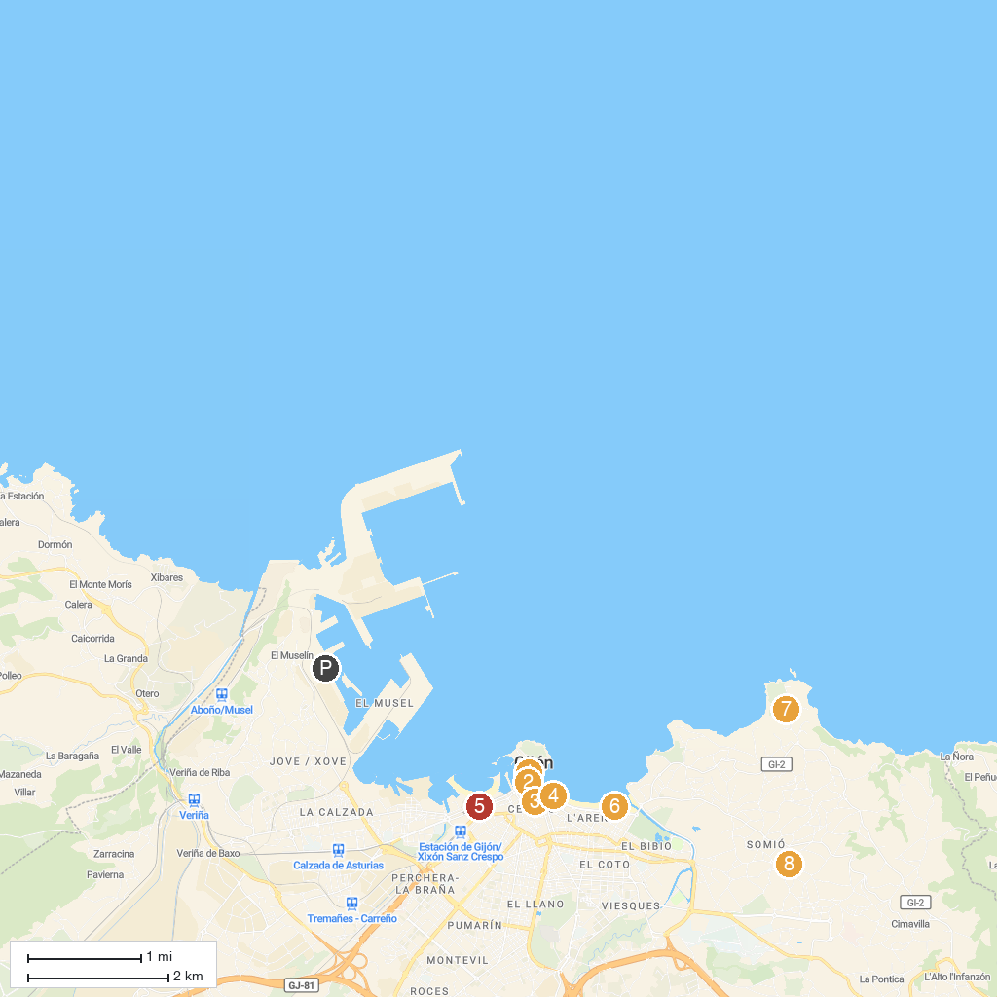
MAP KEY
1. Palacio de Revillagigedo | 5. Museo Ferrocarril
2. Museo Barjola | 6. Playa de San Lorenzo
3. Basilica of the Sacred Heart of Jesus | 7. Cabo San Lorenzo Park
4. La Escalerona | 8. Evaristo Valle Foundation Museum
P. Cruise port / terminal
Map © MapTiler © OpenStreetMap contributors · cruiseports.org

