Gibraltar
A towering limestone Rock where Europe faces Africa — wild Barbary macaques, hand-carved siege tunnels, a glass-bottomed Skywalk, and a slice of Britain guarding the gateway to the Mediterranean.
⚓ Docked (North Mole Terminal) · 🕒 Typical call: 8–10 hrs · 💷 Gibraltar Pound (GIP) · GBP/EUR ok · 🗣️ English (+ Llanito)
✍️ MY DAY IN PORT (FILL IN)
Ship / Date
In port | arrive ______ · all aboard ______
Booked excursion
Notes / meeting point
GETTING ASHORE
- Docking: Gibraltar Cruise Terminal (North Mole)
- To town: ~2 km · 15–20 min walk or shuttle
- Best For: The Rock · Wildlife · History
- Don't Miss: Macaques, Skywalk & siege tunnels
GETTING AROUND
- 🚕 Taxi: ~£5-10 to town; tours higher — Taxis queue at the terminal and are useful for short hops, Europa Point, or Upper Rock sightseeing tours. Agree the pric
- 🚌 Hop-on hop-off: ✅ Gibraltar Hopper Ticket / public bus network · from £8 adult day ticket
TOP THINGS TO DO
- Upper Rock Nature Reserve & Barbary Macaques — Ride the cable car to the summit to meet Europe's only wild monkeys — the bold, curious Barbary macaques — and drink in panoramic…
- Skywalk & Windsor Suspension Bridge — Stand on a glass-bottomed viewing platform 340 metres above sea level and cross a 71-metre suspension bridge hanging over a sheer…
- Great Siege Tunnels & WWII Tunnels — Explore the astonishing 18th-century tunnels hand-carved into the Rock during the Great Siege, then go deeper into the vast WWII…
- St. Michael's Cave — A vast, dramatically lit limestone cavern of stalactites and stalagmites that doubles as a natural concert hall.
- Dolphin Watching in the Bay — The Bay of Gibraltar hosts resident pods of Common, Striped, and Bottlenose dolphins year-round.
BEST WALKS
- Terminal to Casemates Square via Ocean Village: ~2 km · 20 min · easy · flat — From the cruise terminal, walk north along the western waterfront past Ocean Village marina…
- Main Street to Cable Car & Alameda Gardens: ~1.5 km · 20 min · easy — Head south down pedestrian Main Street past the Governor's residence (The Convent), Cathedral…
- Europa Point: short bus or taxi · 30 min each way — The Rock's southern tip: the red-and-white lighthouse, the Ibrahim-al-Ibrahim Mosque, and on clear…
WEATHER · DAYLIGHT · MONEY
Month | High °F | Low °F | Rainy days
May | 73 | 61 | 4
Jul | 85 | 70 | 0
Sep | 80 | 68 | 5
Daylight: May 7:15AM–9:20PM · Jul 7:16AM–9:38PM · Sep 8:04AM–8:28PM
cruiseports.org/gibraltar · Confirm terminal & all-aboard time with your ship

Gibraltar — Port Map
Red = walkable sights · Amber = excursions farther out · P = cruise terminal
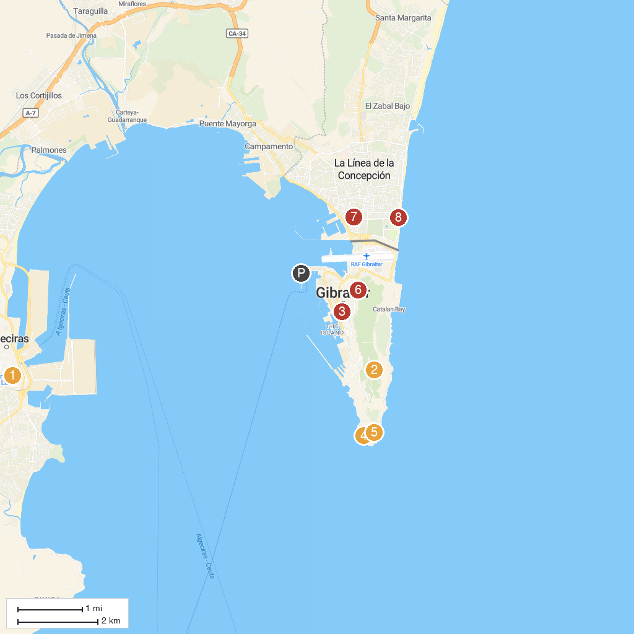
MAP KEY
1. Parque de Las Acacias | 5. King Fahd Bin Abdulaziz al-Saud Mosque
2. Saint Michael's Cave | 6. Moorish Castle
3. The Gibraltar National Museum | 7. Cruz Herrera Museum
4. Shrine of our Lady of Europe | 8. Ruins of Fort St. Barbara
P. Cruise port / terminal
Map © MapTiler © OpenStreetMap contributors · cruiseports.org

