Giardini Naxos-Taormina, Sicily, Italy
Ships anchor in the shadow of Mount Etna while passengers tender ashore to a dual destination: the sun-soaked Greek colony at sea level and the impossibly photogenic clifftop town of Taormina looming 200 metres above.
⚓ Tender (no pier) · 🕒 Typical call: 8–10 hrs · 💶 Euro (€) · 🗣️ Italian
✍️ MY DAY IN PORT (FILL IN)
Ship / Date
In port | arrive ______ · all aboard ______
Booked excursion
Notes / meeting point
GETTING ASHORE
- Docking: Tender — ships anchor in Bay of Naxos; 10–15 min boat ride to shore
- Walk to center: 5 min to Giardini Naxos waterfront; Taormina requires bus or taxi (30 min)
- Best For: Ancient ruins, clifftop views, beaches, Sicilian food & wine
- Don't Miss: Teatro Antico di Taormina at sunrise before the tour buses arrive
GETTING AROUND
- 🚕 Taxi: €12–25 one way — Taxis queue at the port and take about 9 minutes to Taormina center. Fares are metered or negotiated; confirm the rate b
- 📱 Rideshare: ✅ Uber
- 🚌 Hop-on hop-off: ✅ City by See
TOP THINGS TO DO
- Teatro Antico di Taormina — One of the world's most dramatic ancient theaters: 3rd-century BC Greek-Roman ruins framing a natural backdrop of the Ionian Sea…
- Isola Bella Marine Reserve — A tear-shaped island connected to the mainland by a narrow pebbly spit — submerged at high tide.
- Giardini Naxos Archaeological Park — Walk among ruins of Sicily's first Greek colony (734 BC) on the Capo Schisò peninsula — just 15 minutes on foot from the tender…
- Corso Umberto & Piazza IX Aprile, Taormina — Taormina's pedestrian main street is lined with luxury boutiques, pastry shops, and café terraces.
- Giardini Naxos Beach Day — Fine sand and gravel beaches stretch right from the tender pier.
BEST WALKS
- Giardini Naxos Waterfront to Archaeological Park: 1.2 km · 15 min · Flat — From the tender pier head south along the waterfront promenade past the Nike sculpture to the Capo…
- Taormina Old Town: Duomo to Greek Theater: 0.9 km · 20 min · Hilly cobblestones — Start at the Taormina bus terminal, walk Corso Umberto past the Duomo and Piazza IX Aprile balcony…
WEATHER · DAYLIGHT · MONEY
Month | High °F | Low °F | Rainy days
May | 72 | 52 | 7
Jul | 91 | 66 | 1
Sep | 81 | 61 | 6
Daylight: May 5:49AM–8:01PM · Jul 5:49AM–8:20PM · Sep 6:41AM–7:06PM
cruiseports.org/giardini-naxos-taormina · Confirm terminal & all-aboard time with your ship

Giardini Naxos-Taormina, Sicily, Italy — Port Map
Red = walkable sights · Amber = excursions farther out · P = cruise terminal
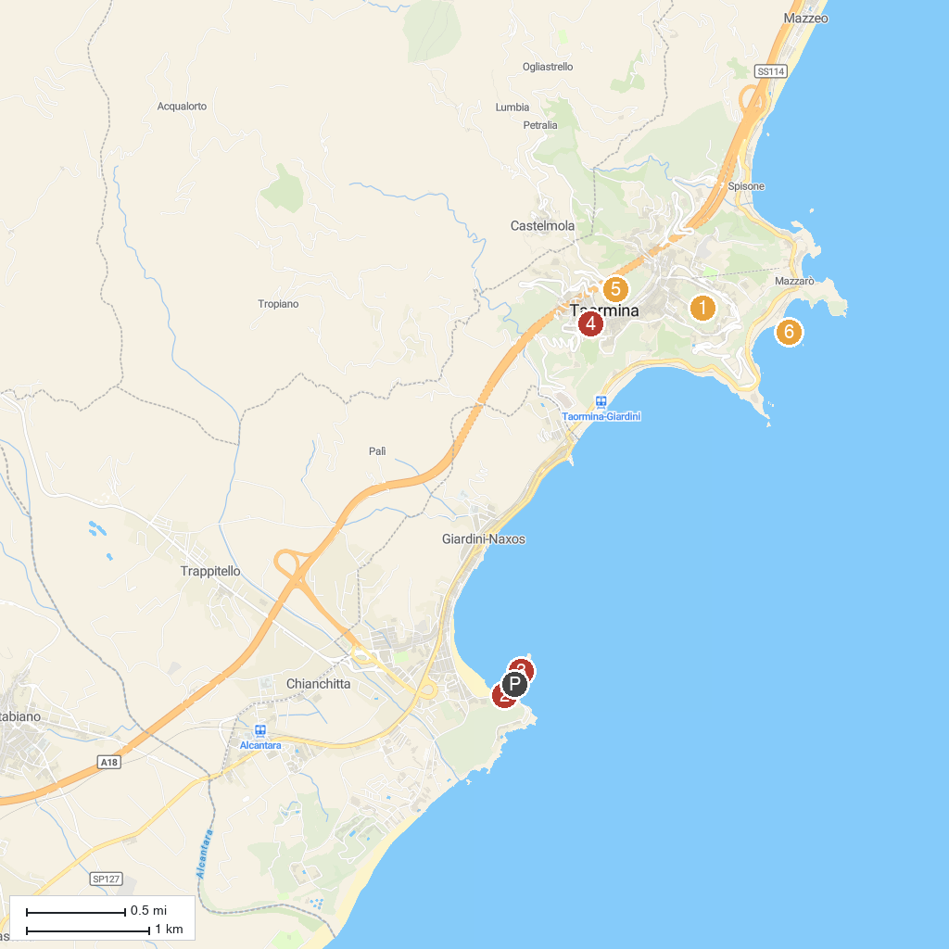
MAP KEY
1. Teatro Antico di Taormina | 4. Porta Catania
2. Archeologic Park Taormina | 5. Chiesa della Madonna della Rocca
3. Escursioni in barca Taormina Giardini Naxos - Blue Diamond - Tour In Barca Isola Bella | 6. Isola Bella
P. Cruise port / terminal
Map © MapTiler © OpenStreetMap contributors · cruiseports.org

