Ghent, East Flanders, Belgium
Belgium's best-kept secret is a car-free medieval city of three soaring towers, glittering canals, and a surprisingly vibrant craft-beer and veggie-food scene — all within easy reach of your river berth.
⚓ Pier (river dock) · 🕒 Typical call: 7-10 hrs · 💶 Euro (€) · 🗣️ Dutch / English widely spoken · 🚲 Car-free historic centre
✍️ MY DAY IN PORT (FILL IN)
Ship / Date
In port | arrive ______ · all aboard ______
Booked excursion
Notes / meeting point
GETTING ASHORE
- Docking: Pier — river cruise ships berth at the Grootdok (Rigakaai) quay; no tendering
- Walk to centre: Berth is ~1.5-2 km north of the historic core; most lines run a free shuttle, or take Tram 4 to Korenmarkt
- Best For: Medieval architecture, the Ghent Altarpiece, canal boat tours, Belgian beer & frites
- Don't Miss: The three-tower view from Sint-Michielsbrug and a cuberdon candy from Groentenmarkt stalls
GETTING AROUND
- 🚕 Taxi: €25–€30 — Taxi from Port of Ghent to the city center takes roughly 14 minutes. Base fare €10 plus €2.60/km (night rate €3/km).
- 📱 Rideshare: ✅ Uber, Bolt
TOP THINGS TO DO
- The Ghent Altarpiece & St. Bavo's Cathedral — The Van Eyck brothers' 1432 masterpiece — the most-stolen painting in history — is now displayed in a state-of-the-art chamber…
- Gravensteen Castle — A hulking 10th-century castle complete with moat, battlements, and a famously hilarious audio guide.
- Canal Boat Tour — A 40-50 minute guided boat ride along the Leie gives you Graslei's guildhalls, the Gravensteen, and the medieval skyline from…
- Belgian Food & Beer Tasting — Sample Gentse Waterzooi (creamy chicken stew), double-fried frites from Frituur Jozef, and a Gruut herb beer brewed in medieval…
- Ghent Belfry (Belfort) — This 91-metre UNESCO World Heritage tower anchors Ghent's skyline.
BEST WALKS
- Ghent Medieval Highlights Loop: ⏱ 2-3 hrs · 📏 ~4 km · 🚶 Easy — flat cobblestones · 📷 Three-tower view included — From the shuttle drop-off (or Korenmarkt tram stop) head to Graslei, cross to Korenlei for the…
- Patershol & Street Art Stroll: ⏱ 1-1.5 hrs · 📏 ~2 km · 🌆 Atmospheric lanes · 🎨 Street art — From Gravensteen, duck into the cobblestone alleys of Patershol for lunch or a Belgian beer, then…
WEATHER · DAYLIGHT · MONEY
Month | High °F | Low °F | Rainy days
May | 65 | 48 | 12
Jul | 73 | 58 | 11
Sep | 69 | 54 | 10
Daylight: May 5:55AM–9:28PM · Jul 5:48AM–9:53PM · Sep 7:20AM–7:58PM
cruiseports.org/ghent · Confirm terminal & all-aboard time with your ship

Ghent, East Flanders, Belgium — Port Map
Red = walkable sights · Amber = excursions farther out · P = cruise terminal
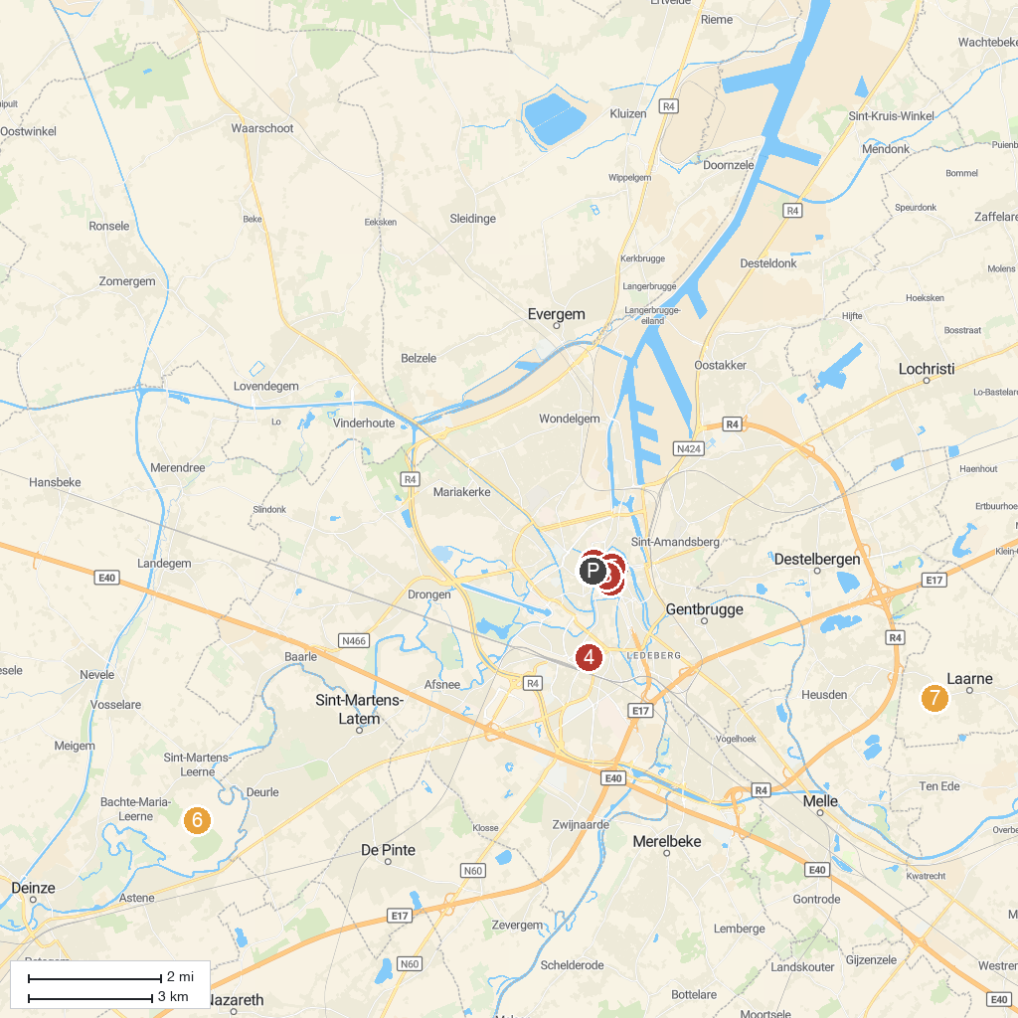
MAP KEY
1. Castle of the Counts | 5. St Jacob's Church
2. St Bavo's Cathedral | 6. Kasteel van Ooidonk
3. Gent Design Museum | 7. Kasteel van Laarne
4. Citadelpark | 8. Gent City Hall
P. Cruise port / terminal
Map © MapTiler © OpenStreetMap contributors · cruiseports.org

