Germersheim, Rhineland-Palatinate, Germany
Most Rhine ports give you a castle on a hill. Germersheim gives you something stranger: a town built entirely inside a massive 19th-century military fortress, where moats are now parks and underground mine tunnels run beneath the streets. Expect brickwork on a grand scale, zero tourist crowds, and excellent Palatinate wine.
⚓ Pier (river pontoon) · 🕒 Typical call: 6-8 hrs · 💶 Currency: Euro (€) · 🗣️ Language: German · 🍷 Palatinate wine country
✍️ MY DAY IN PORT (FILL IN)
Ship / Date
In port | arrive ______ · all aboard ______
Booked excursion
Notes / meeting point
GETTING ASHORE
- Docking: Pier — ships dock at riverside pontoon, no tender
- Walk to center: ~1.2 km / 15-20 min flat walk to Weißenburger Tor
- Best For: History buffs, cyclists, wine lovers, off-the-beaten-path Rhine
- Don't Miss: Fortress tunnel (candlelit underground guided tour)
GETTING AROUND
- 🚕 Taxi: €5–€10 — Local taxis are available at or near the dock. The town is so compact that a taxi ride to any in-town destination is ver
- 📱 Rideshare: ✅ Uber
TOP THINGS TO DO
- Fortress Tunnel Tour (Minengänge) — The undisputed highlight of Germersheim.
- Festungsweg — Fortress Town Walk — A self-guided trail through the heart of one of Germany's best-preserved star fortress towns.
- German Road Museum (Deutsches Straßenmuseum) — Germany's only museum dedicated to road-building history, housed in the former fortress arsenal.
- Palatinate Wine & Saumagen Tasting — Germersheim sits in the Pfalz, one of Germany's top wine regions.
- Rhine Valley Cycling — The area around Germersheim is pancake flat and threaded with the Rheintal-Radweg (Rhine Valley Cycle Path).
BEST WALKS
- Festungsweg Fortress Loop: 3 km | 45-60 min | Easy | Free — The classic loop: from the Weißenburger Tor, follow the trail markers through the Stadtpark Fronte…
- Riverfront Stroll to Ship & Back: 2.4 km return | 30 min | Flat | Scenic — A simple out-and-back along the Rhine riverbank path between the ship and the town gate.
WEATHER · DAYLIGHT · MONEY
Month | High °F | Low °F | Rainy days
May | 67 | 50 | 11
Jul | 80 | 62 | 11
Sep | 72 | 54 | 8
Daylight: May 5:43AM–9:02PM · Jul 5:38AM–9:26PM · Sep 7:03AM–7:39PM
cruiseports.org/germersheim · Confirm terminal & all-aboard time with your ship

Germersheim, Rhineland-Palatinate, Germany — Port Map
Red = walkable sights · Amber = excursions farther out · P = cruise terminal
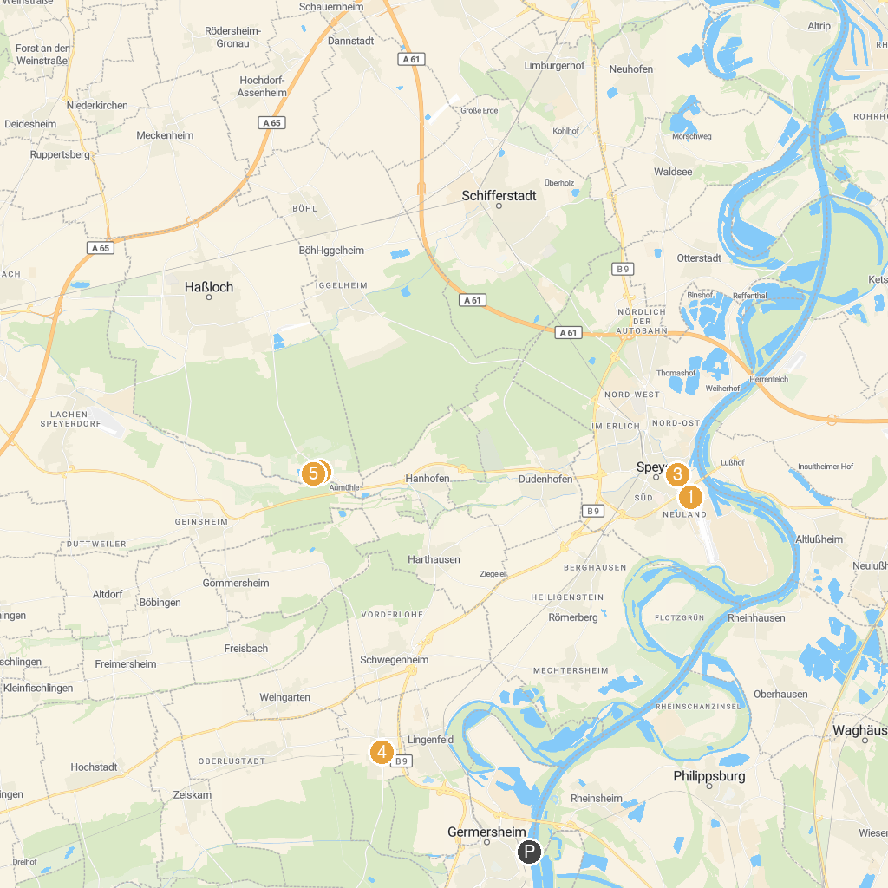
MAP KEY
1. SEA LIFE Speyer | 5. Südpfalz-Draisinenbahn | Bornheim-Westheim
2. Technik Museum Speyer | 6. bigFM Expedition GeForce
3. Plopsaland Germany | 7. Sky Scream
4. Speyerer Dom
P. Cruise port / terminal
Map © MapTiler © OpenStreetMap contributors · cruiseports.org

