Geraldton, Western Australia, Australia
420 km north of Perth, Geraldton is sun-drenched, relentlessly windy, and quietly fascinating — the custodian of the Batavia mutiny story and a memorial to 645 sailors lost in WWII.
⚓ Pier (docked — commercial port) · 🕒 Typical call: 8-10 hrs · 💵 Australian Dollar (AUD) · 🗣️ English · 🦞 Heart of Australia's western rock lobster industry
✍️ MY DAY IN PORT (FILL IN)
Ship / Date
In port | arrive ______ · all aboard ______
Booked excursion
Notes / meeting point
GETTING ASHORE
- Docking: Docked at Berth 4, Geraldton Port (active commercial harbour — no pedestrian access through port)
- Walk to centre: Free shuttle bus to CBD (5–10 min); city centre then flat and walkable
- Best For: History buffs, beach walkers, seafood lovers, scenic flight to Abrolhos Islands
- Don't Miss: HMAS Sydney II Memorial & Museum of Geraldton (Dutch shipwrecks — both free)
GETTING AROUND
- 🚕 Taxi: ~AUD $10–20 minimum — Local taxis have a ~AUD $10–20 minimum fare (flagfall plus booking fee, more for private charter). TaTa Ride app lets yo
- 📱 Rideshare: ✅ Uber, TaTa Ride
TOP THINGS TO DO
- HMAS Sydney II Memorial & Museum of Geraldton — Two must-dos, both free.
- St Francis Xavier Cathedral & Monsignor Hawes Trail — A striking striped Romanesque-Spanish cathedral designed by priest-architect Monsignor Hawes — one of the most unusual churches…
- Abrolhos Islands Scenic Flight — The Houtman Abrolhos are 122 low-lying islands ringed by coral reefs — the site of the 1629 Batavia wreck and home to sea lions.
- Town Beach & Foreshore Walk — Champion Bay (Town Beach) sits right next to the CBD drop-off — calm, sheltered waters good for a swim, with a boardwalk, cafes…
- Western Rock Lobster Lunch — Geraldton sits at the heart of WA's western rock lobster ("crayfish") industry — Australia's most valuable single-species wild…
BEST WALKS
- Foreshore & Museum Loop: 2.5 km · 40–60 min · Easy — From the shuttle drop-off at Marine Terrace, walk north along the foreshore boardwalk past Town…
- Mount Scott Memorial Walk: 3 km return · 50–70 min · Moderate (uphill) — From the Cathedral, head up Hermitage Road to Mount Scott for the HMAS Sydney II Memorial and…
WEATHER · DAYLIGHT · MONEY
Month | High °F | Low °F | Rainy days
May | 75 | 58 | 5
Jul | 67 | 53 | 8
Sep | 71 | 55 | 5
Daylight: May 6:57AM–5:38PM · Jul 7:13AM–5:41PM · Sep 6:19AM–6:14PM
cruiseports.org/geraldton · Confirm terminal & all-aboard time with your ship

Geraldton, Western Australia, Australia — Port Map
Red = walkable sights · Amber = excursions farther out · P = cruise terminal
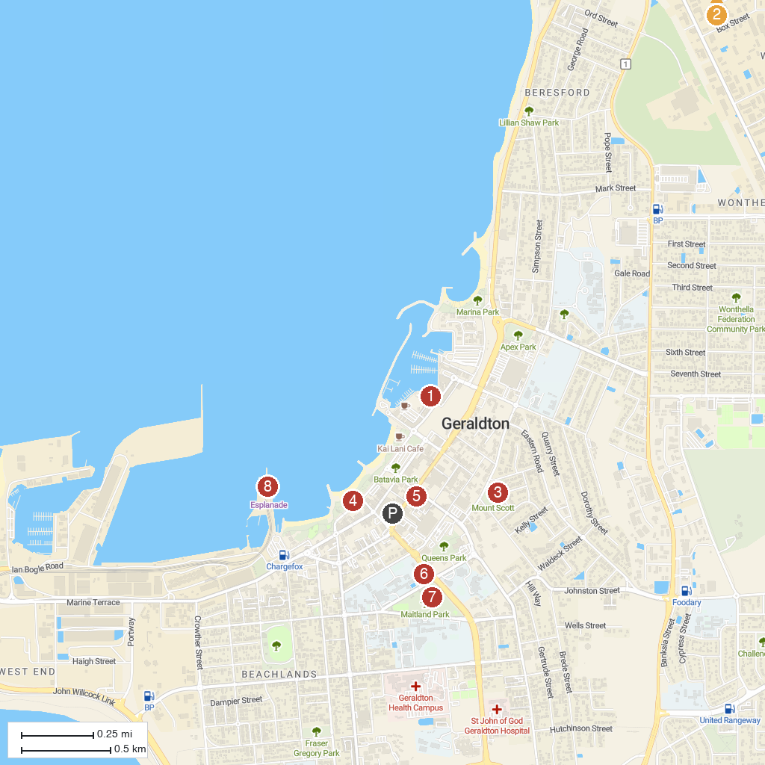
MAP KEY
1. Museum of Geraldton | 5. Geraldton Regional Art Gallery
2. Spalding Park | 6. St Francis Xavier's Cathedral
3. HMAS Sydney II Memorial | 7. Maitland Park
4. Geraldton Water Park | 8. The Esplanade
P. Cruise port / terminal
Map © MapTiler © OpenStreetMap contributors · cruiseports.org

