Geiranger, Møre og Romsdal, Norway
One of the world's most dramatic fjords — sheer cliffs plunge into emerald water, waterfalls cascade from every ledge, and a UNESCO World Heritage tag only scratches the surface of what awaits.
⚓ Mostly tender (SeaWalk dock for select lines) · 🕒 Typical call: 6–8 hrs · 💵 Norwegian Krone (NOK) · 🗣️ Norwegian
✍️ MY DAY IN PORT (FILL IN)
Ship / Date
In port | arrive ______ · all aboard ______
Booked excursion
Notes / meeting point
GETTING ASHORE
- Docking: Tender to village pier (2–10 min ride); select ships use SeaWalk floating dock
- Walk to centre: You land in the village centre — shops and cafes are steps away
- Best For: Fjord scenery, viewpoints, waterfall hikes, RIB safaris
- Don't Miss: Seven Sisters waterfall from the water, Flydalsjuvet viewpoint
GETTING AROUND
- 🚕 Taxi: ~700 NOK/hr (~$65 USD) — Geiranger Turbuss og Taxi offers pre-booked taxis and guided bus tours. Very limited availability — reserve at the touri
- 📱 Rideshare: ❌ not available
- 🚌 Hop-on hop-off: ✅ City Sightseeing Geiranger
TOP THINGS TO DO
- Dalsnibba Skywalk & Eagle Road — Bus tour ascending to Dalsnibba at 1,500 m — Europe's highest fjord viewpoint accessible by road — then past the 11 hairpin bends…
- RIB Fjord Safari — High-speed rigid inflatable boat tour close to the Seven Sisters, The Suitor, and Bridal Veil waterfalls, plus the abandoned…
- Kayaking the Geirangerfjord — Guided kayak tours paddle directly beneath the waterfalls and along the fjord walls.
- Norwegian Fjord Centre — Modern museum in the village covering the geology, ecology, and human history of the Norwegian fjords, including the dramatic…
- Skageflå Mountain Farm Hike — Take a sightseeing boat to Skagehola then hike steeply up to the abandoned Skageflå farm perched above the fjord, facing the…
BEST WALKS
- Waterfall Walk (Fossevandring) to Norwegian Fjord Centre: 1.2 km | 327 steps | ~45 min | Free — A paved path and staircase rising from the village centre past Storfossen waterfall to the…
- Village Waterfront Stroll: 0.5 km | Flat | ~15 min | Free — A short walk along the Geiranger waterfront past the tourist office, local shops, and the Geiranger…
WEATHER · DAYLIGHT · MONEY
Month | High °F | Low °F | Rainy days
May | 53 | 40 | 15
Jul | 68 | 55 | 21
Sep | 61 | 49 | 18
Daylight: May 4:36AM–10:20PM · Jul 4:13AM–10:58PM · Sep 6:57AM–7:53PM
cruiseports.org/geiranger · Confirm terminal & all-aboard time with your ship

Geiranger, Møre og Romsdal, Norway — Port Map
Red = walkable sights · Amber = excursions farther out · P = cruise terminal
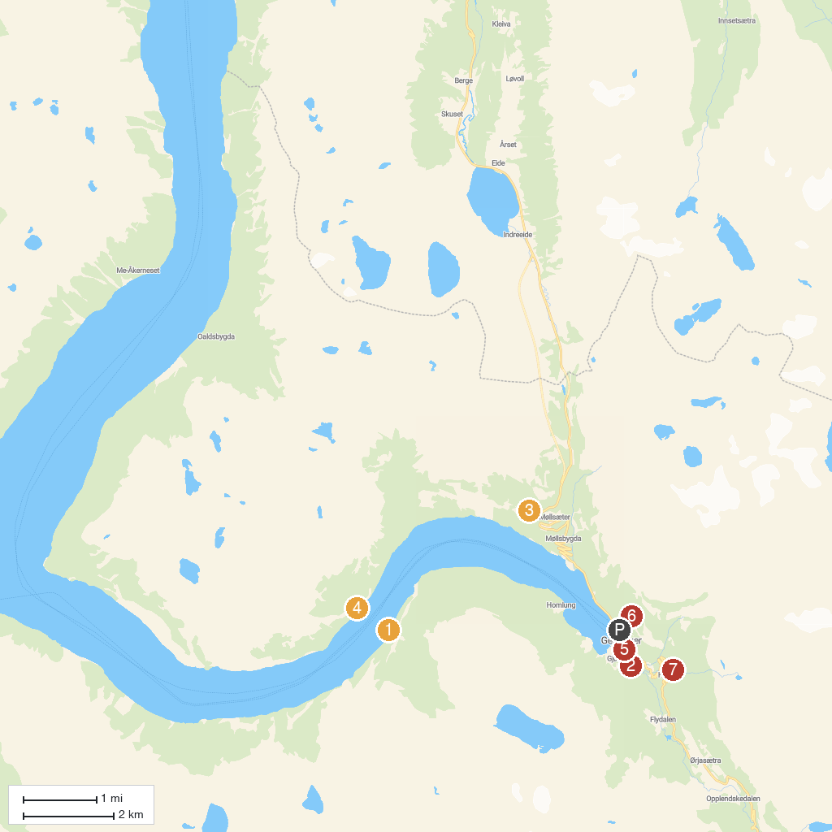
MAP KEY
1. Brudesløret (Bridal Veil) | 5. Geiranger kyrkje
2. Norwegian Fjord Centre | 6. Vesteråsfjellet Utsiktspunkt
3. Ørnesvingen Viewpoint | 7. Waterfall Hole
4. The Seven Sisters
P. Cruise port / terminal
Map © MapTiler © OpenStreetMap contributors · cruiseports.org

