Geelong, Victoria, Australia
Victoria's second city shines brightest along its revitalised waterfront — painted bollards, Art Deco sea baths, and superb food-and-wine all within a short stroll of the pier. It's also the launching pad for the legendary Great Ocean Road.
⚓ Pier (small ships) or tender (large ships) · 🕒 Typical call: 8-10 hrs · 💵 Australian Dollar (AUD) · 🗣️ English
✍️ MY DAY IN PORT (FILL IN)
Ship / Date
In port | arrive ______ · all aboard ______
Booked excursion
Notes / meeting point
GETTING ASHORE
- Docking: Cunningham Pier for ships ≤188 m; larger ships anchor in Corio Bay and tender
- Walk to centre: Immediate from Cunningham Pier; CBD & waterfront 5-10 min on foot
- Best For: Scenic waterfront walks, Australian food & wine, Great Ocean Road day trips
- Don't Miss: The Baywalk Bollards, Eastern Beach Art Deco sea baths, Little Malop Street dining
GETTING AROUND
- 🚕 Taxi: A$18–22 — Short 5–7 minute ride from Cunningham Pier to Geelong city center. Multiple operators including Geelong Taxi Network and
- 📱 Rideshare: ✅ Uber, DiDi
- 🚌 Hop-on hop-off: ✅
TOP THINGS TO DO
- Great Ocean Road Highlights — The world-famous coastal drive begins just 30 minutes from Geelong.
- National Wool Museum — Housed in an 1872 bluestone wool store, this museum tells the story of the industry that built Geelong.
- Surf Coast & Torquay — Torquay is the birthplace of Rip Curl and Australia's surf capital.
- Geelong Heritage & Bollards Walk — Over 100 painted wooden bollards line the waterfront, each depicting a historical character — lifesavers, Koori explorers, opera…
- Bellarine Peninsula Wineries — The Bellarine Peninsula south of Geelong produces outstanding cool-climate Pinot Noir and Chardonnay.
BEST WALKS
- Waterfront Bollards & Eastern Beach Walk: 3 km | 45-60 min | Flat, paved — From Cunningham Pier, head east along the waterfront path spotting the famous painted bollards.
- Waterfront to CBD & Little Malop Street: 1.5 km each way | 20 min | Slight incline to CBD — Head inland from the waterfront up Moorabool Street to Geelong's CBD.
WEATHER · DAYLIGHT · MONEY
Month | High °F | Low °F | Rainy days
May | 61 | 48 | 9
Jul | 56 | 44 | 8
Sep | 61 | 46 | 10
Daylight: May 7:16AM–5:20PM · Jul 7:36AM–5:21PM · Sep 6:23AM–6:12PM
cruiseports.org/geelong · Confirm terminal & all-aboard time with your ship

Geelong, Victoria, Australia — Port Map
Red = walkable sights · Amber = excursions farther out · P = cruise terminal
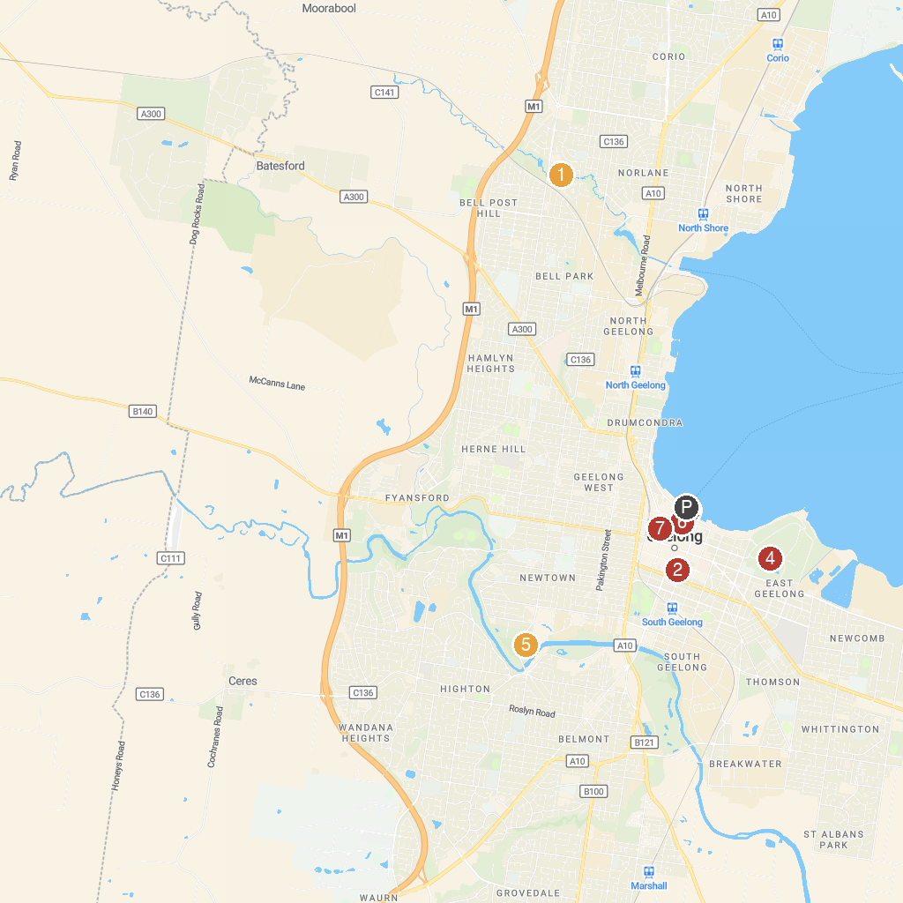
MAP KEY
1. Adventure Park | 5. Friends of Geelong Botanic Gardens
2. Fountain of Friendship Park | 6. Balyang Sanctuary
3. Basilica of Saint Mary of the Angels | 7. National Wool Museum
4. Floating Christmas Tree & Light Show | 8. Johnstone Park
P. Cruise port / terminal
Map © MapTiler © OpenStreetMap contributors · cruiseports.org

