Gdynia / Gdańsk, Pomerania, Poland
Ships dock at Gdynia's Francuskie Pier, putting you within easy reach of Gdańsk's magnificent Old Town — one of Europe's most beautifully restored Hanseatic cities — plus the charming beach resort of Sopot in between.
⚓ Docked (Francuskie Pier, Gdynia) · 🕒 Typical call: 8–10 hrs · 💵 Currency: Polish Złoty (PLN) · 🗣️ Language: Polish (English widely spoken in tourist areas)
✍️ MY DAY IN PORT (FILL IN)
Ship / Date
In port | arrive ______ · all aboard ______
Booked excursion
Notes / meeting point
GETTING ASHORE
- Docking: Docked at Francuskie Pier (French Quay), Gdynia port — industrial area, shuttle or taxi needed
- Distance to Gdańsk: ~21 km south; 25–35 min by SKM commuter train (≈10 PLN) or 30–45 min by taxi
- Best For: WWII history, Hanseatic Old Town, amber shopping, Baltic beach days in Sopot
- Don't Miss: St. Mary's Basilica, Long Market, European Solidarity Center, Neptune Fountain
GETTING AROUND
- 🚕 Taxi: ~20 PLN (~€5) — Metered taxi from Gdynia port to Gdynia city center is quick and cheap. Use official taxis with visible meters to avoid
- 📱 Rideshare: ✅ Uber, Bolt
- 🚌 Hop-on hop-off: ✅ City Sightseeing Gdańsk
TOP THINGS TO DO
- Gdańsk Old Town Walking Tour — Explore the Long Market (Długi Targ), Neptune Fountain, Artus Court, and the Motława riverfront — all within Gdańsk's…
- European Solidarity Center & Westerplatte — Visit the moving Solidarity Center museum where Poland's freedom movement was born, then continue to Westerplatte — the peninsula…
- Malbork Castle Day Trip — About 55 km from Gdańsk, Malbork is the largest brick castle in the world and a UNESCO World Heritage Site — the medieval…
- Sopot Beach & Pier Stroll — Hop off the SKM train at Sopot — Poland's glamorous Baltic resort.
- Amber Museum & Mariacka Street — Visit the Amber Museum in the medieval Great Mill (Wielki Młyn), then browse Mariacka Street's cobblestone gallery of amber…
BEST WALKS
- Gdańsk Old Town Loop: 3 km · 1.5–2 hrs · Easy — From Gdańsk Główny station, walk south down Długa Street to the Long Market, Neptune Fountain, and…
- Gdynia Waterfront Walk: 2.5 km · 1 hr · Easy — From the port gate, walk along the seafront to Kościuszko Square.
- The Royal Way & Long Market: ~2 km · 1.5 hrs · easy — From the Golden Gate down Długa and the Long Market past Neptune's Fountain and the Town Hall to…
WEATHER · DAYLIGHT · MONEY
Month | High °F | Low °F | Rainy days
May | 61 | 47 | 11
Jul | 72 | 60 | 14
Sep | 66 | 54 | 10
Daylight: May 4:40AM–8:44PM · Jul 4:30AM–9:12PM · Sep 6:19AM–7:01PM
cruiseports.org/gdynia-gdansk · Confirm terminal & all-aboard time with your ship

Gdynia / Gdańsk, Pomerania, Poland — Port Map
Red = walkable sights · Amber = excursions farther out · P = cruise terminal
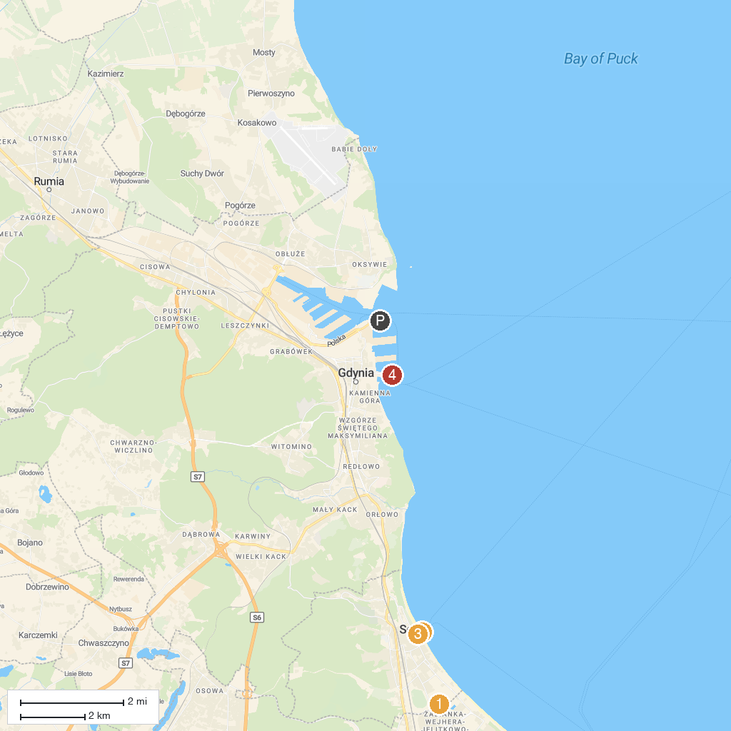
MAP KEY
1. Rezerwat przyrody Cisowa | 5. Westerplatte
2. ERGO ARENA | 6. Gdynia Aquarium
3. Pier in Sopot | 7. Brzeźnieński Park
4. Skwer Kuracyjny | 8. Wieża widokowo - telekomunikacyjna "Góra Donas"
P. Cruise port / terminal
Map © MapTiler © OpenStreetMap contributors · cruiseports.org

