Galway, County Galway, Ireland
The Cultural Heart of Ireland sits right where the Atlantic meets a lively medieval city. Colorful shopfronts, world-class street music, and Galway Bay oysters await — all a short walk from the tender pier.
⚓ Tender port (most ships) · 🕒 Typical call: 6-8 hrs · 💶 Euro (€) · 🗣️ English (Irish Gaeilge official)
✍️ MY DAY IN PORT (FILL IN)
Ship / Date
In port | arrive ______ · all aboard ______
Booked excursion
Notes / meeting point
GETTING ASHORE
- Docking: Tender to Galway Docks (~15-20 min from anchorage)
- Walk to centre: 5-15 min from tender pier on foot
- Best For: Traditional Irish culture, seafood, Wild Atlantic Way day trips
- Don't Miss: Galway Bay oysters with a pint of Guinness at McDonagh's
GETTING AROUND
- 🚕 Taxi: €6–€9 — Taxis queue at the Harbour Hotel rank just steps from the tender pier. Extra passengers add ~€1 each; phone booking adds
- 📱 Rideshare: ✅ Uber
- 🚌 Hop-on hop-off: ✅ · from €19
TOP THINGS TO DO
- Cliffs of Moher — Ireland's most famous natural sight — sheer sea cliffs rising over 200m (max 214m) and stretching 14 km along the Atlantic.
- Connemara & Kylemore Abbey — Wild Atlantic bog, purple mountains, and a fairy-tale Gothic abbey reflected in a lake.
- Aran Islands Ferry — Ancient stone forts, dry-stone walls, and a way of life unchanged for centuries.
- Galway City & Latin Quarter Walk — Explore the medieval Spanish Arch, the winding lanes of the Latin Quarter, and St.
- Galway Seafood & Pub Culture — Galway Bay oysters paired with Guinness are a local institution.
BEST WALKS
- Spanish Arch to Eyre Square Stroll: 1.2 km · 15 min · Flat · All abilities — Walk from the medieval Spanish Arch along the River Corrib quayside, through the colourful Latin…
- The Long Walk & Claddagh: 2 km · 25 min · Flat · Scenic — Follow the picturesque Long Walk promenade past the row of pastel-coloured houses facing Galway…
- Salthill Promenade: 3 km · 35 min · Flat · Coastal — Walk or taxi to the seaside suburb of Salthill and stroll 'The Prom' — a 2 km coastal walkway along…
WEATHER · DAYLIGHT · MONEY
Month | High °F | Low °F | Rainy days
May | 59 | 47 | 14
Jul | 65 | 55 | 16
Sep | 62 | 52 | 15
Daylight: May 5:36AM–9:29PM · Jul 5:28AM–9:55PM · Sep 7:10AM–7:51PM
cruiseports.org/galway · Confirm terminal & all-aboard time with your ship

Galway, County Galway, Ireland — Port Map
Red = walkable sights · Amber = excursions farther out · P = cruise terminal
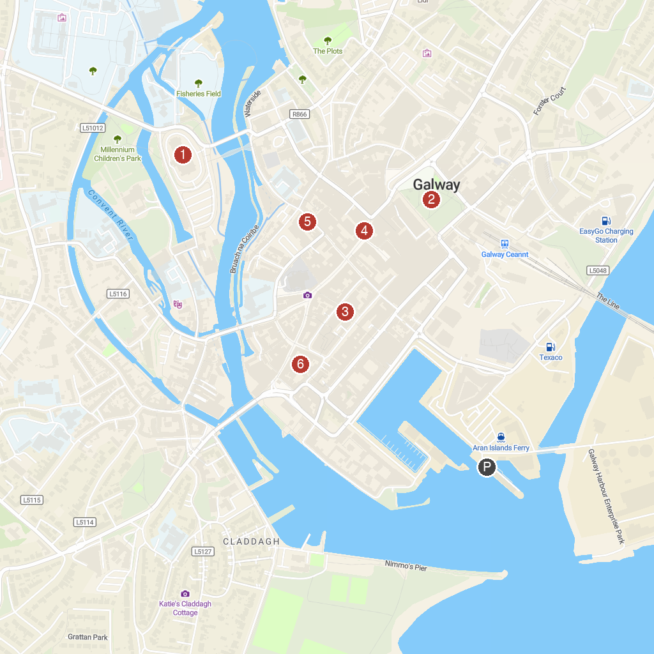
MAP KEY
1. Galway Cathedral | 4. Statue of Oscar Wilde and Eduard Vilde
2. Eyre Square | 5. Great Escape Rooms Galway
3. St Augustine's Catholic Parish | 6. Hall of the Red Earl
P. Cruise port / terminal
Map © MapTiler © OpenStreetMap contributors · cruiseports.org

