Gallipoli, Çanakkale Province, Turkey
Where the Dardanelles narrowed history — the Gallipoli Peninsula is a vast open-air memorial to the 1915 WWI campaign, sacred to Australians, New Zealanders, and Turks alike. No other port will move you quite like this.
⚓ Tender (most ships anchor off Eceabat) · 🕒 Typical call: 7–9 hrs · 💵 Turkish Lira (TL); cards widely accepted · 🗣️ Turkish; English on tour sites
✍️ MY DAY IN PORT (FILL IN)
Ship / Date
In port | arrive ______ · all aboard ______
Booked excursion
Notes / meeting point
GETTING ASHORE
- Docking: Tender to Eceabat (peninsula); some ships dock at Çanakkale (Asian side) and ferry across
- Walk to battlefields: Not walkable — hire a tour, taxi, or rental car from Eceabat
- Best For: WWI history, ANZAC pilgrimage, Dardanelles scenery
- Don't Miss: ANZAC Cove, Lone Pine Memorial, Chunuk Bair, 57th Regiment Memorial
GETTING AROUND
- 🚕 Taxi: ₺100–₺300+ depending on distance — Taxis are available in Çanakkale and Eceabat. Useful for short transfers, but hiring one for the full battlefield circui
TOP THINGS TO DO
- ANZAC Battlefield Circuit — The essential tour: ANZAC Cove, Lone Pine Cemetery & Memorial, Johnston's Jolly trenches, Chunuk Bair New Zealand Memorial, and…
- Full Peninsula Day — ANZAC to Cape Helles — Extended tour covering both the ANZAC sector and the British/French landings at Cape Helles (southern tip), including the Helles…
- Kabatepe Simulation Center + Battlefield — Start at the state-of-the-art Gallipoli Historic Area Simulation Center — 11 rooms with 3D projections recreating the land and…
- Çanakkale Town + Troy Ruins — If your ship calls at Çanakkale (Asian side), explore the waterfront naval museum and the famous Troy wooden horse from the 2004…
- Kilitbahir Castle — A heart-shaped Ottoman fortress built in 1463 by Mehmed II to control the Dardanelles.
BEST WALKS
- Eceabat Waterfront Stroll: Easy · 20 min · flat — From the tender pier, walk the Eceabat harbor front past small cafes and the ferry terminal.
WEATHER · DAYLIGHT · MONEY
Month | High °F | Low °F | Rainy days
May | 75 | 58 | 8
Jul | 89 | 70 | 2
Sep | 81 | 65 | 4
Daylight: May 5:59AM–8:23PM · Jul 5:58AM–8:42PM · Sep 6:55AM–7:23PM
cruiseports.org/gallipoli · Confirm terminal & all-aboard time with your ship

Gallipoli, Çanakkale Province, Turkey — Port Map
Red = walkable sights · Amber = excursions farther out · P = cruise terminal
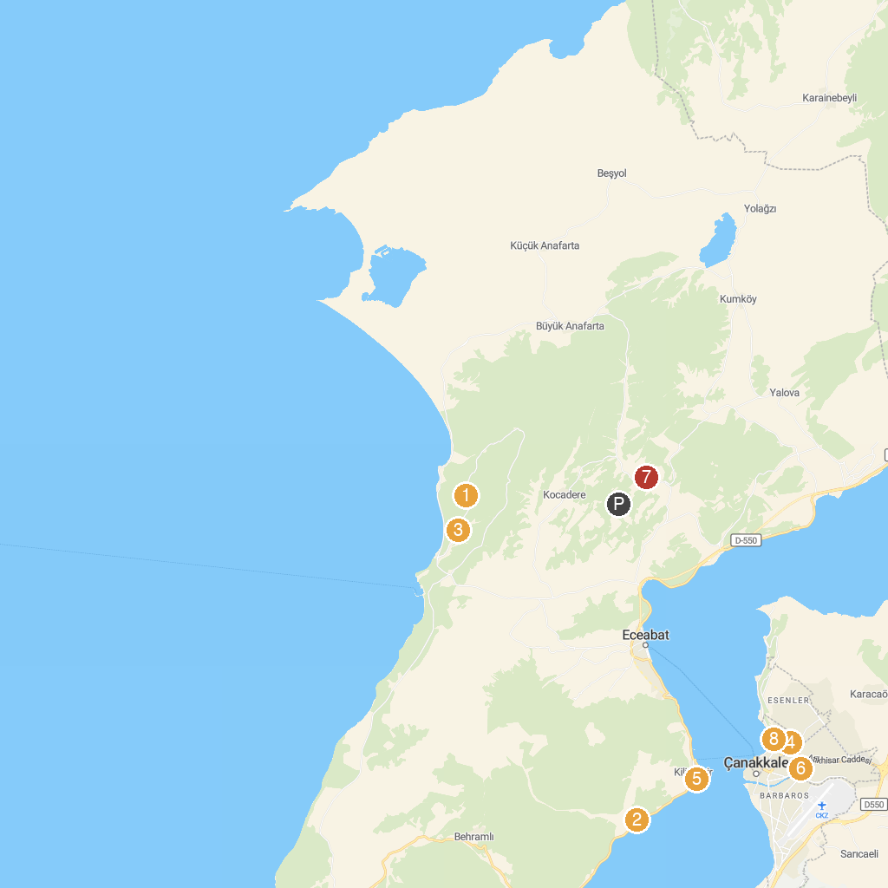
MAP KEY
1. Lone Pine Monument | 5. Namazgah Bastion
2. Havuzlar Şehitliği ve Anıtı | 6. Mecidiye Cami
3. Respect to Mehmetçik Monument | 7. 19. Tümen Müzesi
4. Rotary Parkı | 8. Necip Paşa Cami
P. Cruise port / terminal
Map © MapTiler © OpenStreetMap contributors · cruiseports.org

