Galle, Southern Province, Sri Lanka
A living UNESCO World Heritage fortress rising from Sri Lanka's southwest coast — where Dutch ramparts meet boutique cafes, and the Indian Ocean shimmers just beyond the cannon ports.
⚓ Tender port (most ships) · 🕒 Typical call: 7-9 hrs · 💵 Sri Lankan Rupee (LKR) · 🗣️ Sinhala / English widely spoken · 🌡️ Hot & humid year-round
✍️ MY DAY IN PORT (FILL IN)
Ship / Date
In port | arrive ______ · all aboard ______
Booked excursion
Notes / meeting point
GETTING ASHORE
- Docking: Tender to Galle Port Jetty (small ships may dock at commercial pier)
- Walk to Fort: ~1.2 km (15-20 min flat walk) from jetty to Galle Fort Main Gate
- Best For: Colonial history, fort rampart walks, beach day at Unawatuna
- Don't Miss: Sunset walk on the Dutch ramparts past Galle Lighthouse
GETTING AROUND
- 🚕 Taxi: $5–10 USD for local trips; $80–150 USD for day tours — Metered taxis are limited; negotiate fares or use PickMe/Uber for transparent pricing. Private cars with driver-guides a
- 📱 Rideshare: ✅ Uber, PickMe
TOP THINGS TO DO
- Galle Fort Walking Tour — Explore the UNESCO-listed Dutch fort on foot — ramparts, the 1939 lighthouse, the Dutch Reformed Church (1755), Galle National…
- Unawatuna Beach Day — Sri Lanka's most popular crescent beach is just 5.5 km south of the port.
- Stilt Fishermen & Coastal Drive — Head east along the coast toward Koggala and Ahangama to photograph Sri Lanka's iconic stilt fishermen perched on poles above the…
- Jungle Beach Snorkel — A secluded cove near Rumassala Sanctuary reached by a short forest path.
- Whale & Dolphin Watch from Mirissa — Mirissa, about 35 km east along the coast, is Sri Lanka's premier whale-watching spot.
BEST WALKS
- Rampart Circuit — Fort Walls Walk: 2.5 km loop · 45-60 min · Easy · Best at sunset — Walk the full perimeter of Galle Fort's 17th-century Dutch ramparts.
- Fort Heritage Lane Walk: 1.5 km · 30-45 min · Easy · Shopping & history — Duck inside the fort walls and wander Church Street and Pedlar Street — lined with colonial villas…
WEATHER · DAYLIGHT · MONEY
Month | High °F | Low °F | Rainy days
May | 84 | 78 | 29
Jul | 83 | 78 | 29
Sep | 82 | 77 | 29
Daylight: May 5:53AM–6:17PM · Jul 6:02AM–6:28PM · Sep 6:00AM–6:08PM
cruiseports.org/galle · Confirm terminal & all-aboard time with your ship

Galle, Southern Province, Sri Lanka — Port Map
Red = walkable sights · Amber = excursions farther out · P = cruise terminal
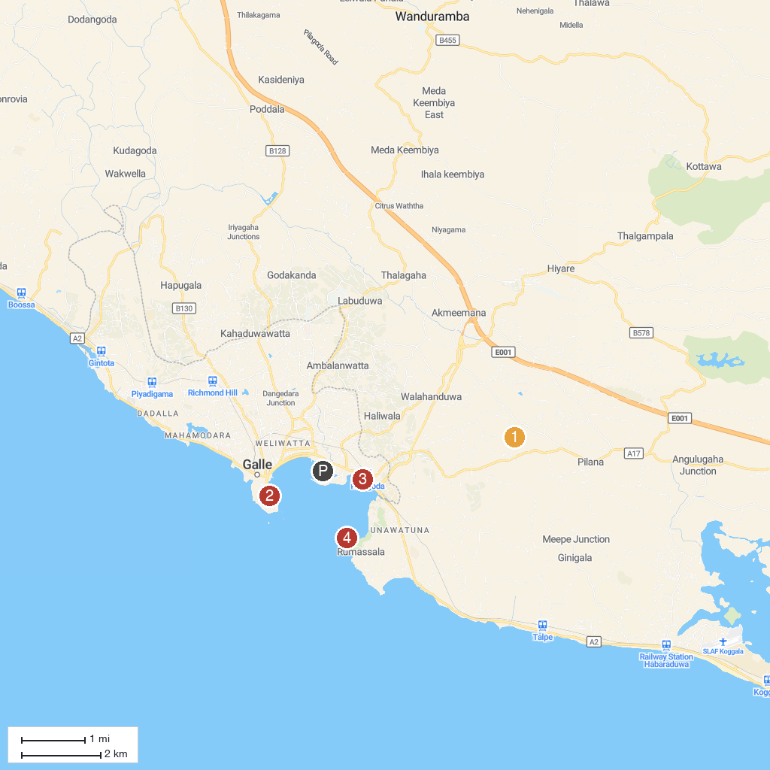
MAP KEY
1. Mahamevnawa Buddhist Monastery - Galle | මහමෙව්නාව භාවනා අසපුව - ගාල්ල | 4. Rumassala South Beach
2. Maritime Archaeology Museum | 5. Martin Wickramasinghe Folk Museum
3. Dewata Beach
P. Cruise port / terminal
Map © MapTiler © OpenStreetMap contributors · cruiseports.org

