Galați, Moldavia, Romania
At the end of the navigable maritime Danube, Galați blends industrial grit with a leafy promenade, Soviet-era iron sculptures, and freshly caught river fish — a surprisingly authentic slice of eastern Romania.
⚓ Pier (direct docking) · 🕒 Typical call: 6-8 hrs · 💵 Romanian Leu (RON) · 🗣️ Romanian (English widely spoken by younger locals)
✍️ MY DAY IN PORT (FILL IN)
Ship / Date
In port | arrive ______ · all aboard ______
Booked excursion
Notes / meeting point
GETTING ASHORE
- Docking: Pier — ships dock at the Danube passenger terminal on the promenade; no tender needed
- Walk to centre: 0 min to promenade; 10-15 min to historic Domnească Street (uphill)
- Best For: Danube fish dining, promenade walks, Socialist-era art, Romanian history
- Don't Miss: Scrumbie de Dunăre (Danube shad) with mămăligă and a cold local beer on the Faleza
GETTING AROUND
- 🚕 Taxi: 5–15 RON (~€1–3) — Taxis are plentiful at the port. The base fare is around 3 RON with ~3.40 RON/km; most city-center destinations cost und
- 📱 Rideshare: ✅ Uber, Bolt
TOP THINGS TO DO
- Faleza Dunării Promenade & Iron Sculpture Trail — Stroll the nearly 4 km riverfront promenade and discover dozens of massive abstract iron sculptures created by Romanian and…
- Precista Fortified Church & Historic Centre — Visit the oldest surviving building in Galați (1647) — a church that doubled as a fortress against Ottoman raids — then walk…
- Danube Fish Lunch on the Faleza — Galați is one of the best places in Romania to eat fresh river fish.
- Danube Ferry Crossing Micro-Adventure — For under $1, take the local car ferry across the Danube to I.C.
- Danube Delta Day Trip — Galați is the gateway to the Danube Delta UNESCO Biosphere Reserve.
BEST WALKS
- Faleza Promenade & Sculpture Walk: 2.5 km · 30-45 min · Flat · Free — From the pier, walk south along the lower Faleza Dunării promenade, pausing at the iron sculptures…
- Upper Town Historic Walk: 1.5 km · 20-30 min · Uphill · Free — From the promenade, climb the steps or sloped streets to reach Domnească Street.
WEATHER · DAYLIGHT · MONEY
Month | High °F | Low °F | Rainy days
May | 72 | 54 | 10
Jul | 85 | 67 | 6
Sep | 77 | 59 | 4
Daylight: May 5:37AM–8:31PM · Jul 5:34AM–8:52PM · Sep 6:46AM–7:18PM
cruiseports.org/galati · Confirm terminal & all-aboard time with your ship

Galați, Moldavia, Romania — Port Map
Red = walkable sights · Amber = excursions farther out · P = cruise terminal
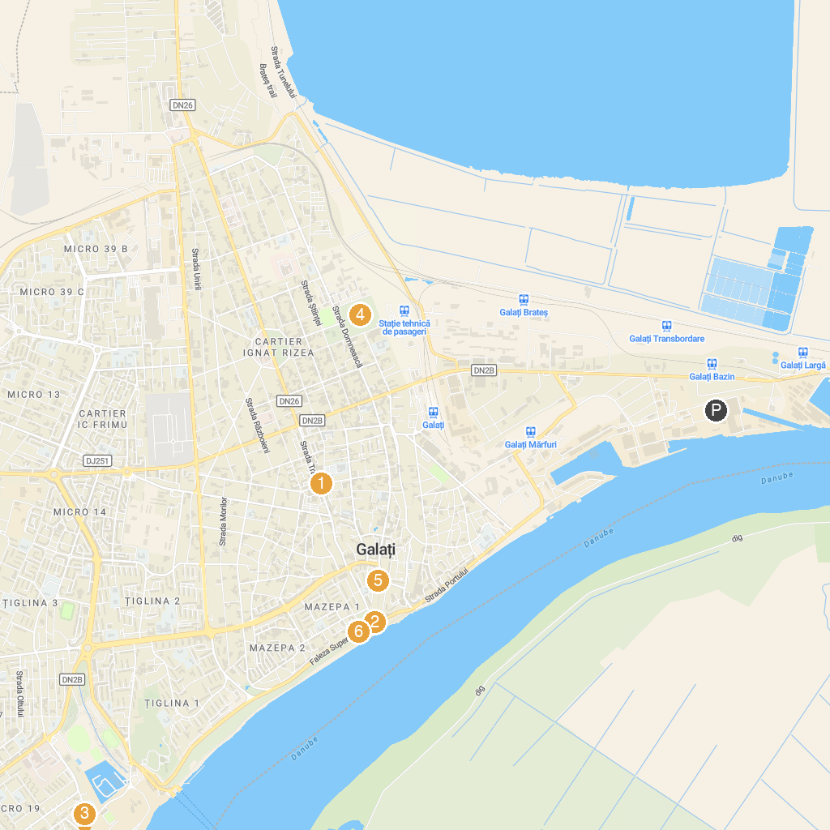
MAP KEY
1. House Museum Collections | 5. Grădina Publică
2. Propeller Monument | 6. "Girl on Waves" Fountain
3. Television Tower | 7. Faleza Dunării
4. Grădina Zoologică-Pădurea Gârboavele
P. Cruise port / terminal
Map © MapTiler © OpenStreetMap contributors · cruiseports.org

