Galapagos Islands, Ecuador
The world's great wildlife encounter — fearless tortoises, penguins, and sea lions in a living laboratory that Darwin never forgot. Every landing here is unlike anywhere else on earth.
⚓ Tender only (zodiac pangas) · 🕒 Expedition cruise — full days ashore · 💵 US Dollar (USD) · 🗣️ Spanish · 🦎 Expedition ships only (max 100 pax)
✍️ MY DAY IN PORT (FILL IN)
Ship / Date
In port | arrive ______ · all aboard ______
Booked excursion
Notes / meeting point
GETTING ASHORE
- Docking: All islands tender via zodiac pangas — wet or dry landings depending on site
- Best For: Wildlife encounters, snorkeling, volcano hikes, photography
- Park Fee: $200 USD per international adult (paid on arrival; verify if pre-paid by cruise line)
- Don't Miss: Giant tortoises in Santa Cruz Highlands, snorkeling at Bartolomé's Pinnacle Rock
GETTING AROUND
- 🚕 Taxi: $2–$4 (San Cristobal town); $25/vehicle (Itabaca Channel to Puerto Ayora) — Taxis in the Galapagos are typically white pickup trucks with fixed fares. On San Cristobal the airport is minutes from
- 📱 Rideshare: ❌ not available
TOP THINGS TO DO
- Santa Cruz Highlands — Giant Tortoises in the Wild — A 25-minute taxi ride from Puerto Ayora pier brings you to ranches like El Chato and Rancho Primicias, where Galapagos giant…
- Bartolomé — Pinnacle Rock Summit & Penguin Snorkel — The most photographed view in the Galapagos.
- Sierra Negra Volcano Hike (Isabela) — One of the world's largest active volcanic calderas, Sierra Negra is a strenuous 16 km round-trip hike from the Isabela highlands.
- Las Tintoreras — Penguins & Sleeping Sharks (Isabela) — A short panga ride from Puerto Villamil to rocky lava islets where white-tip reef sharks rest motionless in a narrow crevice.
- Post Office Bay & Floreana Highlands — Visit the barrel established by British whalers in 1793 — still an active hand-delivery post office where passengers drop…
BEST WALKS
- Puerto Ayora Waterfront to Charles Darwin Research Station: 1.5 km | Flat | Free | ~20 min one way — From the main passenger pier, walk east along the harbour waterfront past the fish market (watch…
- San Cristobal Malecon to Frigatebird Hill (Cerro Tijeretas): 2.5 km | Easy–Moderate | Free | ~40 min one way — From the passenger pier, walk north along the paved coastal malecon past sea-lion-occupied benches…
- Isabela Pier to Concha de Perla & Town: 1.5 km | Flat | Free | ~20 min — Step off the panga at El Embarcadero and walk immediately to the Concha de Perla boardwalk — a…
WEATHER · DAYLIGHT · MONEY
Month | High °F | Low °F | Rainy days
May | 80 | 74 | 22
Jul | 77 | 71 | 17
Sep | 75 | 69 | 12
Daylight: May 5:55AM–5:59PM · Jul 6:05AM–6:09PM · Sep 5:53AM–5:59PM
cruiseports.org/galapagos-islands · Confirm terminal & all-aboard time with your ship

Galapagos Islands, Ecuador — Port Map
Red = walkable sights · Amber = excursions farther out · P = cruise terminal
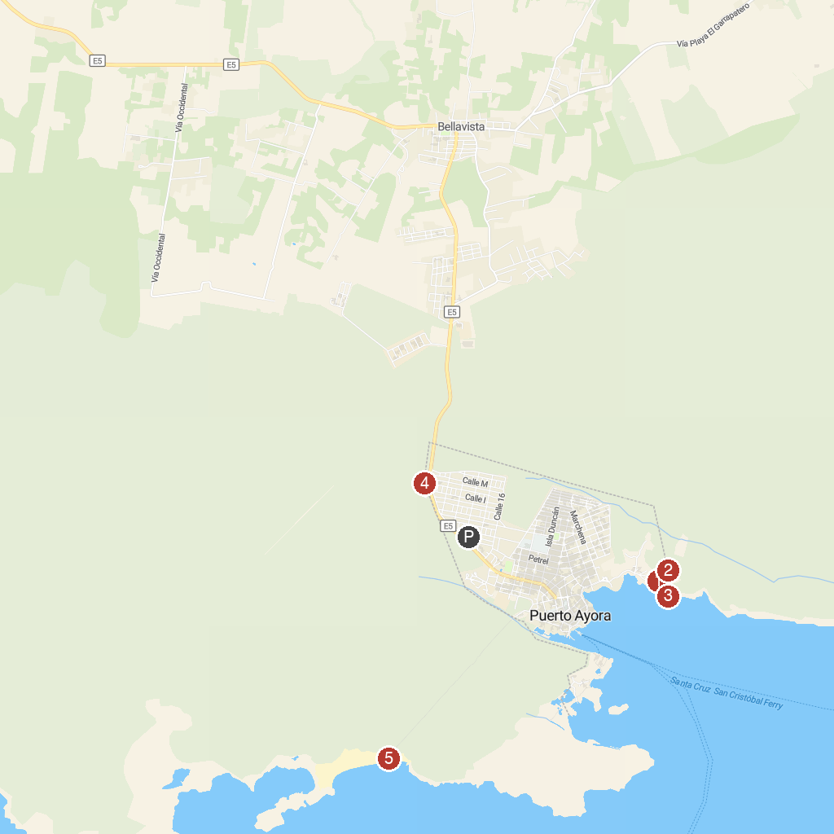
MAP KEY
1. Parque Nacional Galápagos | 5. El Mirador de Los Tuneles
2. Charles Darwin Research Station | 6. Tortuga Bay Beach
3. Fausto Llerena breeding center | 7. Lava Tunnel
4. La Ratonera
P. Cruise port / terminal
Map © MapTiler © OpenStreetMap contributors · cruiseports.org

