Gaeta, Lazio, Italy
Halfway between Rome and Naples, Gaeta is an untouched fortress town where a limestone cliff split at the crucifixion, medieval alleyways lead to legendary beaches, and every bakery sells its own version of the famous tiella pie.
⚓ Tender (most ships) / Docked (small ships) · 🕒 Typical call: 7-9 hrs · 💶 Currency: Euro · 🗣️ Language: Italian · 🏖️ Blue Flag beach in walking distance
✍️ MY DAY IN PORT (FILL IN)
Ship / Date
In port | arrive ______ · all aboard ______
Booked excursion
Notes / meeting point
GETTING ASHORE
- Docking: Tender to Molo Caboto (historic center); small ships dock at Molo Vespucci
- Walk to center: Immediate from tender pier; 15-20 min from Molo Vespucci
- Best For: History, beaches, authentic Italian food, easy walkability
- Don't Miss: Santuario della Montagna Spaccata and a slice of Tiella di Gaeta
GETTING AROUND
- 🚕 Taxi: €4–15 — Local taxis start at ~€4.30 with ~€1.10/km; a 5 km ride runs roughly €10. Useful for reaching the upper town (Monte Orla
- 📱 Rideshare: ❌ not available
TOP THINGS TO DO
- Santuario della Montagna Spaccata — Gaeta's defining sight: a limestone cliff split in three — according to tradition, at the moment of Christ's death.
- Grotta del Turco (Turk's Cave) — Adjacent to the Split Mountain, ~300 steps descend into a dramatic sea cave where waves surge through rocky chambers.
- Castello Angioino-Aragonese — The great fortress dominating Gaeta's skyline has served as royal residence, military stronghold, and prison since the 6th century.
- Serapo Beach — Gaeta's main town beach — wide golden sand, crystal-clear Blue Flag water, beach clubs with sun loungers (~€15-25) and pockets of…
- Via Indipendenza & Tiella Tasting — Gaeta's main pedestrian street is lined with bakeries selling tiella — the town's signature double-crust savory pie stuffed with…
BEST WALKS
- Old Town & Cathedral Loop: 1.5 km · 45 min · Easy (some cobblestones) — From Molo Caboto, wander through Gaeta Vecchia's narrow vicoli to the Duomo di Sant'Erasmo with its…
- Port to Split Mountain: 2.5 km · 30-40 min · Moderate (uphill second half) — Follow the waterfront promenade then climb through residential streets to the Santuario della…
- Cross-Peninsula Beach Walk: 2 km · 25 min · Easy (flat) — Cut across the narrow peninsula from the historic harbor to Serapo Beach on the other side.
WEATHER · DAYLIGHT · MONEY
Month | High °F | Low °F | Rainy days
May | 71 | 58 | 13
Jul | 85 | 72 | 4
Sep | 78 | 66 | 10
Daylight: May 5:47AM–8:17PM · Jul 5:46AM–8:36PM · Sep 6:46AM–7:14PM
cruiseports.org/gaeta · Confirm terminal & all-aboard time with your ship

Gaeta, Lazio, Italy — Port Map
Red = walkable sights · Amber = excursions farther out · P = cruise terminal
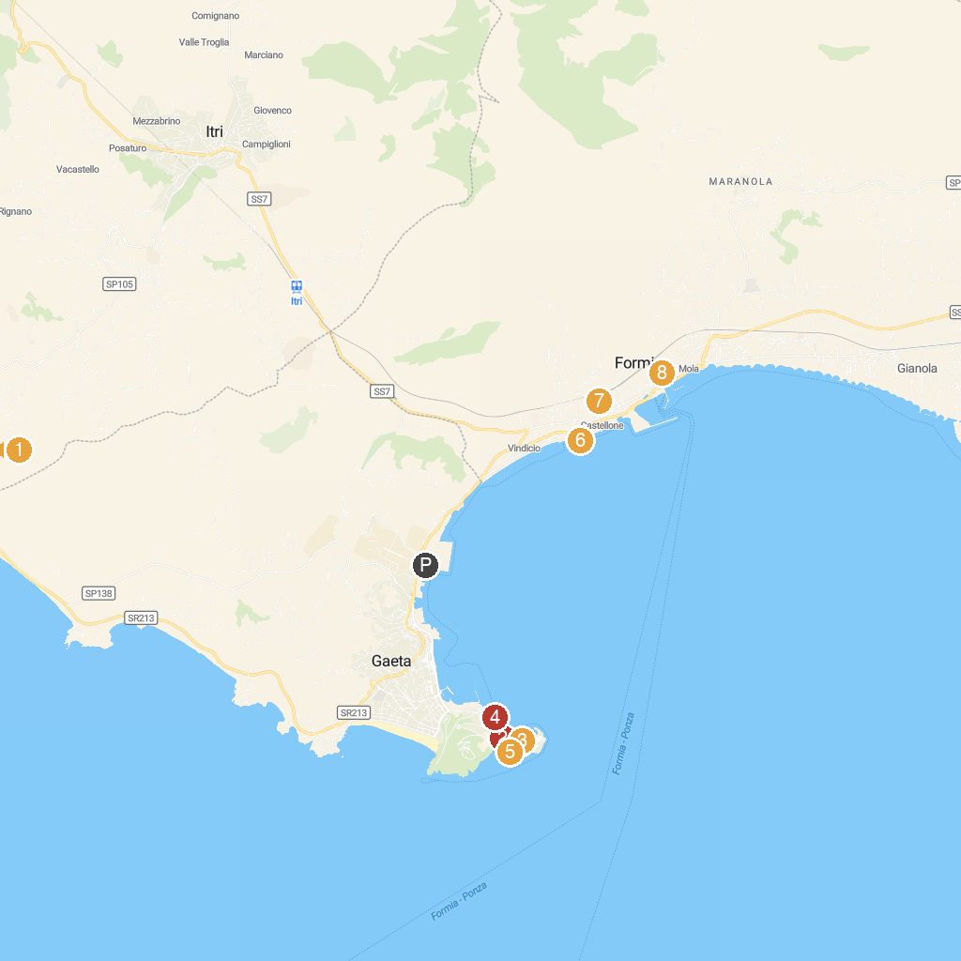
MAP KEY
1. Il Fortino | 5. Castello Angioino-Aragonese
2. Pinacoteca Comunale "Antonio Sapone" di Gaeta | 6. Area Archeologica di Caposele
3. Cathedral Basilica of Gaeta | 7. Cisternone Romano
4. Passeggiata di Gaeta Medievale | 8. Church of Saints Lawrence and John the Baptist
P. Cruise port / terminal
Map © MapTiler © OpenStreetMap contributors · cruiseports.org

