Fujairah, Fujairah Emirate, United Arab Emirates
The UAE's rugged eastern emirate delivers something Dubai can't — ancient mud-brick forts, emerald wadis slicing through the Hajar Mountains, and Gulf of Oman reefs alive with turtles and reef sharks.
⚓ Pier (industrial port) · 🕒 Typical call: 8-10 hrs · 💵 AED (USD widely accepted) · 🗣️ Arabic / English spoken everywhere · 🌊 Best snorkeling in the UAE
✍️ MY DAY IN PORT (FILL IN)
Ship / Date
In port | arrive ______ · all aboard ______
Booked excursion
Notes / meeting point
GETTING ASHORE
- Docking: Ships berth at Port of Fujairah's commercial quay — no tender
- Walk to center: Not walkable — free shuttle to port gate; taxi or shuttle to city (15 min)
- Best For: History, diving/snorkeling, mountain scenery, beach escapes
- Don't Miss: Snoopy Island snorkeling & 15th-century Al Badiyah Mosque
GETTING AROUND
- 🚕 Taxi: 15–30 AED to city center — Taxis queue at the port gate. Base fare is ~10 AED plus ~1.50–2.00 AED/km. The city center and fort are about 5–8 km awa
- 📱 Rideshare: ✅ Careem, Uber
TOP THINGS TO DO
- Fujairah Fort & Old Town — Climb the hill to this 1670 mud-brick fort overlooking the old quarter and date palms.
- Al Badiyah Mosque — The oldest mosque still in use in the UAE (c.
- Snoopy Island Snorkeling — A tiny rock island near Al Aqah that resembles a cartoon dog — and arguably the best snorkeling in the UAE.
- Wadi Wurayah & Mountain Drive — The UAE's only mountain protected area and home to its only permanent waterfall — emerald pools and towering Hajar Mountain…
- Umbrella Beach Day — A well-developed public beach 10 minutes from the port with modern amenities, cafes, water sports, and a jogging track.
BEST WALKS
- Fujairah Fort Hill & Old Quarter: Easy · ~1.5 km · 45 min — From Fujairah city taxi drop-off, walk up to the restored fort, take in views over the date palms…
- Umbrella Beach Corniche Walk: Easy · 2 km · 30 min — A leisurely flat walk along Fujairah's redeveloped public beach promenade, with cafes and sea views…
WEATHER · DAYLIGHT · MONEY
Month | High °F | Low °F | Rainy days
May | 102 | 83 | 1
Jul | 100 | 87 | 1
Sep | 97 | 83 | 0
Daylight: May 5:30AM–6:51PM · Jul 5:34AM–7:06PM · Sep 6:00AM–6:18PM
cruiseports.org/fujairah · Confirm terminal & all-aboard time with your ship

Fujairah, Fujairah Emirate, United Arab Emirates — Port Map
Red = walkable sights · Amber = excursions farther out · P = cruise terminal
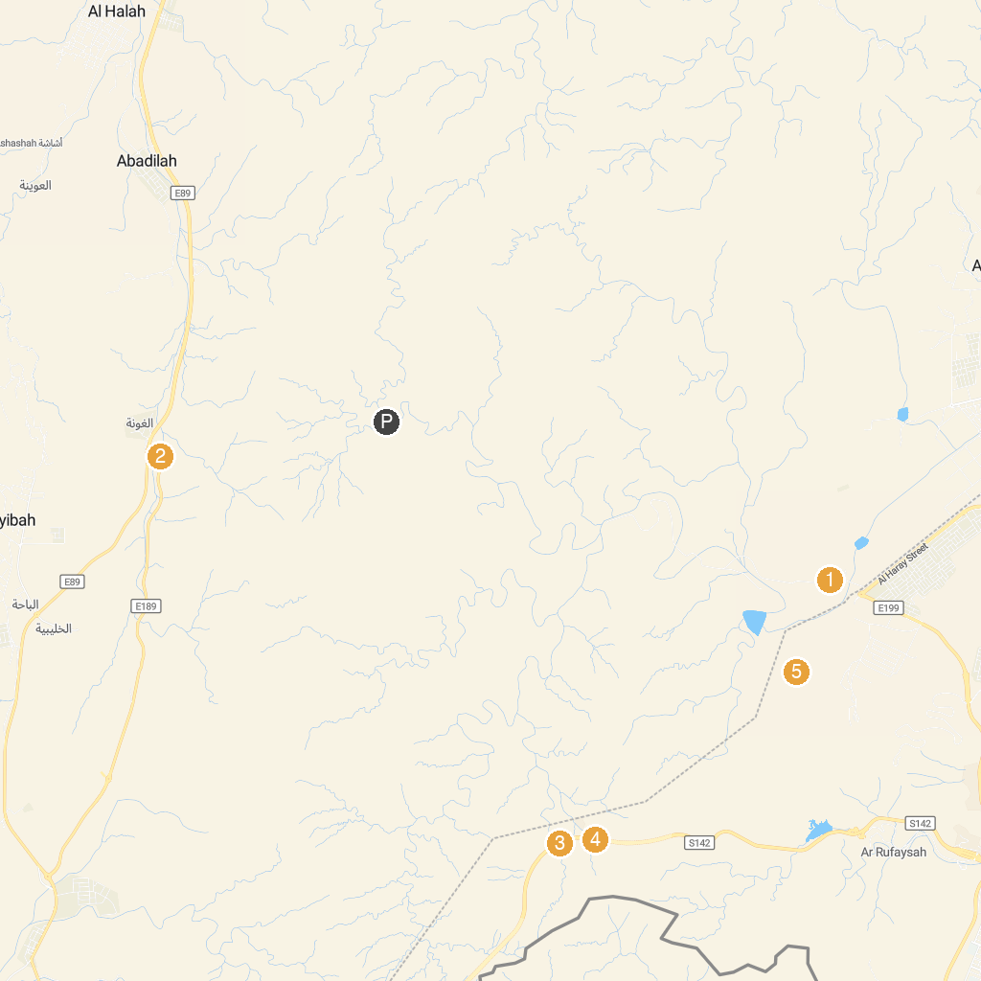
MAP KEY
1. Wadi Wurayah Biosphere Reserve محمية وادي الوريعة | 4. Al Seqb Tunnel
2. Wadi Al Ghuna | 5. Falak Wadi Dababir
3. Al Saha Tunnel (300m)
P. Cruise port / terminal
Map © MapTiler © OpenStreetMap contributors · cruiseports.org

