Friday Harbor, San Juan Island, Washington, USA
A car-free, chain-free harbor town on San Juan Island where orcas cruise the kelp-lined shore and the biggest controversy in local history involved a pig. Small ships only — and all the better for it.
⚓ Small ships — docked at marina · 🕒 Typical call: 6–8 hrs · 💵 USD · 🗣️ English · 🐋 World-class whale watching
✍️ MY DAY IN PORT (FILL IN)
Ship / Date
In port | arrive ______ · all aboard ______
Booked excursion
Notes / meeting point
GETTING ASHORE
- Docking: Direct berth at Port of Friday Harbor Marina; small/expedition ships only
- Walk to center: 0 min — marina steps from Spring Street shops and restaurants
- Best For: Whale watching, Pacific Northwest seafood, island cycling & kayaking
- Don't Miss: The Whale Museum & a whale-watching boat trip to Lime Kiln Point
GETTING AROUND
- 🚕 Taxi: $20–$25 in-town — Eco Taxi and Friday Harbor Taxi serve the island. Useful for reaching farther points like Roche Harbor or Lime Kiln Stat
- 🚌 Hop-on hop-off: ✅ · from 8
TOP THINGS TO DO
- Whale Watching Boat Tour — The San Juan Islands sit astride the feeding grounds of the Southern Resident orcas.
- Lime Kiln Point State Park — Known as Whale Watch Park, this west-coast clifftop is one of the best land-based whale watching sites in the world.
- San Juan Island National Historical Park — The Pig War — In 1859 an American farmer shot a British pig, triggering a 12-year joint military occupation of the island.
- Sea Kayaking the Harbor & Kelp Forests — Guided sea kayak tours depart from the marina and paddle into the kelp beds and rocky coves of Griffin Bay.
- The Whale Museum — The first U.S.
BEST WALKS
- Harbor Waterfront to Spring Street: 0.3 mi · Easy · 10–15 min — From the marina dock, stroll the waterfront boardwalk past moored vessels, then turn up Spring…
- Sunken Park & Ferry View: 0.5 mi · Easy · 20 min — Walk uphill from the dock to Sunken Park, a shady sunken garden above the ferry terminal, where you…
WEATHER · DAYLIGHT · MONEY
Month | High °F | Low °F | Rainy days
May | 59 | 49 | 8
Jul | 67 | 56 | 3
Sep | 63 | 54 | 10
Daylight: May 5:31AM–8:46PM · Jul 5:26AM–9:08PM · Sep 6:49AM–7:23PM
cruiseports.org/friday-harbor-wa · Confirm terminal & all-aboard time with your ship

Friday Harbor, San Juan Island, Washington, USA — Port Map
Red = walkable sights · Amber = excursions farther out · P = cruise terminal
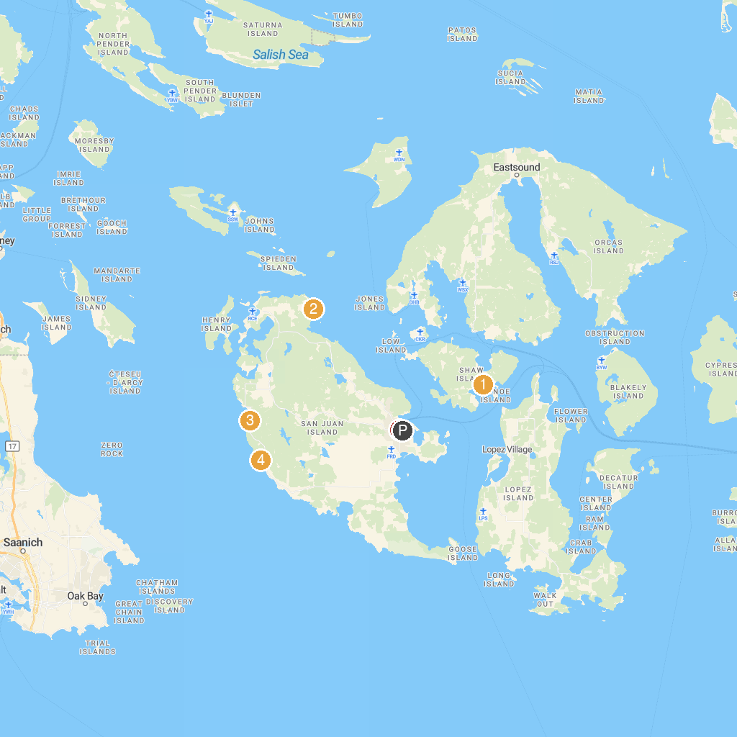
MAP KEY
1. Shaw County Park | 5. John S. McMillin Memorial Mausoleum
2. Reuben Tarte County Park | 6. Lime Kiln Point State Park
3. San Juan County Park | 7. Western Prince Whale Watching Adventures
4. San Juan Islands Sculpture Park & Nature Reserve | 8. The Whale Museum
P. Cruise port / terminal
Map © MapTiler © OpenStreetMap contributors · cruiseports.org

