Freeport, Grand Bahama, Bahamas
Grand Bahama's wide-open island swaps Nassau's hustle for pine forests, one of the world's longest underwater cave systems, and beaches that stay blissfully uncrowded all day.
⚓ Pier port (Lucayan Harbour) · 🕒 Typical call: 7-9 hrs · 💵 USD accepted everywhere (BSD pegged 1:1) · 🗣️ English · 🏝️ Best beach: Gold Rock & Lucayan Beach
✍️ MY DAY IN PORT (FILL IN)
Ship / Date
In port | arrive ______ · all aboard ______
Booked excursion
Notes / meeting point
GETTING ASHORE
- Docking: Pier — Lucayan Harbour (no tender)
- Walk to Center: Port Lucaya is 10 mi away — taxi or tour required
- Best For: Beaches, eco-nature, cave exploration, fresh conch
- Don't Miss: Gold Rock Beach & Lucayan National Park caves
GETTING AROUND
- 🚕 Taxi: $10–15 one way — Taxis queue at the cruise terminal and run on fixed government rates. Fare to Port Lucaya Marketplace (the main tourist
- 📱 Rideshare: ❌ not available
TOP THINGS TO DO
- Lucayan National Park & Gold Rock Beach — A Bahamas National Trust park protecting one of the world's longest charted underwater cave systems — with accessible limestone…
- Lucayan Beach Day — Right across from Port Lucaya Marketplace, this public white-sand beach has calm turquoise water, chair rentals, and water sports.
- Snorkeling & Reef Diving — Grand Bahama sits above one of the world's longest underwater cave systems.
- Garden of the Groves — A 12-acre botanical garden with waterfalls, a hilltop chapel, migratory birds, a labyrinth, and an artisan café.
- Conch & Local Cuisine Tour — Hit Taino Beach for Tony Macaroni's legendary roasted conch, fresh conch salad, and Sky Juice cocktails.
BEST WALKS
- Port Lucaya Marketplace & Marina Walk: ~1 mile | Easy | 30–45 min — After the taxi ride from the pier, wander the colorful Port Lucaya Marketplace around Count Basie…
WEATHER · DAYLIGHT · MONEY
Month | High °F | Low °F | Rainy days
May | 27 | 24 | 15
Jul | 30 | 27 | 19
Sep | 30 | 26 | 20
Daylight: May 5:37AM–8:13PM · Jul 5:35AM–8:32PM · Sep 6:39AM–7:07PM
cruiseports.org/freeport · Confirm terminal & all-aboard time with your ship

Freeport, Grand Bahama, Bahamas — Port Map
Red = walkable sights · Amber = excursions farther out · P = cruise terminal
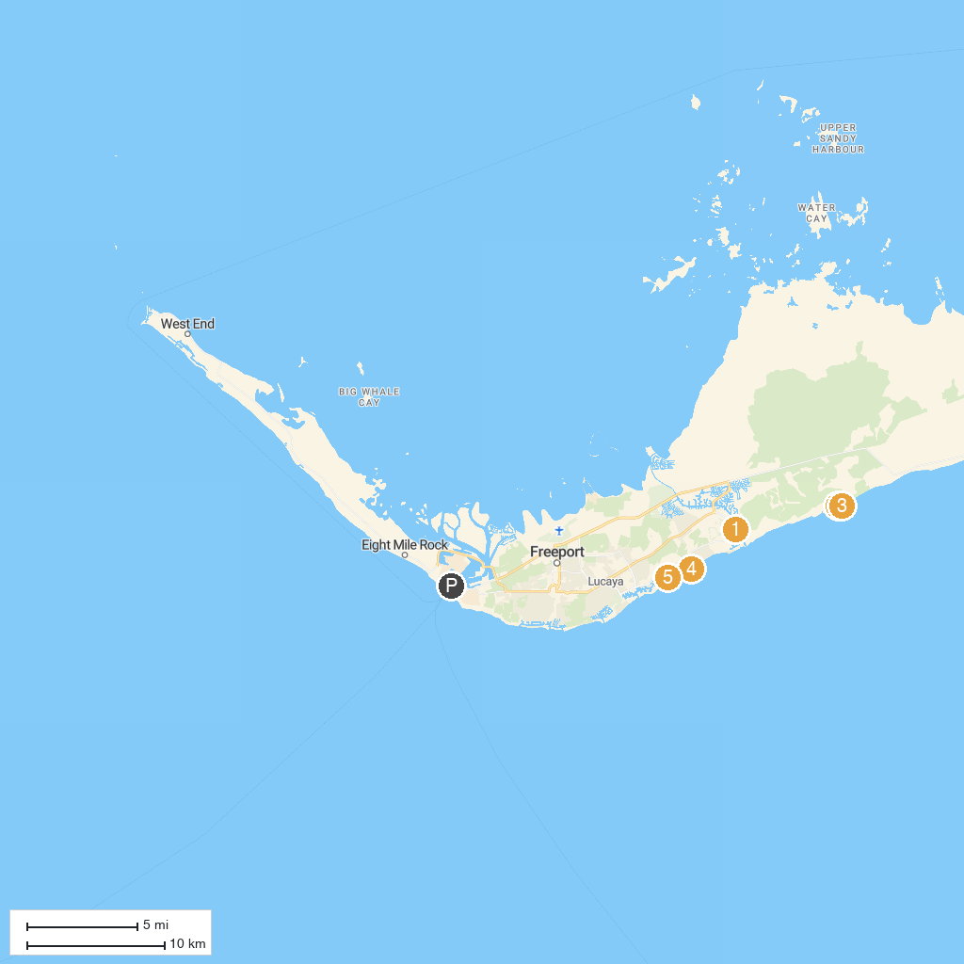
MAP KEY
1. Jubilee Cathedral | 5. Carnival's Celebration Key
2. Rand Nature Center | 6. Creative Eco Adventures
3. Coral Vita Grand Bahama Coral Farm | 7. Sanctuary Bay Grand Bahama
4. Celebration Key Suncastle
P. Cruise port / terminal
Map © MapTiler © OpenStreetMap contributors · cruiseports.org

