Frederikshavn, North Jutland, Denmark
Denmark's gateway to the north blends naval history, a Nordic beach strung with real palm trees in summer, and one of the world's easiest day trips — Skagen is 35 minutes away by train.
⚓ Pier (no tender) · 🕒 Typical call: 7–10 hrs · 💵 Danish Krone (DKK) — nearly cashless · 🗣️ Danish / English widely spoken · 🚂 Train to Skagen: 35 min
✍️ MY DAY IN PORT (FILL IN)
Ship / Date
In port | arrive ______ · all aboard ______
Booked excursion
Notes / meeting point
GETTING ASHORE
- Docking: Pier at Frederikshavn Havn; walk or shuttle to center
- Walk to center: ~1.5 km / 20–25 min flat walk to Danmarksgade
- Best For: History, coastal scenery, day trip to Skagen
- Don't Miss: Krudttårnet tower and the Ellingå Viking ship at Bangsbo Museum
GETTING AROUND
- 🚕 Taxi: 80–150 DKK (~$12–23 USD) — Local taxis are available at the terminal. Base fare is around 49 DKK with per-km charges; a short city-center ride runs
- 📱 Rideshare: ✅ Uber, Bolt
TOP THINGS TO DO
- Krudttårnet — The Powder Tower — Built in 1686 as part of Fladstrand Fortress, this massive round white tower is the symbol of Frederikshavn.
- Kystmuseet Bangsbo — Set in a 14th-century manor, this coastal museum houses the Ellingå ship — an excavated clinker-built vessel from around 1163…
- Bangsbo Fort & Pikkerbakken Viewpoint — A hilltop plateau 82 metres above sea level with sweeping views over Frederikshavn and the Kattegat.
- Palmestranden — The Palm Beach — From May to September, the municipality plants 100 Canary Island date palms in the white sand, creating Scandinavia's only…
- Day Trip to Skagen — Skagen is Denmark's northernmost town — famous for its yellow-ochre houses with red roofs, the Skagen Painters' artistic legacy…
BEST WALKS
- Harbour to Town Centre Stroll: 1.5 km · 20–25 min · Flat · Easy — A straightforward flat walk from the cruise berth into the heart of town, taking in the waterfront…
- Bangsbo Valley Loop: ~5 km · 1.5 hrs · Easy/Moderate · Bike recommended — Head south along the coast to the Bangsbo estate.
WEATHER · DAYLIGHT · MONEY
Month | High °F | Low °F | Rainy days
May | 58 | 47 | 10
Jul | 68 | 58 | 12
Sep | 62 | 54 | 12
Daylight: May 4:57AM–9:32PM · Jul 4:43AM–10:03PM · Sep 6:48AM–7:35PM
cruiseports.org/frederikshavn · Confirm terminal & all-aboard time with your ship

Frederikshavn, North Jutland, Denmark — Port Map
Red = walkable sights · Amber = excursions farther out · P = cruise terminal
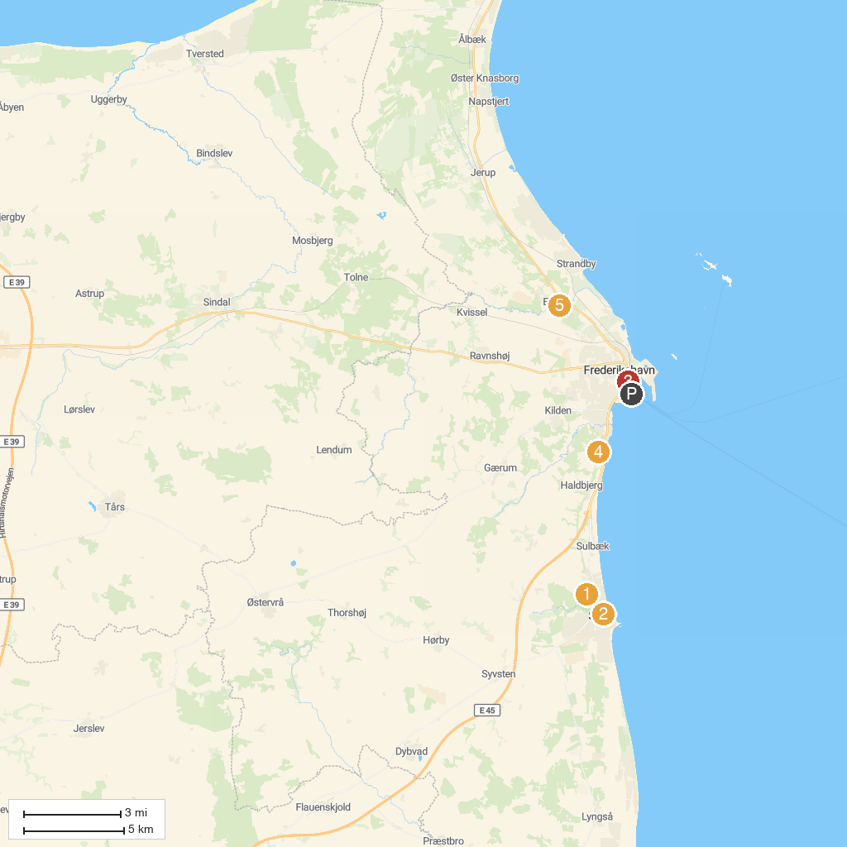
MAP KEY
1. Nellemanns Have | 5. Sæby
2. Sæby Vandmølle | 6. Krudttårnet
3. Minibyen Sæby | 7. Bangsbo Fort - Bunkermuseum
4. Den Selvejende Institution Sæbygård | 8. Elling Kirke
P. Cruise port / terminal
Map © MapTiler © OpenStreetMap contributors · cruiseports.org

