Fredericia, Jutland, Denmark
Founded in 1650 as a royal fortress, Fredericia surprises with pristine ramparts, a Blue Flag beach minutes from the pier, and one of Denmark's most walkable town grids — all right off the ship.
⚓ Pier (Kastelshavnen) · 🕒 Typical call: 6–8 hrs · 💵 Danish Krone (DKK) — cashless city · 🗣️ Danish / English widely spoken · 🏰 Fortress town
✍️ MY DAY IN PORT (FILL IN)
Ship / Date
In port | arrive ______ · all aboard ______
Booked excursion
Notes / meeting point
GETTING ASHORE
- Docking: Pier — Kastelshavnen, steps from old town
- Walk to center: 5–10 min (500 m to Gothersgade)
- Best For: History, beach day, DIY rail to Odense
- Don't Miss: The Ramparts (Volden) & Landsoldaten statue
GETTING AROUND
- 🚕 Taxi: ~65–100 DKK (~€9–14) to city centre — Taxis wait at the cruise quay. Base fare ~50 DKK plus ~15 DKK/km; most major credit cards accepted.
TOP THINGS TO DO
- Ramparts Walk & Landsoldaten — Stroll the massive star-shaped earthworks — some of the best-preserved Renaissance fortifications in Northern Europe.
- Bridgewalking Lillebælt — Walk across the top of the old Little Belt Bridge 60 metres above the water between Fredericia and Middelfart — one of Denmark's…
- Train to Odense — Hans Christian Andersen City — Hop the regional train for 30 minutes to reach Odense, birthplace of Hans Christian Andersen.
- Østerstrand Beach — A Blue Flag beach 15 minutes' walk from the pier — white sand, shallow calm water, sea kayaks, beach volleyball, and a striking…
- Fredericia Town Museum — Explore Fredericia's multicultural founding — Huguenot and Jewish refugees, Danish military history, and the unique grid fortress…
BEST WALKS
- Ramparts & Old Town Loop: 3 km · 45–60 min · Easy — From the pier, walk along the waterfront to the Prinsens Port gate, climb the grass ramparts…
- Pier to Østerstrand Beach: 1.2 km · 15 min · Easy — Head south along the waterfront from the pier past the Kastellet ruins to reach Østerstrand beach.
WEATHER · DAYLIGHT · MONEY
Month | High °F | Low °F | Rainy days
May | 59 | 46 | 11
Jul | 68 | 56 | 12
Sep | 62 | 51 | 13
Daylight: May 5:22AM–5:09PM · Jul 5:33AM–5:17PM · Sep 5:12AM–5:16PM
cruiseports.org/fredericia · Confirm terminal & all-aboard time with your ship

Fredericia, Jutland, Denmark — Port Map
Red = walkable sights · Amber = excursions farther out · P = cruise terminal
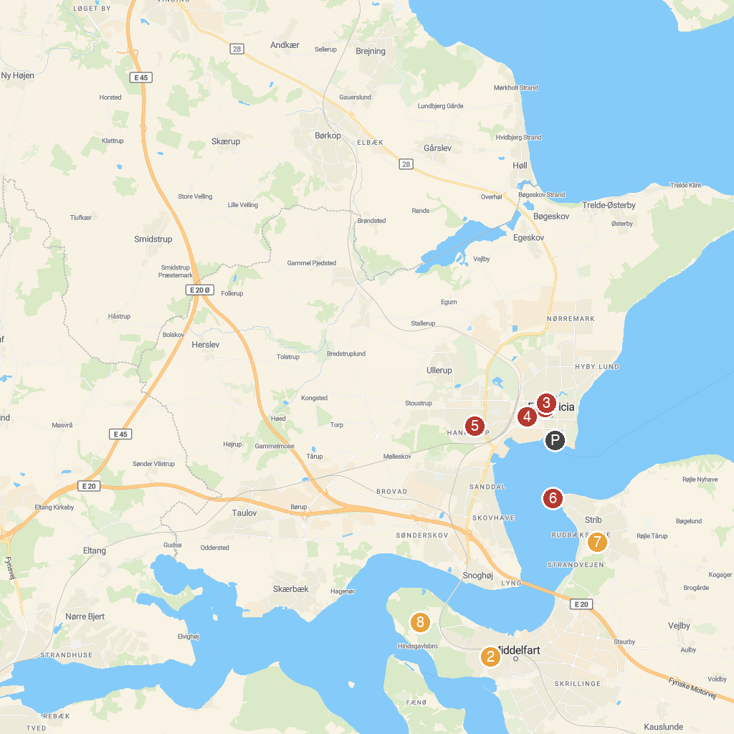
MAP KEY
1. Landsoldatpladsen | 5. Hannerup Kirke
2. Mind Museum | 6. Stribfyr
3. Det Hvide Vandtårn | 7. Strib Automobilmuseum
4. Museum Fredericia | 8. Hindsgavl Dyrehave
P. Cruise port / terminal
Map © MapTiler © OpenStreetMap contributors · cruiseports.org

