Fraser Island (K'gari), Queensland, Australia
The world's largest sand island grows ancient rainforests from pure silica dunes — K'gari is utterly unlike any other cruise port. Your tender brings you to a UNESCO wilderness where dingoes wander the shore and crystal freshwater lakes shimmer in the bush.
⚓ Tender only (Kingfisher Bay Jetty) · 🕒 Typical call: 7–9 hrs · 💵 Australian Dollar (AUD) · 🗣️ English · 🚙 4WD required to explore beyond the resort
✍️ MY DAY IN PORT (FILL IN)
Ship / Date
In port | arrive ______ · all aboard ______
Booked excursion
Notes / meeting point
GETTING ASHORE
- Docking: Tender to Kingfisher Bay Resort Jetty
- Walk to centre: Short walk along the jetty to the Kingfisher Bay Resort hub; beyond requires 4WD
- Best For: Nature lovers, wildlife, unique landscapes, guided eco-tours
- Don't Miss: Lake McKenzie's brilliant blue perched lake and the Maheno Shipwreck on 75 Mile Beach
GETTING AROUND
- 🚕 Taxi: Varies — pre-book required — A single licensed 4WD taxi operates on K'gari. Must be booked in advance; very limited availability. Not a practical opt
TOP THINGS TO DO
- Lake McKenzie (Boorangoora) 4WD Tour — The island's most iconic sight: a perched freshwater lake fed solely by rainwater, ringed by 98% pure white silica sand.
- 75 Mile Beach & Eli Creek Drive — Drive the famous beach highway and float down Eli Creek — a clear freshwater stream that rushes from the island's interior to the…
- Maheno Shipwreck — The rusting iron skeleton of the SS Maheno — a 1905 luxury liner driven ashore by a cyclone in 1935 — lies decaying on 75 Mile…
- Dingo & Ranger Walk — Kingfisher Bay Resort rangers lead free and low-cost guided walks covering K'gari's famous wild dingoes — among the last…
- Central Station Rainforest — One of the world's great oddities: a full-canopy subtropical rainforest growing directly from sand dunes.
BEST WALKS
- Kingfisher Bay Coastal Walk: Easy · ~3 km return · 45–60 min — A flat coastal path north from the resort towards the ruins of McKenzie's historic timber jetty.
- Dundonga Creek Mangrove Walk: Easy · 1.8 km loop · 30–40 min — A short loop through mangrove forest near the resort, good for spotting mud crabs, shore birds, and…
WEATHER · DAYLIGHT · MONEY
Month | High °F | Low °F | Rainy days
May | 73 | 64 | 12
Jul | 69 | 59 | 8
Sep | 74 | 63 | 8
Daylight: May 6:17AM–5:10PM · Jul 6:33AM–5:14PM · Sep 5:45AM–5:41PM
cruiseports.org/fraser-island · Confirm terminal & all-aboard time with your ship

Fraser Island (K'gari), Queensland, Australia — Port Map
Red = walkable sights · Amber = excursions farther out · P = cruise terminal
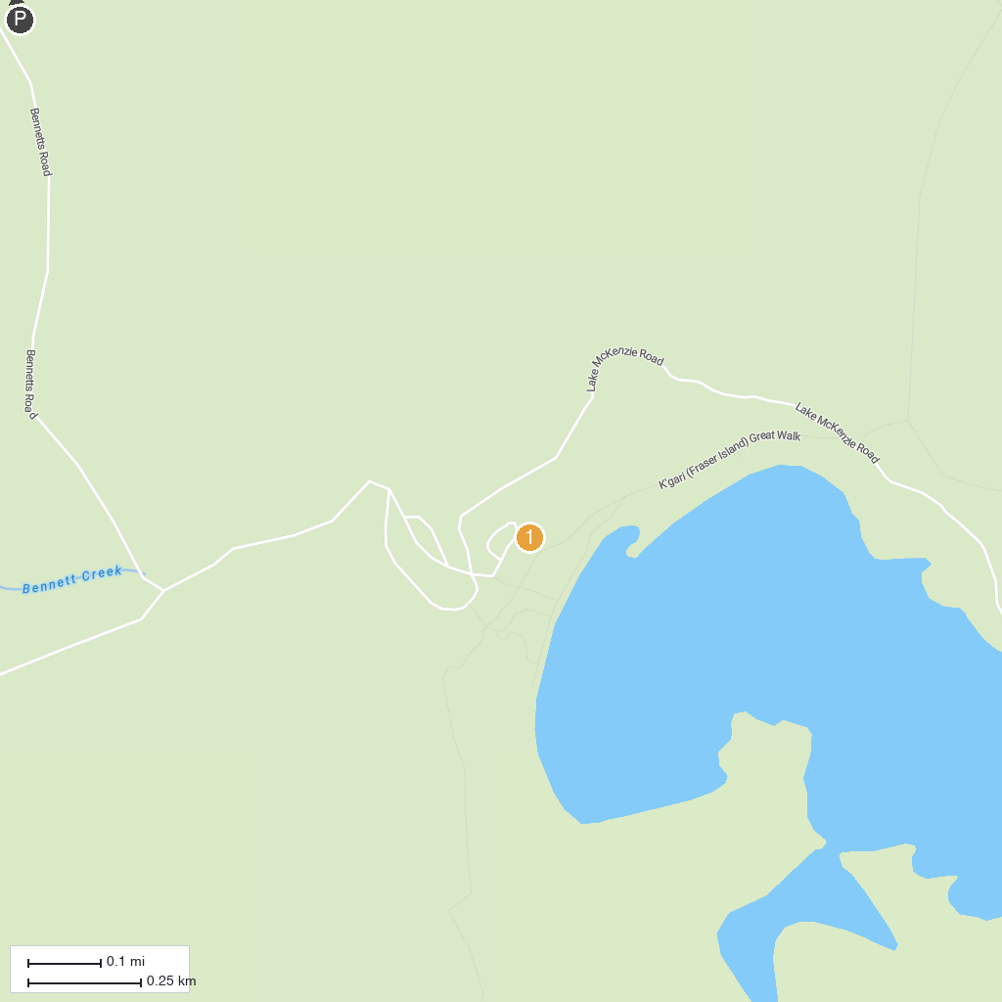
MAP KEY
1. Urangan Pier Hervey Bay | 5. Whalesong Cruises Hervey Bay
2. Reef World Aquarium | 6. Apex Park
3. Wetside Water Park | 7. Lake McKenzie (Boorangoora)
4. Spirit of Hervey Bay | Whale Watching Hervey Bay | 8. Eli Creek
P. Cruise port / terminal
Map © MapTiler © OpenStreetMap contributors · cruiseports.org

