Frankfurt an der Oder, Brandenburg, Germany
A quiet Hanseatic city on the German–Polish border where you can walk off the ship in Germany and lunch in Poland — two cultures, two currencies, one bridge.
⚓ River pier (no tender) · 🕒 Typical call: 6–8 hrs · 💶 Euro (Germany) / Złoty (Poland) · 🗣️ German / Polish
✍️ MY DAY IN PORT (FILL IN)
Ship / Date
In port | arrive ______ · all aboard ______
Booked excursion
Notes / meeting point
GETTING ASHORE
- Docking: River pier on Oderpromenade, 5 min walk to Old Town
- Walk to centre: ~5 min to Rathaus; Poland border bridge 4 min
- Best For: History, twin-city novelty, Gothic architecture
- Don't Miss: St. Mary's Church stained glass & crossing to Słubice
GETTING AROUND
- 🚕 Taxi: €9–17 — Taxis are available at or near the port. Regulated fares start at €4 base plus ~€2.70/km; a short ride within the city t
TOP THINGS TO DO
- St. Mary's Church & Brick Gothic Old Town — Frankfurt's landmark is a massive 5-aisled Gothic brick church damaged in WWII and painstakingly restored.
- Twin-City Walk: Frankfurt → Słubice — Cross the Stadtbrücke into Poland — no border formalities — and experience an entirely different culture in minutes.
- Kleist Museum — Compact museum dedicated to Heinrich von Kleist, the great German dramatist born here in 1777.
- Lennépark Stroll — Germany's second-oldest civic park, designed by Peter Joseph Lenné.
BEST WALKS
- Old Town & St. Mary's Loop: 1.5 km · 25 min · flat — From the pier walk along the Oderpromenade to the Stadtbrücke, then turn inland up Collegienstraße…
- Cross the Border — Słubice Walk: 2.5 km round trip · 30 min walking + time in Poland · flat — Walk from the pier to the Stadtbrücke, cross into Słubice, find the Wikipedia Monument on Plac…
cruiseports.org/frankfurt-an-der-oder · Confirm terminal & all-aboard time with your ship

Frankfurt an der Oder, Brandenburg, Germany — Port Map
Red = walkable sights · Amber = excursions farther out · P = cruise terminal
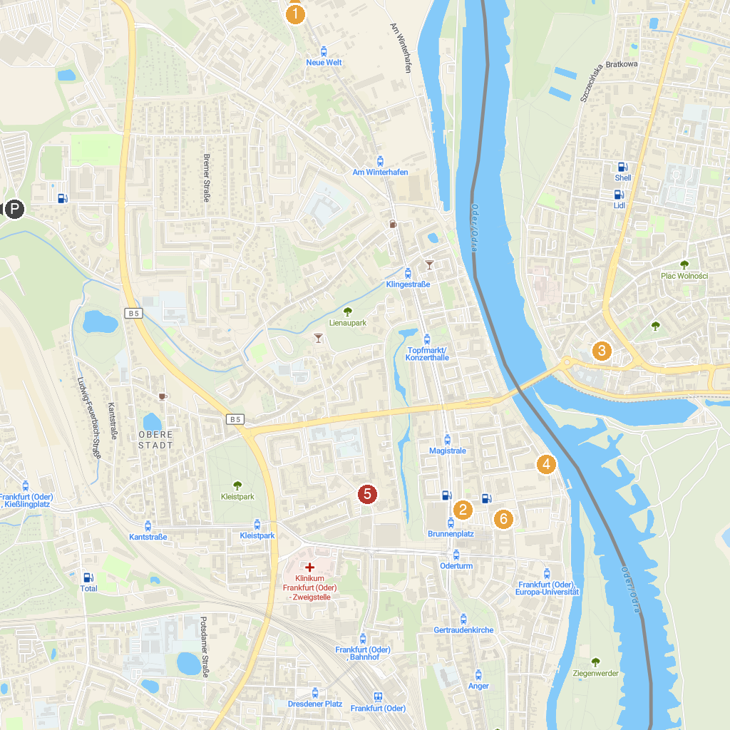
MAP KEY
1. Oderwiesen nördlich Frankfurt | 4. Museum Viadrina – Junkerhaus
2. Comic Fountain | 5. Kath. Kirchengemeinde „Heilig Kreuz“ Frankfurt (Oder)
3. Wikipedia Monument | 6. St. Mary's Church Frankfurt (Oder)
P. Cruise port / terminal
Map © MapTiler © OpenStreetMap contributors · cruiseports.org

