Foynes, County Limerick, Ireland
A tiny Shannon Estuary village with an outsized legacy — the birthplace of Irish Coffee and the transatlantic flying boat era, all within a 2-minute walk of the pier shuttle drop.
⚓ Docked (working cargo port — mandatory shuttle) · 🕒 Typical call: 6–8 hrs · 💶 Euro (€) · 🗣️ English
✍️ MY DAY IN PORT (FILL IN)
Ship / Date
In port | arrive ______ · all aboard ______
Booked excursion
Notes / meeting point
GETTING ASHORE
- Docking: Deep-water pier; shuttle bus mandatory through cargo port
- Walk to center: 2 min from shuttle drop-off
- Best For: Aviation history, Irish Coffee, day trips to Adare & Limerick
- Don't Miss: Boeing 314 Clipper replica at the Flying Boat Museum
GETTING AROUND
- 🚕 Taxi: €60–€75 — Taxis to Limerick city center (~38 km, ~32 min) cost approximately €60–€75 per car. Additional charges apply for extra p
TOP THINGS TO DO
- Foynes Flying Boat & Maritime Museum — The must-do in Foynes.
- Adare Village Day Trip — Often called Ireland's prettiest village, Adare (25 min by taxi) offers thatched-roof cottages, a 13th-century Augustinian abbey…
- King John's Castle, Limerick City — A 13th-century Norman castle on the River Shannon in Limerick City (35 min).
- Bunratty Castle & Folk Park — A beautifully restored 15th-century tower house paired with a living-history 19th-century Irish village.
- Monument Hill Walk & Spring-Rice Monument — A free, short climb from Marine Cove in the village up to the Spring-Rice Monument — a Celtic cross erected c.
BEST WALKS
- Foynes Village Stroll: 0.5 km · 15 min · Easy — From the shuttle drop, walk to the Flying Boat Museum, continue along Main Street past O'Connor's…
- Monument Hill Walk: 0.5 km · 30–45 min · Easy–Moderate — From Marine Cove in the village center, follow the short Monument Hill path as it climbs steeply to…
WEATHER · DAYLIGHT · MONEY
Month | High °F | Low °F | Rainy days
May | 60 | 47 | 14
Jul | 66 | 55 | 16
Sep | 63 | 52 | 15
Daylight: May 5:40AM–9:26PM · Jul 5:31AM–9:52PM · Sep 7:11AM–7:50PM
cruiseports.org/foynes · Confirm terminal & all-aboard time with your ship

Foynes, County Limerick, Ireland — Port Map
Red = walkable sights · Amber = excursions farther out · P = cruise terminal
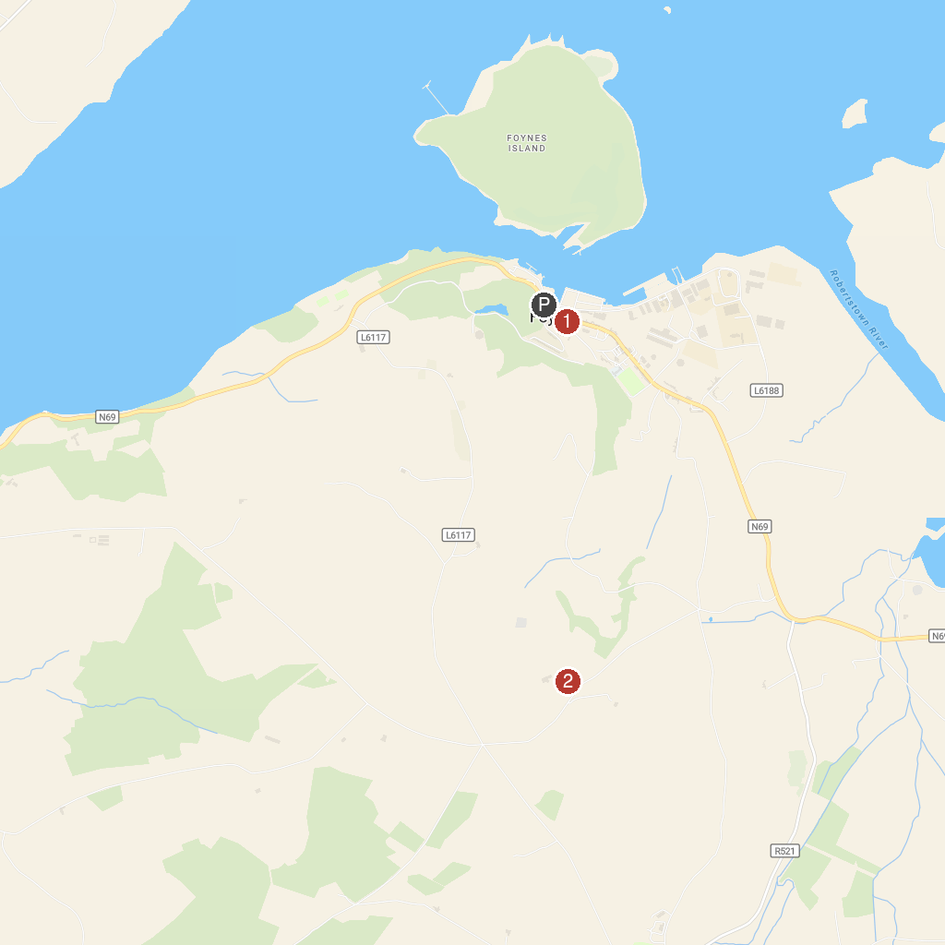
MAP KEY
1. Foynes Flying Boat & Maritime Museum | 4. Glin Pier
2. Knockpatrick Gardens | 5. Limerick Greenway Rathkeale
3. Limerick Greenway Ardagh
P. Cruise port / terminal
Map © MapTiler © OpenStreetMap contributors · cruiseports.org

