Fowey, Cornwall, England
Pronounced 'Foy', this steep medieval harbour town packs Daphne du Maurier history, a free Tudor castle, a sandy cove, and excellent pasties into one of Cornwall's most rewarding tender calls.
⚓ Tender port · 🕒 Typical call: 6-8 hrs · 💷 British Pound (GBP) · 🗣️ English · 📚 Literary heritage
✍️ MY DAY IN PORT (FILL IN)
Ship / Date
In port | arrive ______ · all aboard ______
Booked excursion
Notes / meeting point
GETTING ASHORE
- Docking: Tender to Town Quay or Albert Quay — you land in the town centre
- Walk to centre: 0 min — tender drops right at the quay
- Best For: History, walking, Cornish food, literary sites, scenic estuary
- Don't Miss: St Catherine's Castle (free), Readymoney Cove, Cornish cream tea
GETTING AROUND
- 🚕 Taxi: Metered (varies) — Several local taxi firms serve Fowey (K.P. Cabs, Yeo's Taxis, White River Cars). Ideal for day trips to the Eden Project
TOP THINGS TO DO
- St Catherine's Castle & Readymoney Cove — Walk the Esplanade south from the quay to reach sheltered Readymoney Cove beach, then climb the wooded trail to Henry VIII's…
- The Hall Walk — Circular Estuary Hike — A legendary 4-mile circuit: take the Bodinnick car ferry across the estuary, follow wooded clifftop paths with sweeping views of…
- Daphne du Maurier Literary Trail — Fowey inspired Rebecca, Jamaica Inn, and The Birds.
- Eden Project — Just 15 minutes by road, the Eden Project houses the world's largest indoor rainforest under giant biomes — a once-in-a-lifetime…
- Lost Gardens of Heligan — Around 20-25 minutes by road, these beautifully restored Victorian gardens cover 200 acres of heritage planting, jungle trails…
BEST WALKS
- Town Centre & Fore Street Wander: Easy · 30-45 min · Flat to gentle — From Town Quay, head up Fore Street through Fowey's medieval merchant quarter — independent…
- Esplanade to Readymoney Cove & St Catherine's Castle: Moderate · 1.5-2 hrs · Some steep sections — Head south along the Esplanade past grand Victorian houses to sheltered Readymoney Cove.
WEATHER · DAYLIGHT · MONEY
Month | High °F | Low °F | Rainy days
May | 59 | 49 | 13
Jul | 67 | 57 | 13
Sep | 64 | 55 | 13
Daylight: May 5:31AM–8:59PM · Jul 5:25AM–9:23PM · Sep 6:54AM–7:31PM
cruiseports.org/fowey · Confirm terminal & all-aboard time with your ship

Fowey, Cornwall, England — Port Map
Red = walkable sights · Amber = excursions farther out · P = cruise terminal
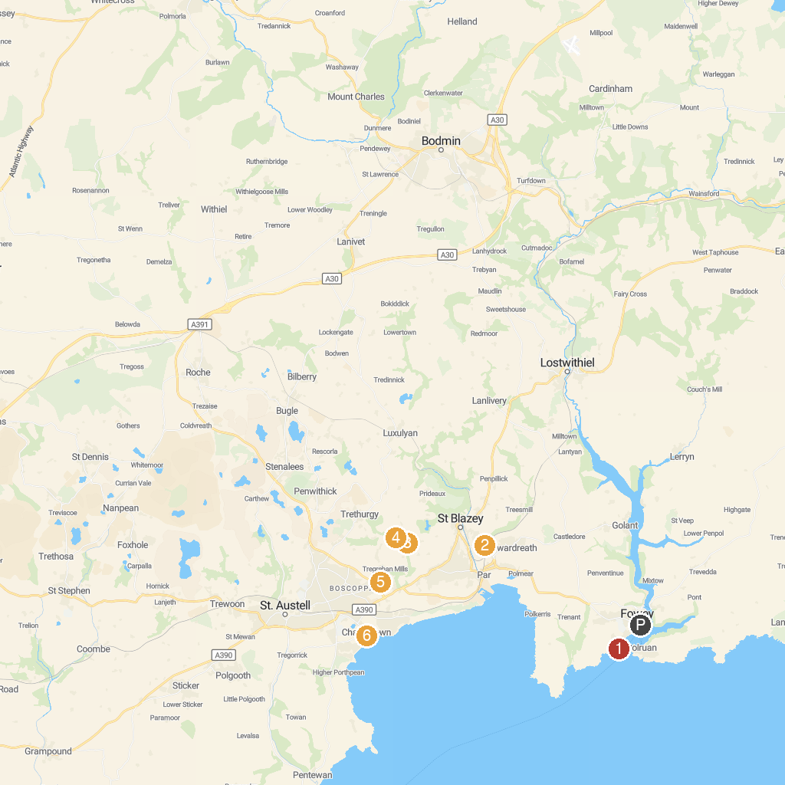
MAP KEY
1. St Catherine's Castle | 5. Cornwall FootballGolf Park
2. Marsh Villa Gardens | 6. Historic Port of Charlestown
3. Hangloose Adventure | 7. The Lost Gardens of Heligan
4. Eden Project | 8. National Trust - Lanhydrock House & Garden
P. Cruise port / terminal
Map © MapTiler © OpenStreetMap contributors · cruiseports.org

