Fort Augustus, Scottish Highlands, Scotland
A pocket-sized Highland village sliced in half by the Caledonian Canal, where boutique cruise ships rise and fall through five hand-operated locks with Loch Ness stretching ahead. Watch the swing bridge halt traffic, then walk to the loch shore in minutes.
⚓ Canal berth (direct docking) · 🕒 Typical call: overnight or full day · 💷 British Pound (GBP) · 🗣️ English
✍️ MY DAY IN PORT (FILL IN)
Ship / Date
In port | arrive ______ · all aboard ______
Booked excursion
Notes / meeting point
GETTING ASHORE
- Docking: Canal berth, heart of village — no tender
- Walk to center: 0–5 min (directly on towpath)
- Best For: Canal history, Loch Ness cruises, Highland scenery
- Don't Miss: Watching boats transit the five-lock staircase
GETTING AROUND
- 🚕 Taxi: ~£50–80 to Inverness — Local operators including ScotTaxi and Inverness Taxis offer transfers to Inverness, Urquhart Castle, and other Highland
- 📱 Rideshare: ❌ not available
TOP THINGS TO DO
- Cruise Loch Ness Boat Tour — Board a catamaran at the foot of the locks for a 50-minute cruise on Loch Ness with onboard sonar displays.
- Urquhart Castle — Dramatic 13th-century ruins perched on a cliff above the deepest part of Loch Ness, ~25 minutes north on the A82.
- Clansman Centre Living History Show — Costumed interpreters in a converted 19th-century schoolhouse recreate 17th-century clan life — how the kilt was bound, weapons…
- Great Glen Way Towpath Walk or Cycle — The flat towpath heading west from the locks toward Loch Oich offers serene Highland scenery through pine forests.
BEST WALKS
- Lock Staircase to Loch Ness Shore: 1.2 km · 20 min · flat · free — Walk down the five locks to the swing bridge, then continue along the canal bank to the shore of…
- Caledonian Canal Towpath to Loch Oich: 4 km one-way · 1 hr · flat · free — Head west along the tree-lined towpath from the lock basin toward Loch Oich.
WEATHER · DAYLIGHT · MONEY
Month | High °F | Low °F | Rainy days
May | 57 | 44 | 17
Jul | 64 | 53 | 20
Sep | 60 | 50 | 16
Daylight: May 4:59AM–9:31PM · Jul 4:46AM–10:01PM · Sep 6:50AM–7:36PM
cruiseports.org/fort-augustus · Confirm terminal & all-aboard time with your ship

Fort Augustus, Scottish Highlands, Scotland — Port Map
Red = walkable sights · Amber = excursions farther out · P = cruise terminal
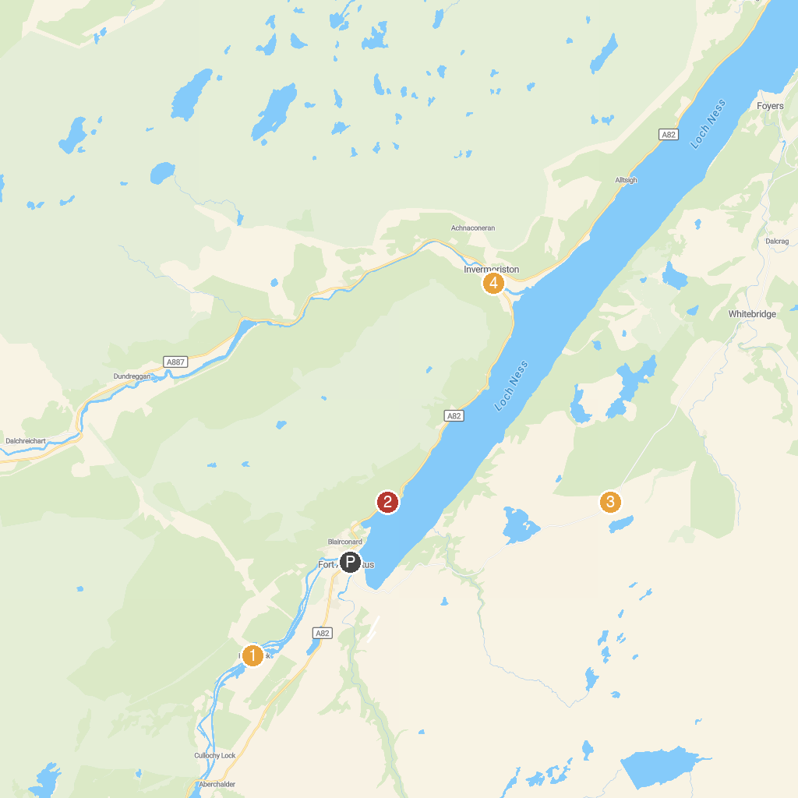
MAP KEY
1. Kytra Lock | 3. Suidhe Viewpoint
2. Allt na Criche | 4. Summer House
P. Cruise port / terminal
Map © MapTiler © OpenStreetMap contributors · cruiseports.org

