Formentera Island, Balearic Islands, Spain
The 'Caribbean of the Mediterranean' — Formentera's impossibly turquoise waters and bohemian soul make it one of the most coveted shore days in the Balearics. No high-rises, no crowds by design, just powdery sand and posidonia-filtered sea.
⚓ Tender (no cruise pier) · 🕒 Typical call: 6–8 hrs · 💶 Currency: Euro (€) · 🗣️ Spanish / Catalan · 🏖️ Best beaches in the Med
✍️ MY DAY IN PORT (FILL IN)
Ship / Date
In port | arrive ______ · all aboard ______
Booked excursion
Notes / meeting point
GETTING ASHORE
- Docking: Tender to La Savina marina; large ships often dock Ibiza + ferry across (30–35 min)
- Walk to center: Steps from tender dock to La Savina village; rent a bike or scooter to explore
- Best For: World-class beaches, e-biking, hippie markets, snorkeling in posidonia-clear water
- Don't Miss: Platja de Ses Illetes — consistently ranked among the world's best beaches
GETTING AROUND
- 🚕 Taxi: €10–€18 — Fixed-rate taxis from La Savina port. Sant Francesc Xavier (capital) costs ~€10–€15; Es Pujols ~€15–€18. Expect 30–45 mi
- 📱 Rideshare: ❌ not available
TOP THINGS TO DO
- Platja de Ses Illetes Beach Day — The headline act — a long spit of powdery white sand with impossibly shallow, turquoise water on both sides.
- Cap de Barbaria Lighthouse & Cliffs — Drive or cycle to the island's southernmost tip, where a dramatic lighthouse stands above sheer cliffs.
- La Mola Hippie Market — Running every Wednesday and Sunday from May to October on the island's elevated eastern plateau, this legendary market sells…
- E-Bike Island Loop via Rutas Verdes — Formentera has 30+ km of flat, dedicated green cycling routes connecting La Savina, Sant Francesc, Es Pujols, and the beaches.
- Sant Francesc Xavier Village Stroll — The island's charming capital.
BEST WALKS
- La Savina to Platja de Ses Illetes: ~4 km one-way | ~50 min | Easy, flat — Follow the main road north from the marina past the salt flats and Ses Salines Natural Park edge to…
- Sant Francesc Xavier Village Walk: 1 km loop | ~30 min | Easy — Wander the pedestrianized streets of Formentera's island capital.
WEATHER · DAYLIGHT · MONEY
Month | High °F | Low °F | Rainy days
May | 68 | 64 | 2
Jul | 80 | 76 | 0
Sep | 78 | 75 | 6
Daylight: May 6:42AM–8:59PM · Jul 6:42AM–9:18PM · Sep 7:36AM–8:02PM
cruiseports.org/formentera-island · Confirm terminal & all-aboard time with your ship

Formentera Island, Balearic Islands, Spain — Port Map
Red = walkable sights · Amber = excursions farther out · P = cruise terminal
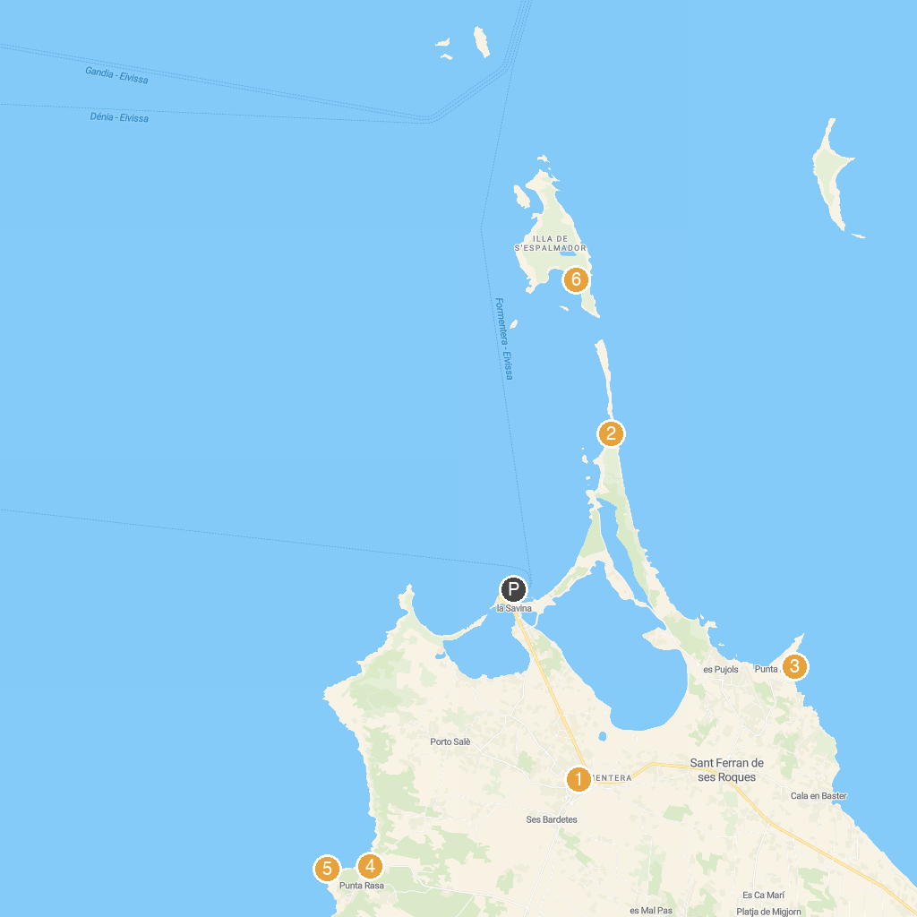
MAP KEY
1. Museu d’Etnografia de Formentera | 5. Cala Saona
2. Molino viejo de la Mola | 6. Punta Rasa
3. Platja de Ses Illetes | 7. Platja de S'Alga
4. Torre de la Punta Prima
P. Cruise port / terminal
Map © MapTiler © OpenStreetMap contributors · cruiseports.org

