Folegandros Island, Cyclades, Greece
One of the Cyclades' best-kept secrets, Folegandros rewards those who make the tender crossing with whitewashed clifftop villages, a living medieval fortress, and beaches that have barely changed in centuries.
⚓ Tender (no pier) · 🕒 Typical call: 6–8 hrs · 💶 Currency: Euro (€) · 🗣️ Language: Greek · 🌊 Small ships & yachts
✍️ MY DAY IN PORT (FILL IN)
Ship / Date
In port | arrive ______ · all aboard ______
Booked excursion
Notes / meeting point
GETTING ASHORE
- Docking: Tender to Karavostasis port
- Walk to center: Chora is 3 km from port — take the bus or taxi
- Best For: Authentic Cyclades vibe, clifftop views, hiking, quiet beaches
- Don't Miss: Chora's Kastro & the hike to the Church of Panagia
GETTING AROUND
- 🚕 Taxi: €12–€17 — Taxis meet ferries and cruise tenders at Karavostasi port. Fare to Chora (the main town) is ~€12 day / €17 after midnigh
- 📱 Rideshare: ❌ not available
TOP THINGS TO DO
- Chora, Kastro & Panagia Church — Walk the three flower-draped squares of Chora, duck into the 13th-century Kastro quarter, then hike the stone path up to the…
- Boat Tour to Katergo Beach & Sea Caves — Jump on a small tourist boat from Karavostasis to Katergo — the island's most beautiful beach of white pebbles and electric-blue…
- Ano Meria Village & Folklore Museum — Hire an ATV and head to Ano Meria, a traditional village of scattered farmsteads.
- Agali Beach Day — One of the island's finest sandy beaches, set in a bay backed by dramatic hills.
- Lunch in Chora — Matsata & Local Wines — Sit in one of Chora's three shaded squares and try matsata — the island's signature handmade ribbon pasta with slow-cooked rabbit…
BEST WALKS
- Karavostasis Beach Stroll: Easy · 10 min · Flat — From the tender dock, a 2-minute walk brings you to Chochlidia Beach (pebbles, tamarisk shade…
- Chora Kastro & Panagia Hike: Moderate · 1.5–2 hrs · Uphill path — From Chora's main square, explore the Kastro alleys, then follow the signed stone path uphill for…
WEATHER · DAYLIGHT · MONEY
Month | High °F | Low °F | Rainy days
May | 65 | 62 | 3
Jul | 76 | 73 | 0
Sep | 74 | 71 | 2
Daylight: May 6:13AM–8:20PM · Jul 6:13AM–8:38PM · Sep 7:02AM–7:27PM
cruiseports.org/folegandros-island · Confirm terminal & all-aboard time with your ship

Folegandros Island, Cyclades, Greece — Port Map
Red = walkable sights · Amber = excursions farther out · P = cruise terminal
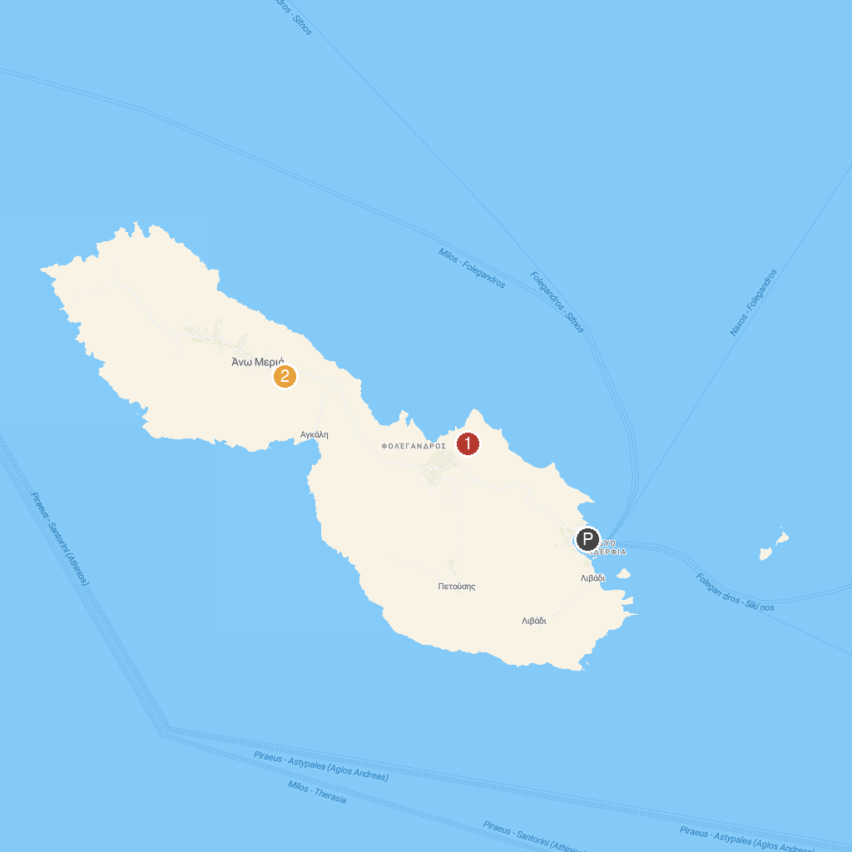
MAP KEY
1. Church of Virgin Mary of Folegandros | 2. Λαογραφικό Μουσείο Φολεγάνδρου
P. Cruise port / terminal
Map © MapTiler © OpenStreetMap contributors · cruiseports.org

