Florø, Sogn og Fjordane, Norway
Norway's westernmost town greets you with pastel wooden houses, a pier you can walk right off into the town center, and an archipelago of islands crowned by a medieval stone church on wave-battered Kinn.
⚓ Pier (Fugleskjær Quay) · 🕒 Typical call: 6–8 hrs · 💳 Cashless Norway — card everywhere · 🗣️ Norwegian (English widely spoken)
✍️ MY DAY IN PORT (FILL IN)
Ship / Date
In port | arrive ______ · all aboard ______
Booked excursion
Notes / meeting point
GETTING ASHORE
- Docking: Pier — Fugleskjær Quay, central waterfront
- Walk to center: 2–5 min (200–300 m to Strandgata)
- Best For: Island day trips, Coastal Museum, craft beer, coastal hiking
- Don't Miss: Express boat to Kinn Island & 12th-century Kinn Church
GETTING AROUND
- 🚕 Taxi: 140–200 NOK (~$13–19 USD) — Kinn Taxi AS (24/7) and Florø Drosjesentral serve the area. Short in-town trips are inexpensive given how compact Florø
- 📱 Rideshare: ❌ not available
TOP THINGS TO DO
- Kinn Island & Medieval Church — Take the express boat 30 minutes across open water to Kinn, a wild grass-covered island.
- Coastal Museum (Kystmuseet) — A rewarding indoor/outdoor museum 2 km along the shore covering west-coast fishing, boatbuilding, and the herring boom that…
- Brandsøyåsen Summit Hike — Climb to the 293 m peak behind town for a 360° panorama of ocean, islands, and distant alpine peaks.
- Kinn Brewery Tasting — Kinn Bryggeri is one of Norway's most acclaimed craft breweries, known for open-fermentation English- and Belgian-style ales.
- Svanøy Island & Deer Centre — Boat across to Svanøy, the 'Pearl of Sunnfjord' — a lush island with a 17th-century manor, Viking-age traces, and the Svanøy…
BEST WALKS
- Waterfront Stroll to Coastal Museum: 4 km round trip · 45–60 min · Easy · Free — Follow the shoreline path south-east from the pier along Markegata and the coastal promenade to…
- Åsen Viewpoint Walk: 3 km round trip · 45 min · Easy-moderate · Free — A signed gravel trail from near the town centre winds up through birch woodland to Utsikten…
WEATHER · DAYLIGHT · MONEY
Month | High °F | Low °F | Rainy days
May | 52 | 45 | 16
Jul | 61 | 54 | 18
Sep | 58 | 51 | 20
Daylight: May 4:49AM–10:24PM · Jul 4:28AM–11:01PM · Sep 7:06AM–8:01PM
cruiseports.org/floro · Confirm terminal & all-aboard time with your ship

Florø, Sogn og Fjordane, Norway — Port Map
Red = walkable sights · Amber = excursions farther out · P = cruise terminal
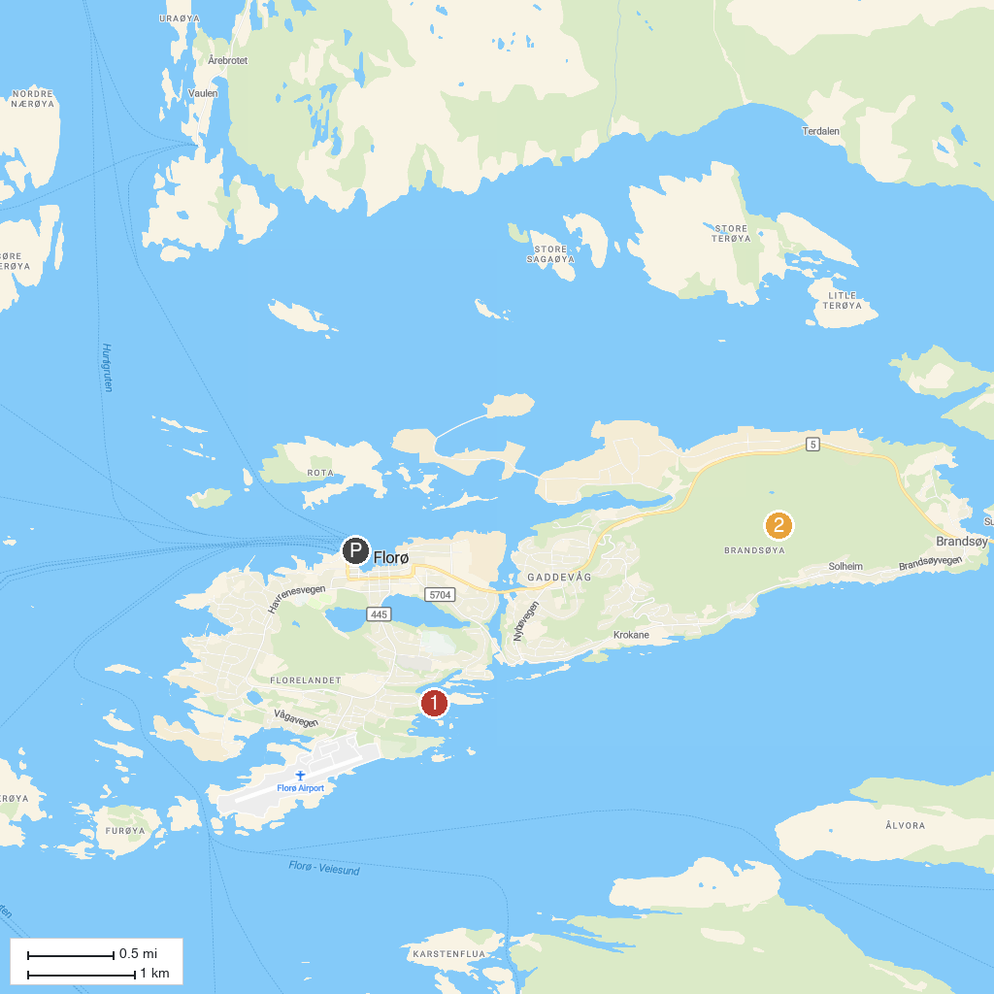
MAP KEY
1. Coastal Museum in Sogn og Fjordane | 3. Svanøy Hovedgård
2. Brandsøyåsen Viewpoint | 4. Ausevika rock carvings
P. Cruise port / terminal
Map © MapTiler © OpenStreetMap contributors · cruiseports.org

