Floreana Island, Galápagos, Ecuador
One of the Galápagos' oldest and most enigmatic islands, Floreana blends extraordinary wildlife — flamingos, sea turtles, reef sharks — with a stranger-than-fiction 1930s mystery that still isn't solved. Almost exclusively visited by small expedition ships.
⚓ Tender only (panga/zodiac) · 🕒 Typical call: 6–8 hrs · 💵 USD (cash rarely needed ashore) · 🗣️ Spanish · 🦎 Galápagos National Park — guide required
✍️ MY DAY IN PORT (FILL IN)
Ship / Date
In port | arrive ______ · all aboard ______
Booked excursion
Notes / meeting point
GETTING ASHORE
- Docking: Anchor & tender (panga) — no deep-water pier; wet landings at most sites
- Walk to center: Puerto Velasco Ibarra is tiny — side to side in 10 min; other sites require ship repositioning
- Best For: Wildlife, snorkeling, history, the famous Post Office Bay barrel tradition
- Don't Miss: Post Office Bay barrel, Cormorant Point flamingo lagoon, Devil's Crown snorkel
GETTING AROUND
- 🚕 Taxi: ~$1–2 per person — Passengers arriving by inter-island ferry or speedboat from Santa Cruz use a small water taxi (taxibote) to transfer fro
- 📱 Rideshare: ❌ not available
TOP THINGS TO DO
- Post Office Bay & the Barrel Tradition — Since 1793, sailors have left unstamped postcards in a barrel at Post Office Bay, trusting fellow travelers to hand-deliver them.
- Cormorant Point: Flamingos & Flour Beach — A flat 2 km loop trail passes a saltwater lagoon populated by Greater Flamingos, then ends at Flour Beach — ultra-fine white sand…
- Devil's Crown Snorkeling — Corona del Diablo — a partially submerged eroded volcanic cone — is among the best snorkel sites in the entire Galápagos.
- Highlands: Asilo de la Paz & Giant Tortoises — A bumpy 8 km chiva (open-air truck) ride into Floreana's lush highlands (Asilo de la Paz) brings you to the island's only…
- Champion Islet Snorkeling — A short panga ride from Floreana brings you to Champion Islet, another excellent snorkel and dive site with sea lions, penguins…
BEST WALKS
- Puerto Velasco Ibarra Village Stroll: Easy · ~10 min side to side · flat — The tiny settlement of Puerto Velasco Ibarra — Floreana's only village of ~170 residents — is…
- Cormorant Point Nature Trail: Easy · 2 km loop · flat volcanic path — Guided loop from the wet landing beach past the flamingo lagoon to Flour Beach.
WEATHER · DAYLIGHT · MONEY
Month | High °F | Low °F | Rainy days
May | 75 | 70 | 16
Jul | 71 | 66 | 11
Sep | 69 | 64 | 6
Daylight: May 5:56AM–5:59PM · Jul 6:06AM–6:09PM · Sep 5:53AM–5:59PM
cruiseports.org/floreana-island · Confirm terminal & all-aboard time with your ship

Floreana Island, Galápagos, Ecuador — Port Map
Red = walkable sights · Amber = excursions farther out · P = cruise terminal
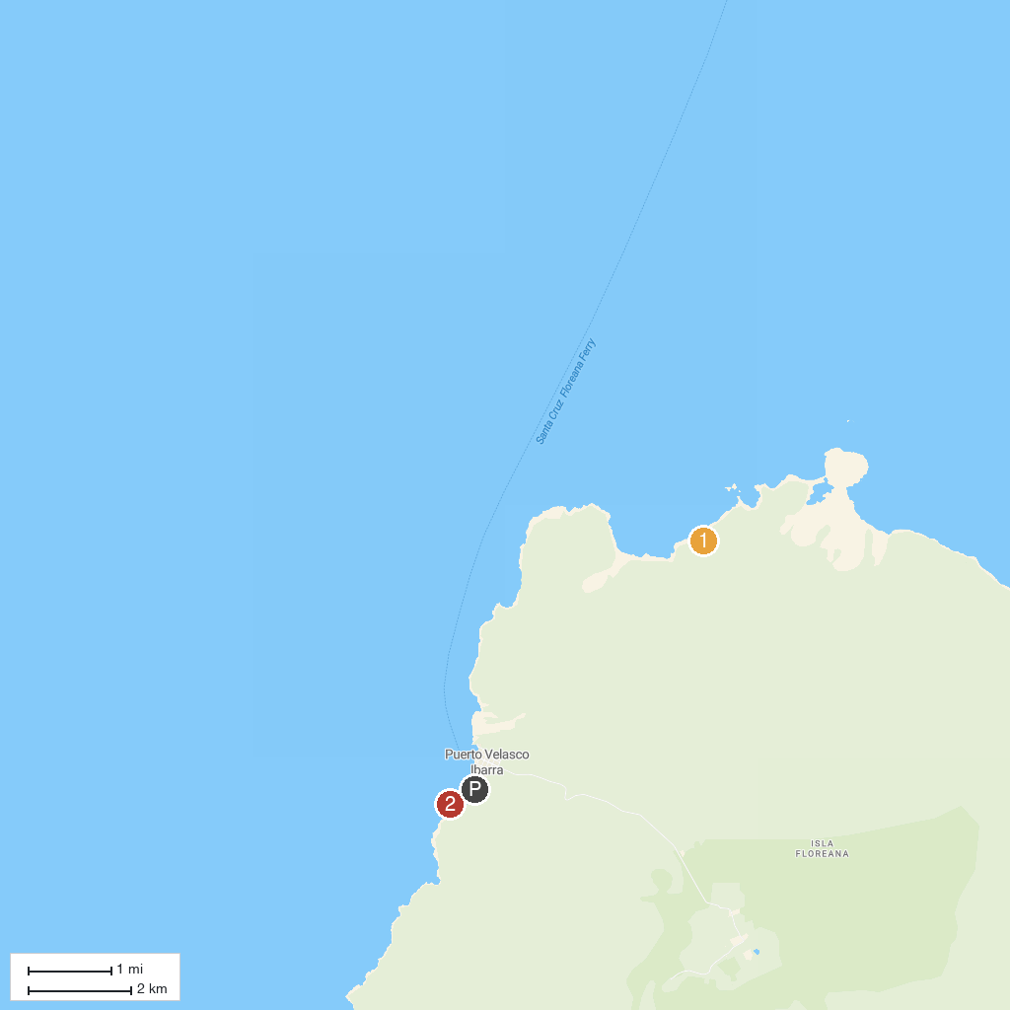
MAP KEY
1. Post Office Bay | 2. La Loberia Isla Floreana
P. Cruise port / terminal
Map © MapTiler © OpenStreetMap contributors · cruiseports.org

