Flekkefjord, Agder, Norway
One of Southern Norway's best-kept secrets, Flekkefjord blends 18th-century Dutch-influenced architecture with world-class street murals and a signature rail-biking adventure through 17 hand-carved mountain tunnels.
⚓ Pier (city-center berth) · 🕒 Typical call: 6-8 hrs · 💵 Norwegian Krone (NOK) — mostly cashless · 🗣️ Norwegian (English widely spoken) · 🚶 Highly walkable
✍️ MY DAY IN PORT (FILL IN)
Ship / Date
In port | arrive ______ · all aboard ______
Booked excursion
Notes / meeting point
GETTING ASHORE
- Docking: Pier — Eschebrygga, 90 m quay, max 210 m ship length
- Walk to center: 0 min — pier is in the town center
- Best For: Rail biking, Dutch Quarter history, street art photography
- Don't Miss: Flekkefjordbanen draisine ride through 17 tunnels
GETTING AROUND
- 🚕 Taxi: ~100 NOK base + ~14.5 NOK/km — Local taxis (Flekkefjord og omegn drosjesentral) are available for destinations outside the immediate center. Useful for
TOP THINGS TO DO
- Flekkefjordbanen Rail Biking (Draisine) — The town's signature activity: pedal a tandem railway bike along 17 km of decommissioned track through 17 hand-carved tunnels and…
- Hollenderbyen (Dutch Quarter) Walk — Wander the 18th-century merchant streets of the Dutch Quarter, where Norwegian timber and fish traders built close ties with the…
- Street Art Trail — Flekkefjord hosts a world-class street art scene — international murals painted on historic wooden buildings throughout…
- Flekkefjord Museum — Inside a well-preserved 1724 merchant house in the Dutch Quarter, this museum covers the Dutch trade era with period interiors…
- Brufjell Glacial Potholes Hike — About a 30-minute drive from town (near Åna-Sira), enormous sea-carved potholes set into a cliffside overlook the water.
BEST WALKS
- Hollenderbyen & Street Art Loop: 1.5 km · 45 min · Easy · Flat cobblestones — Start at the cruise pier and walk into the Dutch Quarter's historic lanes, picking up a free…
- Grønnes Coastal Walk: 3 km return · 50 min · Easy · Flat path — Follow the waterfront path southwest from the pier to Grønnes recreation area, passing old…
WEATHER · DAYLIGHT · MONEY
Month | High °F | Low °F | Rainy days
May | 58 | 44 | 12
Jul | 67 | 54 | 16
Sep | 61 | 51 | 16
Daylight: May 5:07AM–9:53PM · Jul 4:52AM–10:25PM · Sep 7:03AM–7:52PM
cruiseports.org/flekkefjord · Confirm terminal & all-aboard time with your ship

Flekkefjord, Agder, Norway — Port Map
Red = walkable sights · Amber = excursions farther out · P = cruise terminal
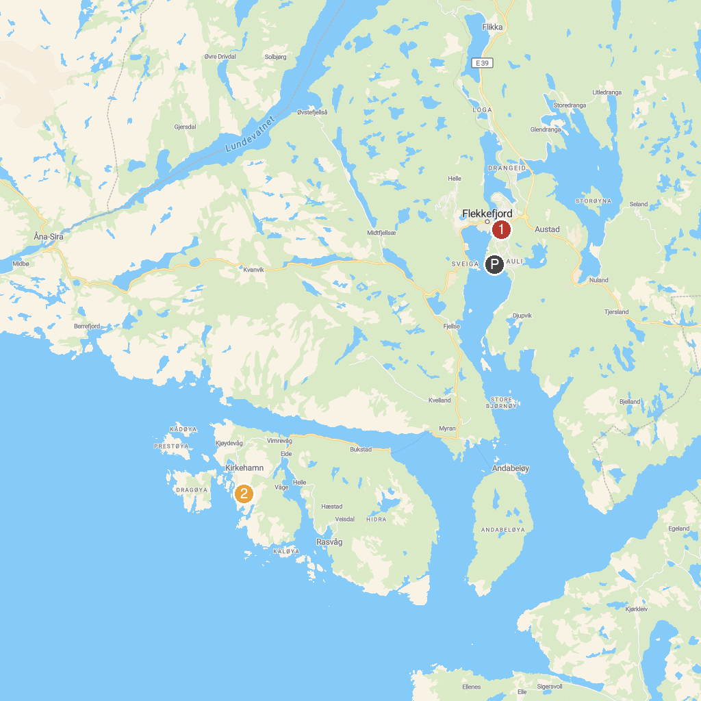
MAP KEY
1. Flekkefjord Line | 3. Varnes fort
2. Hågåsen kystbatteri | 4. Brufjellhålene
P. Cruise port / terminal
Map © MapTiler © OpenStreetMap contributors · cruiseports.org

