Flateyri, Westfjords, Iceland
A village of 200 souls perched on a narrow spit in Önundarfjörður fjord, Flateyri punches far above its size with Iceland's oldest store, a haunting avalanche wall, and an endearingly eccentric museum.
⚓ Expedition / tender port · 🕒 Typical call: 4–6 hrs · 💵 ISK (cards accepted everywhere) · 🗣️ Icelandic / English widely spoken · 🏔️ Westfjords, Iceland
✍️ MY DAY IN PORT (FILL IN)
Ship / Date
In port | arrive ______ · all aboard ______
Booked excursion
Notes / meeting point
GETTING ASHORE
- Docking: Small expedition ships can berth at Flateyri harbor quay; larger vessels anchor and tender in
- Walk to center: 2–5 min from the pier to the main street
- Best For: Authentic Iceland, history, quirky museums, fjord scenery
- Don't Miss: The 1914 bookstore and the avalanche defense wall viewpoint
GETTING AROUND
- 🚕 Taxi: ~690 ISK base + 330 ISK/km (~$6 USD minimum, ~$3 USD/km) — Local taxis serve the Ísafjarðarbær municipality but are very limited in Flateyri. Advance booking is strongly recommend
- 📱 Rideshare: ❌ not available
TOP THINGS TO DO
- The 1914 Old Bookstore — Iceland's oldest surviving shop, run by the same family for four generations.
- Avalanche Defense Wall — After the 1995 avalanche killed 20 villagers and destroyed or damaged some 17 homes, Flateyri completed (in 1998) a massive…
- The Nonsense Museum — A delightfully eccentric display of Icelandic collectors' obsessions — police caps from 100+ countries, PEZ dispensers, sugar…
- Fjord Kayaking or RIB Tour — Local operators occasionally run sea kayaking in the calm waters of Önundarfjörður or high-speed RIB boat tours of the fjord…
- Spit Walk & Birdwatching — Stroll the sandy shoreline of the eyri, the flat sandspit the village sits on.
BEST WALKS
- Village Loop: Pier → Bookstore → Church → Nonsense Museum: 1.5 km · 20–30 min · Flat · Free — A compact circuit of the village's main historic sites.
- Avalanche Wall Viewpoint: 2 km return · 30–40 min · Moderate (uphill) · Free — Follow the track behind the village up to the top of the massive earthen avalanche defense wall for…
WEATHER · DAYLIGHT · MONEY
Month | High °F | Low °F | Rainy days
May | 43 | 36 | 14
Jul | 53 | 46 | 14
Sep | 48 | 42 | 19
Daylight: Sep 6:55AM–8:01PM
cruiseports.org/flateyri · Confirm terminal & all-aboard time with your ship

Flateyri, Westfjords, Iceland — Port Map
Red = walkable sights · Amber = excursions farther out · P = cruise terminal
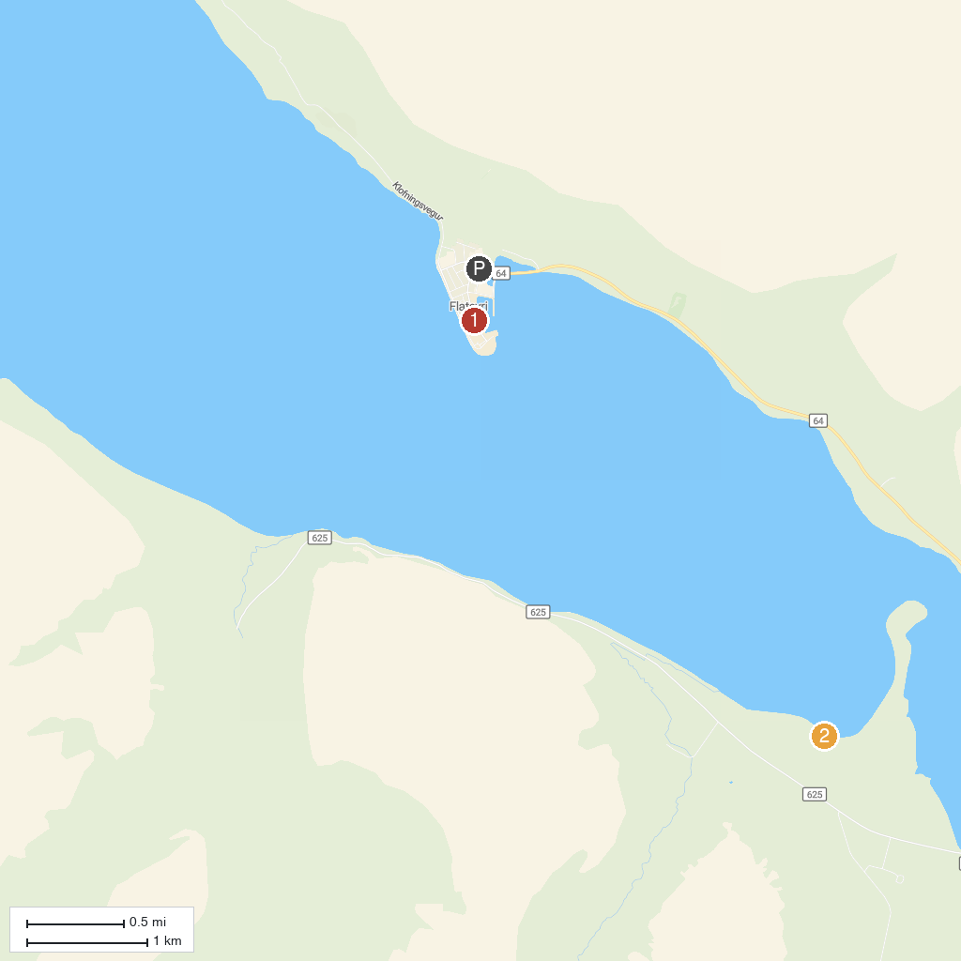
MAP KEY
1. Gamla Bókabúðin á Flateyri | 3. Bunárfoss
2. Önundarfjörður Pier (Holt í Önundarfirði) | 4. Minnibakki Beach
P. Cruise port / terminal
Map © MapTiler © OpenStreetMap contributors · cruiseports.org

