Flåm, Vestland, Norway
A tiny fjord village punching way above its weight: ride one of the world's steepest railways, cruise into a UNESCO fjord, or simply stand and stare at waterfalls tumbling off kilometre-high walls.
⚓ Docked (pier in village centre) · 🕒 Typical call: 7-10 hrs · 💵 Currency: Norwegian Krone (NOK) · 🗣️ Language: Norwegian (English widely spoken) · 🚂 Famous for the Flåm Railway
✍️ MY DAY IN PORT (FILL IN)
Ship / Date
In port | arrive ______ · all aboard ______
Booked excursion
Notes / meeting point
GETTING ASHORE
- Docking: Direct berth 200 m from village; tender occasionally used for second ships
- Walk to Centre: 2-3 min on foot from gangway to shops and railway station
- Best For: Scenic rail journeys, fjord cruises, waterfalls, cycling
- Don't Miss: Flåm Railway to Myrdal — book tickets before the ship docks
GETTING AROUND
- 🚕 Taxi: ~100 NOK base + 14.5 NOK/km (~220–270 NOK to Aurland) — Local taxis are available but very limited in number. Pre-booking is strongly recommended, especially during peak cruise
TOP THINGS TO DO
- Flåm Railway to Myrdal — The 20-km Flåmsbana climbs 863 m in under an hour, threading through 20 tunnels and pausing at the thundering Kjosfossen waterfall.
- Nærøyfjord Sightseeing Cruise — Silent electric boats glide through the UNESCO-listed Nærøyfjord — just 250 m wide at its narrowest — surrounded by walls of rock…
- Stegastein Viewpoint Drive or E-Bike — A cantilevered platform 650 m above the Aurlandsfjord offers one of Norway's most dramatic panoramas.
- Viking Valley at Gudvangen (Njardarheimr) — At the far end of the Nærøyfjord, Gudvangen's living Viking village has costumed guides, axe-throwing, longhouses, and craft…
- Kayaking on the Aurlandsfjord — Guided sea-kayak tours launch from Flåm dock, paddling past waterfalls and fjord farms with a guide's running commentary on the…
BEST WALKS
- Village & Flåm Church Walk: 3 km · 45 min · Easy — An easy stroll along the river from the pier to the 17th-century Flåm Church (Flåm kyrkje, built…
- Riverside Cycle/Walk to Brekkefossen: 6 km return · 1.5 hrs · Easy-Moderate — Follow the Flåmselvi river up the valley from the village to Brekkefossen waterfall, passing old…
WEATHER · DAYLIGHT · MONEY
Month | High °F | Low °F | Rainy days
May | 54 | 43 | 15
Jul | 69 | 57 | 20
Sep | 61 | 50 | 17
Daylight: May 4:47AM–10:09PM · Jul 4:27AM–10:45PM · Sep 6:59AM–7:52PM
cruiseports.org/flam · Confirm terminal & all-aboard time with your ship

Flåm, Vestland, Norway — Port Map
Red = walkable sights · Amber = excursions farther out · P = cruise terminal
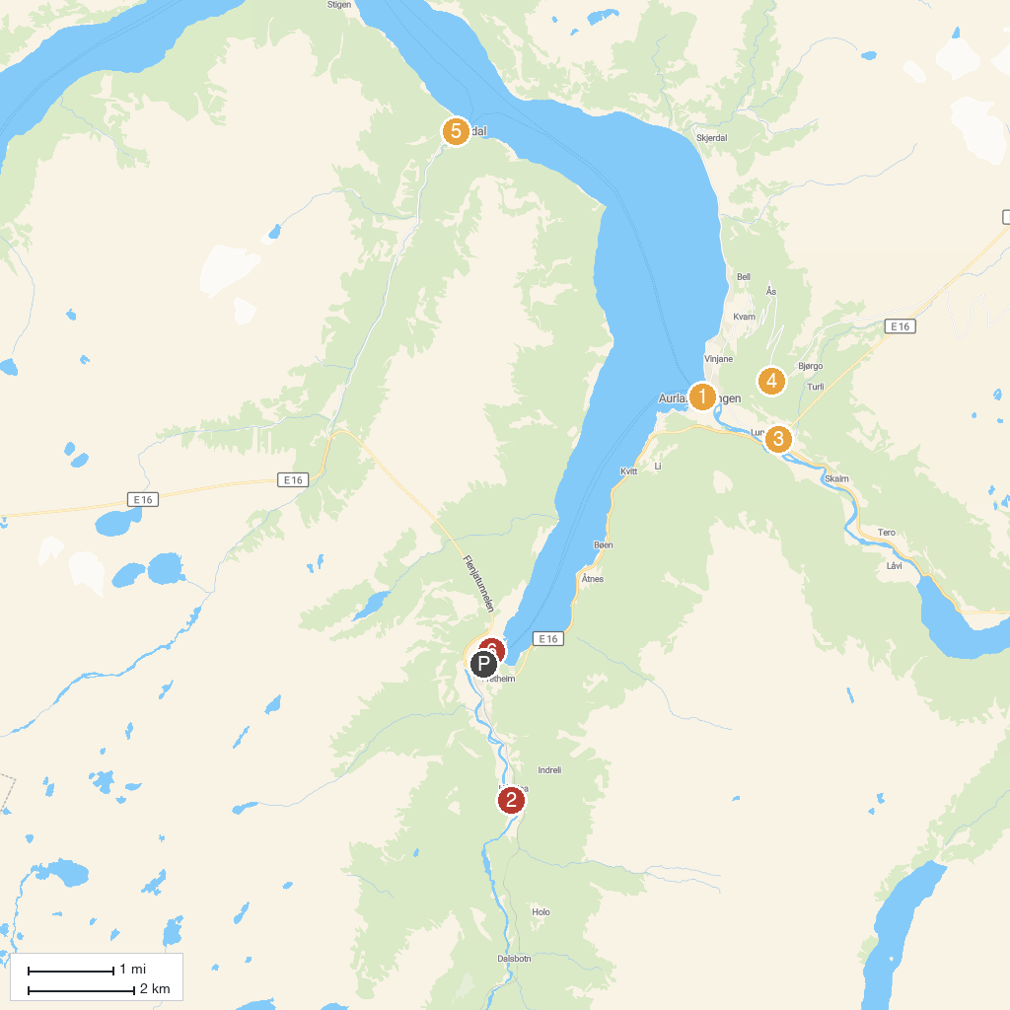
MAP KEY
1. Vangen kyrkje | 5. Undredal Stave Church
2. Flåm kyrkje | 6. Viking Valley
3. Lærdalstunnelen - World's Longest Tunnel | 7. Flåmsbana
4. Stegastein
P. Cruise port / terminal
Map © MapTiler © OpenStreetMap contributors · cruiseports.org

