Florence (via Livorno), Tuscany, Italy
Home to the Uffizi, Michelangelo's David, and the Duomo's famous terracotta dome, Florence packs more Renaissance genius into one city than anywhere else on earth — though reaching it from your ship takes planning.
⚓ Docked (Port of Livorno) · 🕒 Typical call: 9-11 hrs · 💶 Euro (€) · 🗣️ Italian · 🚂 ~1.5 hrs by train or shuttle from Livorno to Florence
✍️ MY DAY IN PORT (FILL IN)
Ship / Date
In port | arrive ______ · all aboard ______
Booked excursion
Notes / meeting point
GETTING ASHORE
- Docking: Ships dock at the Port of Livorno — Florence is 90 km inland, reached by train, ship shuttle bus, or taxi.
- Walk to Florence?: No — Livorno itself is walkable, but Florence requires a 1.5-hr train or shuttle ride each way. Budget at least 6 hrs in the city.
- Best For: Renaissance art (Uffizi, Accademia), the Duomo, Ponte Vecchio, leather markets, and Tuscan food.
- Don't Miss: Pre-book the Uffizi and Accademia — walk-up queues can consume hours of your limited shore day.
GETTING AROUND
- 🚕 Taxi: €110–140 one-way (up to 3 pax) — Pre-booked private transfer from Livorno cruise pier to central Florence takes about 75 minutes. Vans for up to 7–8 pass
- 🚌 Hop-on hop-off: ✅
TOP THINGS TO DO
- Florence City Highlights — The classic shore-day loop: Piazza del Duomo and the terracotta dome (exterior free, interior ticketed), Piazza della Signoria…
- Uffizi Gallery — One of the world's great art museums — Botticelli's Birth of Venus and Primavera, Leonardo, Raphael, Caravaggio, and Michelangelo…
- Accademia Gallery — Michelangelo's David — Michelangelo's original David stands 5.17 metres tall in the Galleria dell'Accademia.
- Florentine Food & Market Tour — Mercato Centrale, the 19th-century iron-and-glass market hall in San Lorenzo, is two floors of Tuscan produce, cheese, cured…
- Chianti Wine Country Drive — The rolling vineyards between Florence and Siena — cypress avenues, stone farmhouses, sangiovese vines — are exactly what Tuscany…
BEST WALKS
- Florence Historic Core: Duomo to Ponte Vecchio: 2.5 km · 1-2 hrs · Easy (cobblestones throughout) — Exit Firenze Santa Maria Novella station and walk east along Via de' Cerretani to Piazza del Duomo…
- Oltrarno & Piazzale Michelangelo Climb: 3 km · 1.5 hrs · Moderate (uphill) — Cross Ponte Vecchio into the quieter Oltrarno neighborhood — less touristy, better lunch spots.
- Livorno Venetian Quarter (if staying in port): 2 km · 45-60 min · Easy, flat — If you choose to stay in Livorno, the Venezia Nuova quarter is a 15-minute walk from the cruise…
WEATHER · DAYLIGHT · MONEY
Month | High °F | Low °F | Rainy days
May | 72 | 53 | 14
Jul | 89 | 67 | 5
Sep | 79 | 60 | 9
Daylight: May 5:49AM–8:33PM · Jul 5:47AM–8:54PM · Sep 6:54AM–7:24PM
cruiseports.org/firenze-florence · Confirm terminal & all-aboard time with your ship

Florence (via Livorno), Tuscany, Italy — Port Map
Red = walkable sights · Amber = excursions farther out · P = cruise terminal
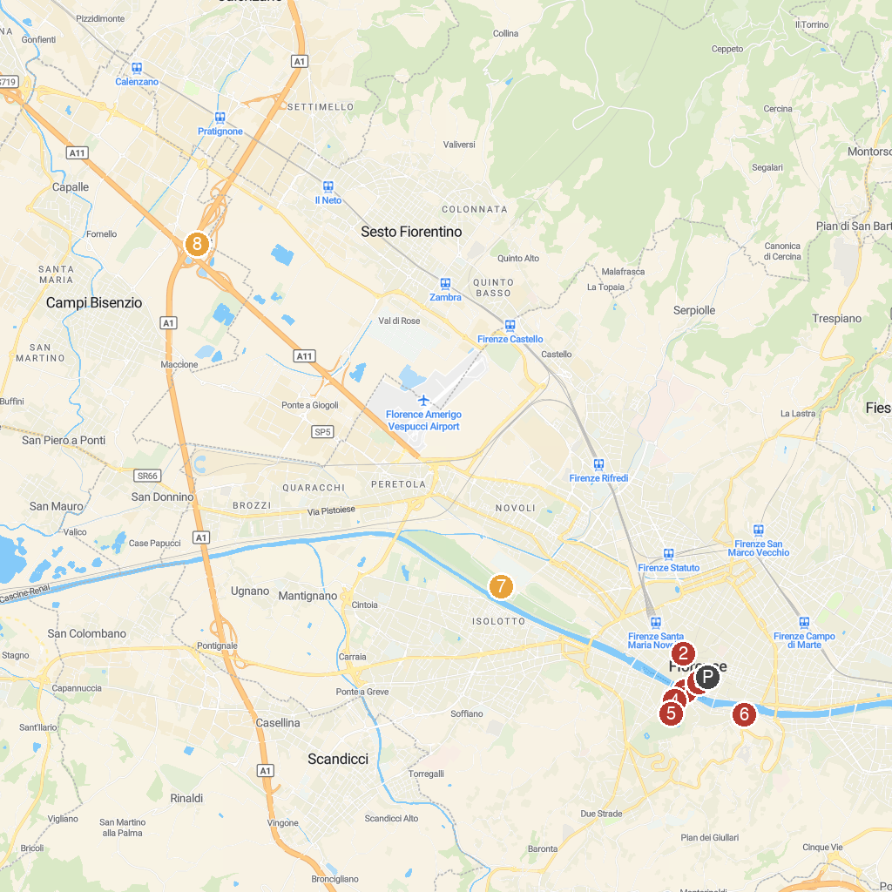
MAP KEY
1. Ponte Vecchio | 5. Fontana del Carciofo
2. Chiesa di Santa Maria Maggiore | 6. Porta San Niccolò
3. Hercules and Cacus | 7. Parco delle Cascine
4. Palazzo Guicciardini | 8. Chiesa di San Giovanni Battista
P. Cruise port / terminal
Map © MapTiler © OpenStreetMap contributors · cruiseports.org

