Fethiye, Muğla, Turkey
Built over the ancient Lycian city of Telmessos, Fethiye tumbles down to a sweeping natural harbor framed by pine-clad cliffs and scattered stone sarcophagi. It's Turkey's Turquoise Coast at its most accessible.
⚓ Mostly tender (large ships anchor in bay) · 🕒 Typical call: 7–9 hrs · 💵 Turkish Lira (TRY); USD/EUR accepted widely · 🗣️ Turkish · 🏛️ UNESCO-listed Lycian heritage
✍️ MY DAY IN PORT (FILL IN)
Ship / Date
In port | arrive ______ · all aboard ______
Booked excursion
Notes / meeting point
GETTING ASHORE
- Docking: Tender for large ships; small ships may dock at the town pier
- Walk to centre: Tender landing is right on the promenade — 5 min to Old Town
- Best For: History, paragliding, beach day at Ölüdeniz, Turkish market shopping
- Don't Miss: Amyntas Rock Tombs & the fish-market dining experience
GETTING AROUND
- 🚕 Taxi: ~$2–5 USD — Metered taxis are available at the port gate. The short ride into the city center is inexpensive. Taxis are regulated; c
- 📱 Rideshare: ✅ Uber, BiTaksi
TOP THINGS TO DO
- Amyntas Rock Tombs — Climb to the 4th-century BC Lycian tombs carved temple-style into the cliff above town.
- Kayaköy Ghost Village — Eight kilometres inland, hundreds of roofless stone Greek Orthodox houses and churches stand abandoned since the 1923 population…
- Tandem Paragliding over Ölüdeniz — Launch from up to ~1,900 m on Babadağ Mountain and glide down to the famous Blue Lagoon beach.
- Ölüdeniz Blue Lagoon Beach — The turquoise lagoon ringed by pine forests is one of Turkey's most photographed spots.
- Fethiye Fish Market Lunch — Pick your fish from the central fishmongers, hand it to a surrounding restaurant, and they cook it for a small fee.
BEST WALKS
- Promenade to Old Town Bazaar: 1 km · 15 min · flat · free — From the tender pier, stroll the kordon past gulet-lined marina to the Paspatur Old Town.
- Old Town to Amyntas Rock Tombs: 1.5 km · 20–25 min · moderate uphill · ~€4 entry — From the Paspatur bazaar, follow signs uphill through residential streets to the Amyntas Tomb…
WEATHER · DAYLIGHT · MONEY
Month | High °F | Low °F | Rainy days
May | 78 | 59 | 8
Jul | 93 | 73 | 1
Sep | 87 | 68 | 4
Daylight: May 5:56AM–8:03PM · Jul 5:56AM–8:21PM · Sep 6:46AM–7:10PM
cruiseports.org/fethiye · Confirm terminal & all-aboard time with your ship

Fethiye, Muğla, Turkey — Port Map
Red = walkable sights · Amber = excursions farther out · P = cruise terminal
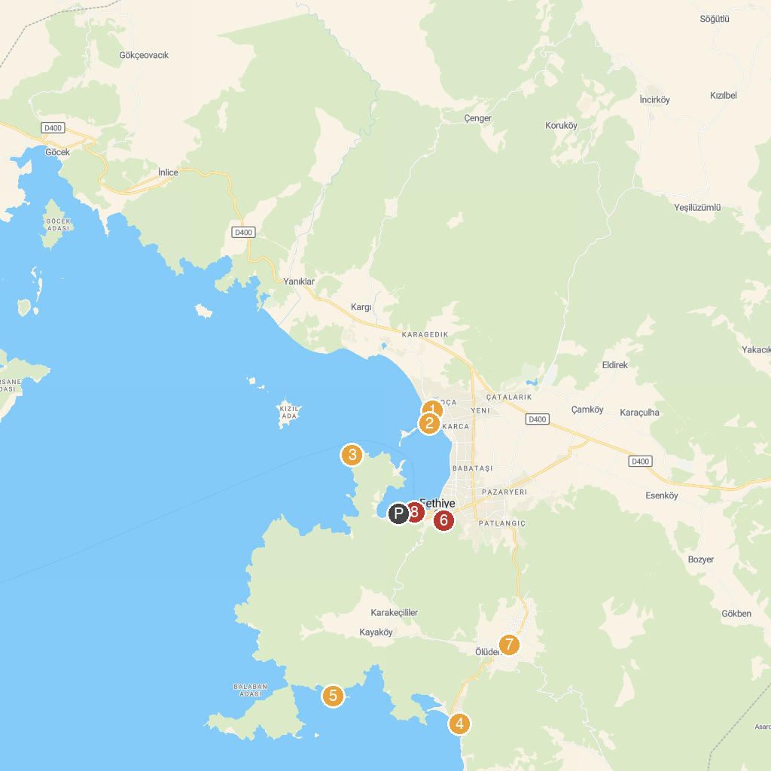
MAP KEY
1. Sultans Aqua City | 5. Gemiler Island
2. Calis Beach Bird Sanctuary | 6. Amyntas Rock Tombs
3. Towered Beach | 7. Ölüdeniz Ovacık Cami
4. Sky Star Paragliding | 8. Tourist Information Centers
P. Cruise port / terminal
Map © MapTiler © OpenStreetMap contributors · cruiseports.org

