Ferrol, Galicia, Spain
Spain's great naval secret: a handsome Enlightenment grid, active warships at the pier, and a jaw-dropping castle-flanked entry channel — all with Santiago de Compostela just an hour away.
⚓ Pier (Curuxeiras docks) · 🕒 Typical call: 8-10 hrs · 💶 Euro (€) · 🗣️ Spanish / Galician
✍️ MY DAY IN PORT (FILL IN)
Ship / Date
In port | arrive ______ · all aboard ______
Booked excursion
Notes / meeting point
GETTING ASHORE
- Docking: Pier — Curuxeiras docks, Ferrol Vello district
- Walk to centre: ~10 min on foot to Barrio de la Magdalena
- Best For: History buffs, Camino de Santiago, authentic Galician seafood
- Don't Miss: The narrow channel arrival flanked by two historic castles
GETTING AROUND
- 🚕 Taxi: ~€3–5 — Taxis wait at the pier and the city center is only about 1 km away. Metered fares start around €2.50 base plus ~€1/km, s
TOP THINGS TO DO
- Santiago de Compostela Day Trip — The ultimate Galician excursion: the UNESCO-listed cathedral city and pilgrimage endpoint of the Camino de Santiago, about 95 km…
- Naval Museum & Military Arsenal — Ferrol's 18th-century Arsenal Militar was once Europe's most powerful naval base.
- Barrio de la Magdalena Walking Tour — Ferrol's most distinctive district is a rare intact example of 18th-century Enlightenment urban planning: a perfect grid of…
- Castillo de San Felipe — A 16th-century Atlantic fortress guarding the mouth of the Ría de Ferrol, paired with Castillo de la Palma on the opposite bank.
- Camino Inglés — First Stage Walk — Ferrol is the official starting point of the English Way (Camino Inglés) to Santiago.
BEST WALKS
- Ferrol Vello to Barrio de la Magdalena: 1.5 km | ~25 min | Flat to gentle uphill | Free — Follow the waterfront from the pier into historic Ferrol Vello, then turn up Rúa Real into the…
- Meninas de Canido Street Art Walk: 2 km loop | ~40 min | Mostly flat | Free — The Canido neighbourhood hosts a celebrated open-air gallery of Las Meninas-inspired murals painted…
WEATHER · DAYLIGHT · MONEY
Month | High °F | Low °F | Rainy days
May | 65 | 54 | 11
Jul | 72 | 62 | 8
Sep | 71 | 60 | 11
Daylight: May 7:08AM–9:50PM · Jul 7:06AM–10:11PM · Sep 8:12AM–8:42PM
cruiseports.org/ferrol · Confirm terminal & all-aboard time with your ship

Ferrol, Galicia, Spain — Port Map
Red = walkable sights · Amber = excursions farther out · P = cruise terminal
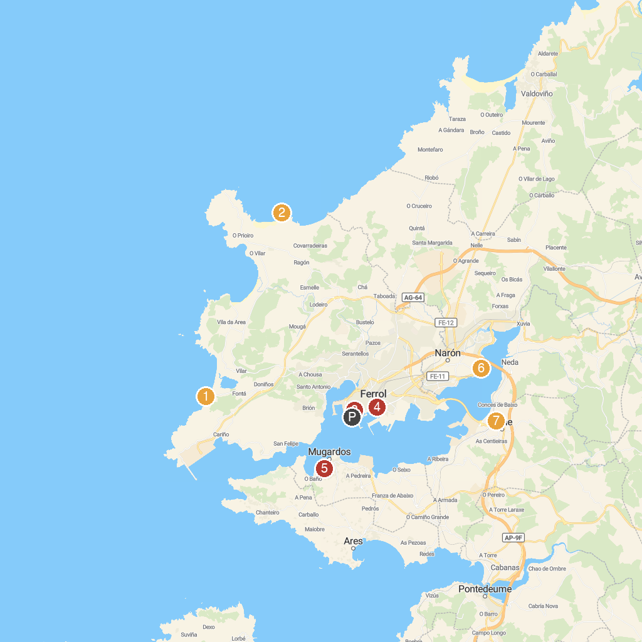
MAP KEY
1. Punta Penencia | 5. Naval Construction Museum
2. Ermita de Santa Comba | 6. Centro de Interpretación de Caldoval - Xacemento Romano
3. Fragas do Eume | 7. Monastery of San Martiño de Xuvia
4. Aquaciencia Park | 8. Museo Do Humor De Fene
P. Cruise port / terminal
Map © MapTiler © OpenStreetMap contributors · cruiseports.org

