Falmouth, Cornwall, England
One of the world's deepest natural harbours, Falmouth combines a lively Georgian waterfront with Tudor castles, subtropical gardens, and easy access to some of Cornwall's most dramatic scenery.
⚓ Tender (large ships) or Docked (small ships) · 🕒 Typical call: 7-10 hrs · 💷 Currency: British Pound (GBP) · 🗣️ Language: English
✍️ MY DAY IN PORT (FILL IN)
Ship / Date
In port | arrive ______ · all aboard ______
Booked excursion
Notes / meeting point
GETTING ASHORE
- Docking: Large ships tender to Prince of Wales Pier or Custom House Quay; smaller ships (<240 m) dock at A&P Falmouth Docks or County Wharf
- Walk to Centre: Tenders land in the town centre; A&P Docks is a 10-20 min walk or shuttle along the waterfront
- Best For: History buffs, garden lovers, coastal walkers, and day-trippers to wider Cornwall
- Don't Miss: Pendennis Castle views, the National Maritime Museum Cornwall, a Cornish pasty from a local bakery
GETTING AROUND
- 🚕 Taxi: £10–£20 — Taxis are available at the pier. Metered fares apply; a short ride to the town center or Pendennis Castle area typically
- 📱 Rideshare: ✅ Uber
TOP THINGS TO DO
- Pendennis Castle — Henry VIII built this coastal fortress in the 1540s to defend against French and Spanish invasion.
- National Maritime Museum Cornwall — Award-winning waterfront museum with interactive galleries on Britain's seafaring heritage, a working harbour pontoon, and a…
- Trebah & Glendurgan Gardens — Two neighbouring subtropical valley gardens — Glendurgan is run by the National Trust, while Trebah is an independent charity…
- Eden Project Day Trip — The world-famous biomes built in a reclaimed china clay pit house rainforest and Mediterranean ecosystems.
- St Mawes Ferry & Castle — Jump on the passenger ferry from Custom House Quay to the postcard village of St Mawes (10 minutes).
BEST WALKS
- Town Centre & Waterfront Stroll: 1.5 miles · Easy · 45 min — From the Prince of Wales Pier, walk along the Events Square waterfront past the National Maritime…
- Pendennis Castle Headland Walk: 2 miles · Moderate · 1 hr — Head southeast from the town centre through Falmouth's Victorian terraces up to the Pendennis…
WEATHER · DAYLIGHT · MONEY
Month | High °F | Low °F | Rainy days
May | 59 | 48 | 10
Jul | 66 | 56 | 8
Sep | 64 | 55 | 10
Daylight: May 6:25AM–8:42PM · Jul 6:25AM–9:00PM · Sep 7:19AM–7:44PM
cruiseports.org/falmouth-uk · Confirm terminal & all-aboard time with your ship

Falmouth, Cornwall, England — Port Map
Red = walkable sights · Amber = excursions farther out · P = cruise terminal
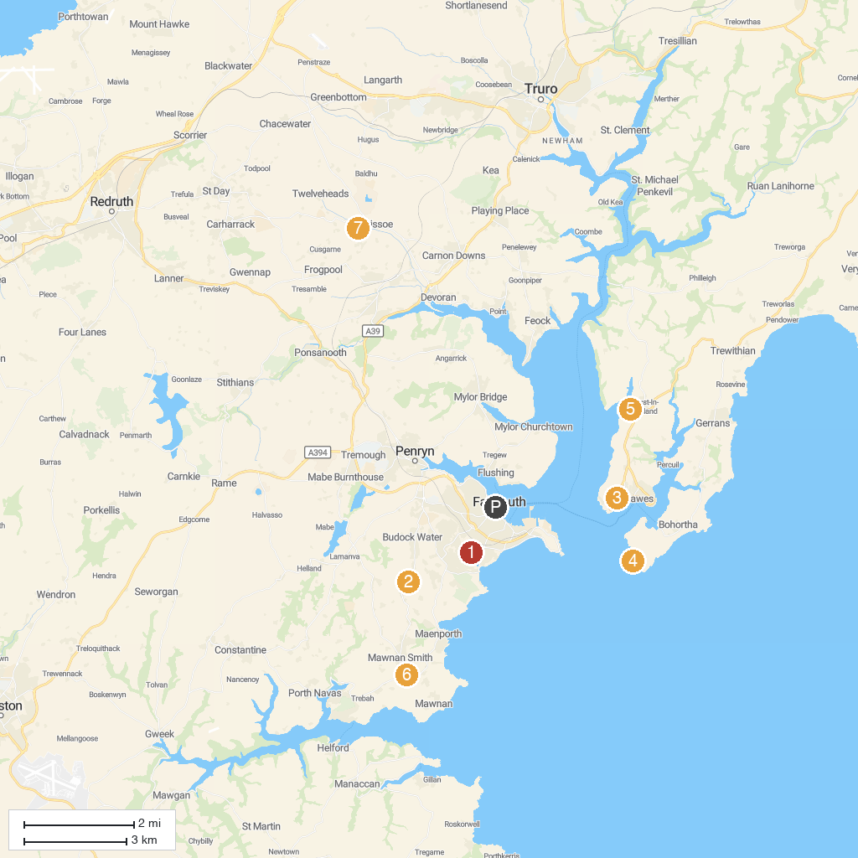
MAP KEY
1. Truro Cathedral | 5. National Trust - St Anthony Head
2. Swanvale Nature Reserve | 6. St Just-in-Roseland Church
3. Penjerrick Garden | 7. Carwinion Woods
4. Lamorran Gardens | 8. Bissoe Valley Nature Reserve
P. Cruise port / terminal
Map © MapTiler © OpenStreetMap contributors · cruiseports.org

