Falmouth, Trelawny, Jamaica
Built to berth the world's biggest ships, Falmouth's purpose-built pier drops you into one of the Caribbean's best-preserved Georgian towns — but the real draws are just down the road: river rafting, waterfalls, and Jamaican jerk smoke.
⚓ Docked — Falmouth Cruise Ship Pier · 🕒 Typical call: 8-10 hrs · 💵 USD widely accepted (JMD official) · 🗣️ English
✍️ MY DAY IN PORT (FILL IN)
Ship / Date
In port | arrive ______ · all aboard ______
Booked excursion
Notes / meeting point
GETTING ASHORE
- Docking: Falmouth Cruise Ship Pier — purpose-built (2011), can berth two Oasis-class ships simultaneously
- Walk to center: ~5 min walk from pier gate to Falmouth's historic town square and courthouse
- Best For: Georgian architecture, Martha Brae river rafting, Dunn's River Falls day trip, Chukka Blue Hole
- Don't Miss: Falmouth Courthouse (1815) and Water Square — the original piped-water fountain predating New York City's
GETTING AROUND
- 🚕 Taxi: ~$5–10 USD (local); ~$45–60 USD to Montego Bay — Official port taxis have set fares regulated by the Jamaica Tourist Board. For nearby trips around Falmouth, fares are m
TOP THINGS TO DO
- Martha Brae River Rafting — Just 5 km from the pier, bamboo raft operators pole you along a calm, jungle-lined river on a two-seat bamboo raft.
- Chukka Blue Hole & River Tubing — Chukka's Blue Hole excursion takes you into the Trelawny interior to swim in crystalline limestone pools, tube down a jungle…
- Dunn's River Falls — Jamaica's most iconic landmark sits ~65 km east near Ocho Rios.
- Falmouth Heritage Walk — Falmouth is one of the best-preserved Georgian towns in the Caribbean, with over 50 listed heritage buildings from the…
- Good Hope Great House & Estate Tour — A 2,000-acre 18th-century plantation in the Trelawny hills, Good Hope offers horse riding, ATV tours, and river swimming on the…
BEST WALKS
- Falmouth Georgian Heritage Loop: 1.5-2 hrs · ~2.5 km · Easy · Flat — A self-guided loop through the core of Falmouth's UNESCO-listed historic district.
- Pier to Town Stroll: 30 min · ~1 km · Easy — A simple orientation walk from the cruise pier into the town centre.
- Georgian Falmouth Town Walk: 1.5 km | ~1 hr | Easy | Free — Start at the cruise terminal gate and follow Harbour Street west to Water Square.
WEATHER · DAYLIGHT · MONEY
Month | High °F | Low °F | Rainy days
May | 75 | 56 | 14
Jul | 86 | 68 | 13
Sep | 80 | 61 | 7
Daylight: May 6:25AM–8:42PM · Jul 6:25AM–9:00PM · Sep 7:19AM–7:44PM
cruiseports.org/falmouth · Confirm terminal & all-aboard time with your ship

Falmouth, Trelawny, Jamaica — Port Map
Red = walkable sights · Amber = excursions farther out · P = cruise terminal
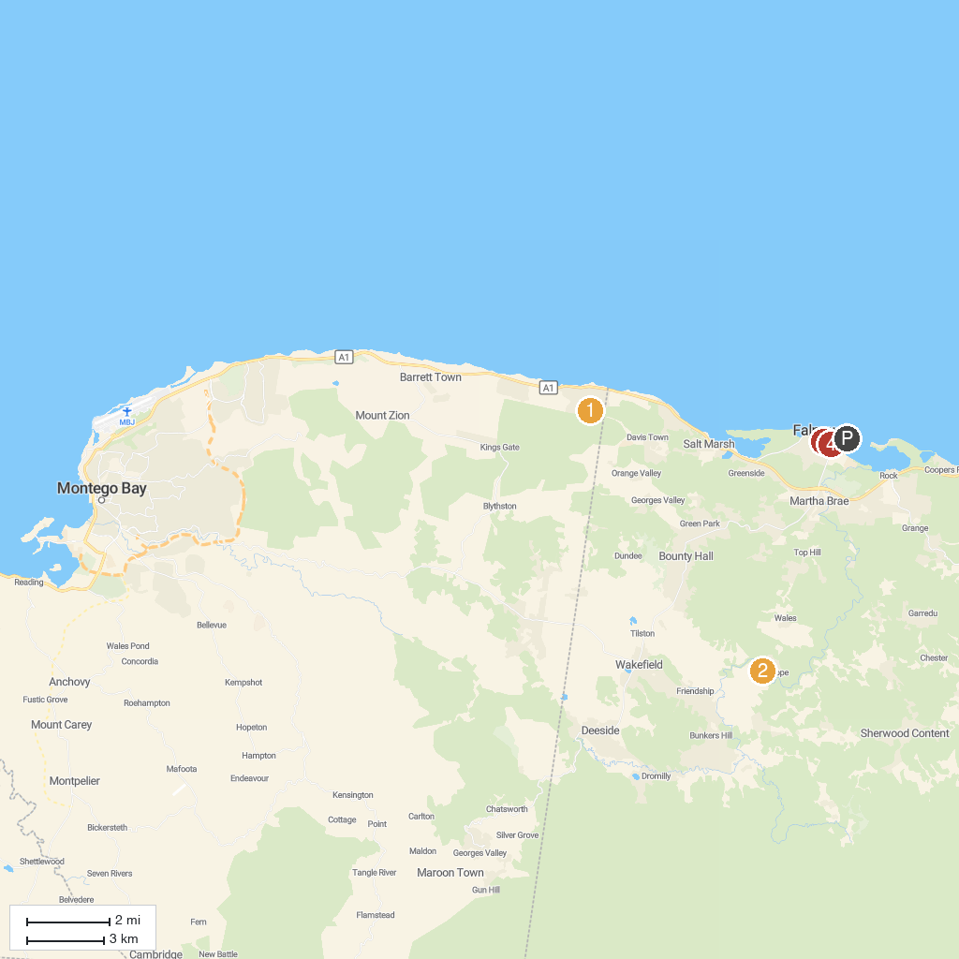
MAP KEY
1. Greenwood Great House | 3. St. Peter's Anglican Church
2. Chukka Eco-Adventure Outpost at Good Hope | 4. William Knibb Memorial Baptist Church
P. Cruise port / terminal
Map © MapTiler © OpenStreetMap contributors · cruiseports.org

