Falmouth, Trelawny, Jamaica
Jamaica's best-preserved Georgian town sits steps from a purpose-built mega-ship pier — and one of the world's brightest bioluminescent bays glows just minutes away after dark.
⚓ Docked (pier) · 🕒 Typical call: 8–10 hrs · 💵 USD widely accepted / JMD · 🗣️ English · 🌴 Caribbean island
✍️ MY DAY IN PORT (FILL IN)
Ship / Date
In port | arrive ______ · all aboard ______
Booked excursion
Notes / meeting point
GETTING ASHORE
- Docking: Two deep-water berths accommodate Oasis-class ships; ships dock, not tender
- Walk to center: 5–10 min (300–800 m) along level walkways to Falmouth's historic district
- Best For: History buffs, river rafters, waterfall climbers, bioluminescent bay seekers
- Don't Miss: Luminous Lagoon boat tour at dusk — one of the world's brightest bioluminescent bays
GETTING AROUND
- 🚕 Taxi: $15–$60 USD — Licensed taxis line up just outside the terminal. Shared shuttles to Montego Bay run ~$15/person one-way; a private taxi
TOP THINGS TO DO
- Martha Brae River Bamboo Rafting — Float 3 miles down the Martha Brae River on a 30-foot bamboo raft poled by a local captain.
- Dunn's River Falls Climb — Jamaica's most famous attraction: 55-metre terraced waterfalls near Ocho Rios that you climb in a human chain.
- Luminous Lagoon Night Boat Tour — Glistening Waters Luminous Lagoon, just 10 minutes from the pier, is among the world's brightest bioluminescent bays.
- Falmouth Georgian Town Walk — Falmouth's historic district is one of the best-preserved colonial Georgian towns in the Caribbean.
- Chukka Good Hope Estate Eco Adventures — Former 18th-century sugar plantation 25 minutes from the pier now hosts zip-lining, ATV rides, river tubing, and a Great House…
BEST WALKS
- Falmouth Historic District Loop: 1.5 km · 30–45 min · Flat — Walk from the pier into Water Square, the civic heart of old Falmouth.
WEATHER · DAYLIGHT · MONEY
Month | High °F | Low °F | Rainy days
May | 86 | 75 | 7
Jul | 88 | 76 | 6
Sep | 88 | 76 | 9
Daylight: May 6:25AM–8:42PM · Jul 6:25AM–9:00PM · Sep 7:19AM–7:44PM
cruiseports.org/falmouth-jamaica · Confirm terminal & all-aboard time with your ship

Falmouth, Trelawny, Jamaica — Port Map
Red = walkable sights · Amber = excursions farther out · P = cruise terminal
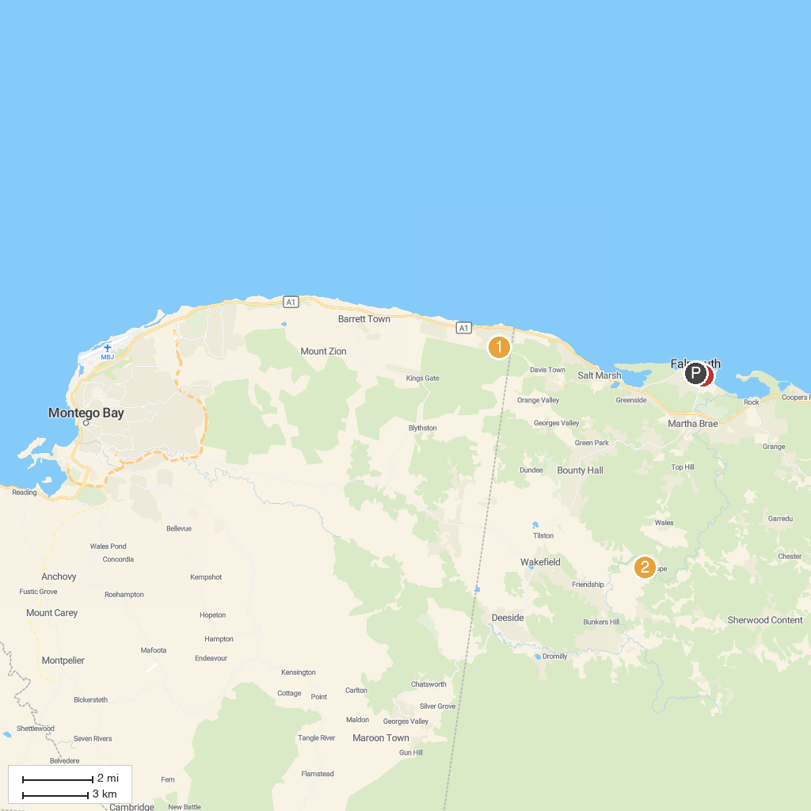
MAP KEY
1. Greenwood Great House | 3. St. Peter's Anglican Church
2. Chukka Eco-Adventure Outpost at Good Hope | 4. William Knibb Memorial Baptist Church
P. Cruise port / terminal
Map © MapTiler © OpenStreetMap contributors · cruiseports.org

