Falmouth Harbour, Antigua, Antigua and Barbuda
A Georgian naval dockyard turned yachting hub, Falmouth Harbour pairs UNESCO history with stunning hilltop views and easy access to 365 Antiguan beaches.
⚓ Tendered / small-ship marina berth · 🕒 Typical call: 7-9 hrs · 💵 Eastern Caribbean Dollar / USD accepted · 🗣️ English
✍️ MY DAY IN PORT (FILL IN)
Ship / Date
In port | arrive ______ · all aboard ______
Booked excursion
Notes / meeting point
GETTING ASHORE
- Docking: Small luxury and expedition ships tender into Falmouth Harbour or berth at the marina; large ships dock in St. John's instead
- Walk to center: ~30-35 min walk (or short taxi) to Nelson's Dockyard and English Harbour restaurants
- Best For: History, sailing culture, hilltop views, snorkeling
- Don't Miss: Shirley Heights Sunday party (if your call coincides) and sunset from the Lookout
GETTING AROUND
- 🚕 Taxi: $25–$35 — Government-regulated fixed fares (per vehicle, up to 4 passengers) to St. John's city center. Rate boards are posted at
TOP THINGS TO DO
- Nelson's Dockyard National Park — Explore the world's only continuously operating Georgian naval dockyard — a UNESCO World Heritage Site.
- Shirley Heights Lookout — Hike or taxi up to this former military signal station for panoramic views over Falmouth and English Harbours — on a clear day…
- Pigeon Point Beach & Fort Berkeley Hike — Pigeon Point Beach sits just minutes from the pier with calm, clear water and beach bars.
- Catamaran Snorkel Cruise — Sail the south coast on a catamaran for snorkeling at Cades Reef — one of Antigua's best coral gardens — then enjoy a beach BBQ…
- Stingray City Encounter — Interact with friendly Southern Rays in their natural shallow-water habitat off the east coast near Seaton's Village, then…
BEST WALKS
- Falmouth Harbour to Nelson's Dockyard & English Harbour: 2.5 km · 30-35 min · Easy · Paved path — Walk along the waterfront from the pier into Nelson's Dockyard, through the Copper and Lumber Store…
- Dow's Hill Interpretation Centre to Shirley Heights: 1.2 km · 30 min · Moderate · Some uphill — Start at the Dow's Hill Interpretation Centre (a short taxi ride from the pier) for an animated…
WEATHER · DAYLIGHT · MONEY
Month | High °F | Low °F | Rainy days
May | 83 | 77 | 16
Jul | 85 | 79 | 20
Sep | 85 | 79 | 22
Daylight: May 5:35AM–6:31PM · Jul 5:41AM–6:44PM · Sep 5:55AM–6:08PM
cruiseports.org/falmouth-antigua · Confirm terminal & all-aboard time with your ship

Falmouth Harbour, Antigua, Antigua and Barbuda — Port Map
Red = walkable sights · Amber = excursions farther out · P = cruise terminal
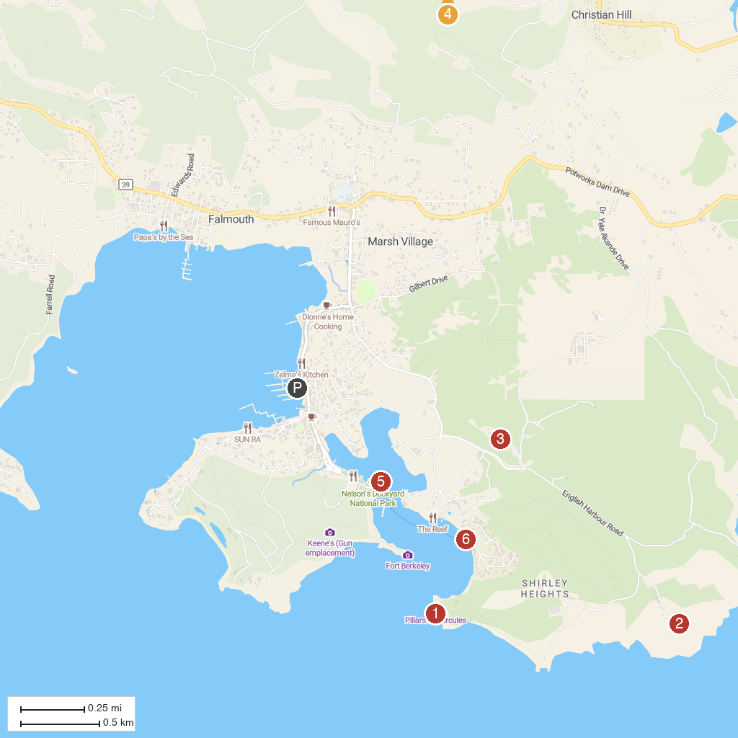
MAP KEY
1. Pillars Of Hercules | 5. Holy Family Catholic Cathedral
2. The Blockhouse | 6. Nelson's Dockyard
3. Dow's Hill Interpretation Centre | 7. Galleon Beach
4. Antigua's Donkey Sanctuary Humane Society
P. Cruise port / terminal
Map © MapTiler © OpenStreetMap contributors · cruiseports.org

