Falkland Islands
A windswept British outpost at the bottom of the world, where penguins outnumber people, 1982 war history is vivid, and every street corner leads to something extraordinary.
⚓ Tender (most ships) · 🕒 Typical call: 8-10 hrs · 💷 Falkland/UK Pound (USD accepted) · 🗣️ English · 🐧 Wildlife-rich
✍️ MY DAY IN PORT (FILL IN)
Ship / Date
In port | arrive ______ · all aboard ______
Booked excursion
Notes / meeting point
GETTING ASHORE
- Docking: Tender to Public Jetty (large ships); FIPASS dock for small expedition vessels
- Walk to center: 0 min — tender lands right at Stanley town center
- Best For: King penguins at Volunteer Point, battlefield tours, wildlife photography
- Don't Miss: Volunteer Point King Penguin colony (book months ahead), Whalebone Arch, Lady Elizabeth shipwreck
GETTING AROUND
- 🚕 Taxi: Agree fare before boarding — Taxis are limited on ship days. Arrange return pickup before heading outside Stanley, especially for beaches, penguin ar
- 📱 Rideshare: ❌ not available
TOP THINGS TO DO
- Volunteer Point King Penguin Colony — The Falklands' most spectacular excursion: a 1,000+ breeding-pair King Penguin colony, plus Gentoo and Magellanic penguins.
- Gypsy Cove & Magellanic Penguins — The closest wildlife day-trip from Stanley.
- 1982 Falklands War Battlefield Tour — Local guides — some who lived through the conflict — lead you to Mount Longdon, Mount Harriet, and the Liberation Monument…
- Bertha's Beach & Gentoo Penguins — A sweeping expanse of white sand near Mount Pleasant, with Gentoo penguins nesting near the surf and dolphins regularly spotted…
- Stanley Town Walk & Historic Dockyard Museum — Self-guided town walk taking in Christ Church Cathedral, the Whalebone Arch, the Liberation Monument, and the excellent Dockyard…
BEST WALKS
- Ross Road Heritage Stroll: 1.5 miles | 30–45 min | Easy flat seafront — Walk west along Ross Road from the Public Jetty past the Whalebone Arch, Christ Church Cathedral…
- Lady Elizabeth Shipwreck Walk: 2 miles one-way | 1 hr | Easy flat — Head east along Ross Road and the shoreline path to Whalebone Cove.
WEATHER · DAYLIGHT · MONEY
Month | High °F | Low °F | Rainy days
May | 46 | 38 | 11
Jul | 40 | 34 | 11
Sep | 45 | 37 | 11
Daylight: May 6:09AM–9:23PM · Jul 6:05AM–9:45PM · Sep 7:27AM–8:00PM
cruiseports.org/falkland-islands · Confirm terminal & all-aboard time with your ship

Falkland Islands — Port Map
Red = walkable sights · Amber = excursions farther out · P = cruise terminal
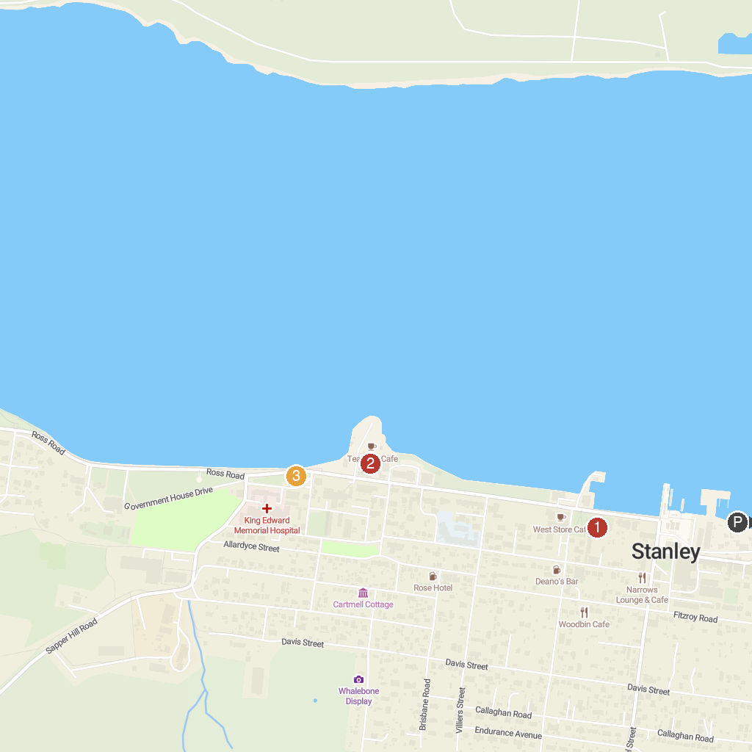
MAP KEY
1. Christ Church Cathedral | 3. 1982 Liberation Memorial
2. Falkland Islands Museum and National Trust
P. Cruise port / terminal
Map © MapTiler © OpenStreetMap contributors · cruiseports.org

