Faaborg, Funen, Denmark
A tidy harbor town where Funen's rolling hills meet the South Funen Archipelago — step off your ship into cobblestone lanes, a world-class regional art museum, and easy ferry hops to idyllic small islands.
⚓ Small pier (compact vessels dock; large ships may tender) · 🕒 Typical call: 6–8 hrs · 💵 Danish Krone (DKK) · 🗣️ Danish (English widely spoken)
✍️ MY DAY IN PORT (FILL IN)
Ship / Date
In port | arrive ______ · all aboard ______
Booked excursion
Notes / meeting point
GETTING ASHORE
- Docking: Small quay — boutique/expedition ships dock directly; max draft ~4 m. Larger ships tender.
- Walk to center: 2–5 min from the quay to Torvet (main square)
- Best For: Scandinavian art, island-hopping, quiet cobblestone walks, smoked fish
- Don't Miss: Faaborg Museum (Funen Painters) and a ferry to Lyø or Avernakø
GETTING AROUND
- 🚕 Taxi: 55–70 DKK — Local taxis (Faaborg Taxa) wait at the harbour. Base fare is ~33 DKK plus ~10 DKK/km; a short hop to the town square is
- 📱 Rideshare: ✅ Uber
TOP THINGS TO DO
- Faaborg Museum — Funen Painters — One of Denmark's most important regional art museums, the 1915 building itself is a total work of art.
- Egeskov Castle — One of Europe's best-preserved Renaissance water castles, Egeskov sits on oak piles in a lake ~21 km from Faaborg.
- Ferry to Lyø or Avernakø — Short passenger ferries from Faaborg harbour reach the quiet archipelago islands of Lyø and Avernakø — car-free, unspoiled, and…
- Svanninge Hills (Fynske Alps) — Denmark's hilliest terrain — modest by international standards but genuinely dramatic for this flat country.
- Cobblestone Town Walk & Øhavsmuseet — Wander Faaborg's medieval lanes, past the old church, the freestanding medieval Bell Tower (Klokketårnet), and the Øhavsmuseet…
BEST WALKS
- Harbor to Old Town Loop: 1.5 km · 25–35 min · Easy — A short loop that takes in the harbor, main square (Torvet), the medieval church, the Bell Tower…
- To the Faaborg Museum: 0.8 km one way · 10 min · Easy — A straight walk from the harbor through the pedestrian zone to the Faaborg Museum on Grønnegade…
WEATHER · DAYLIGHT · MONEY
Month | High °F | Low °F | Rainy days
May | 59 | 47 | 11
Jul | 69 | 58 | 13
Sep | 64 | 55 | 12
Daylight: May 5:11AM–9:20PM · Jul 5:00AM–9:48PM · Sep 6:51AM–7:35PM
cruiseports.org/faaborg · Confirm terminal & all-aboard time with your ship

Faaborg, Funen, Denmark — Port Map
Red = walkable sights · Amber = excursions farther out · P = cruise terminal
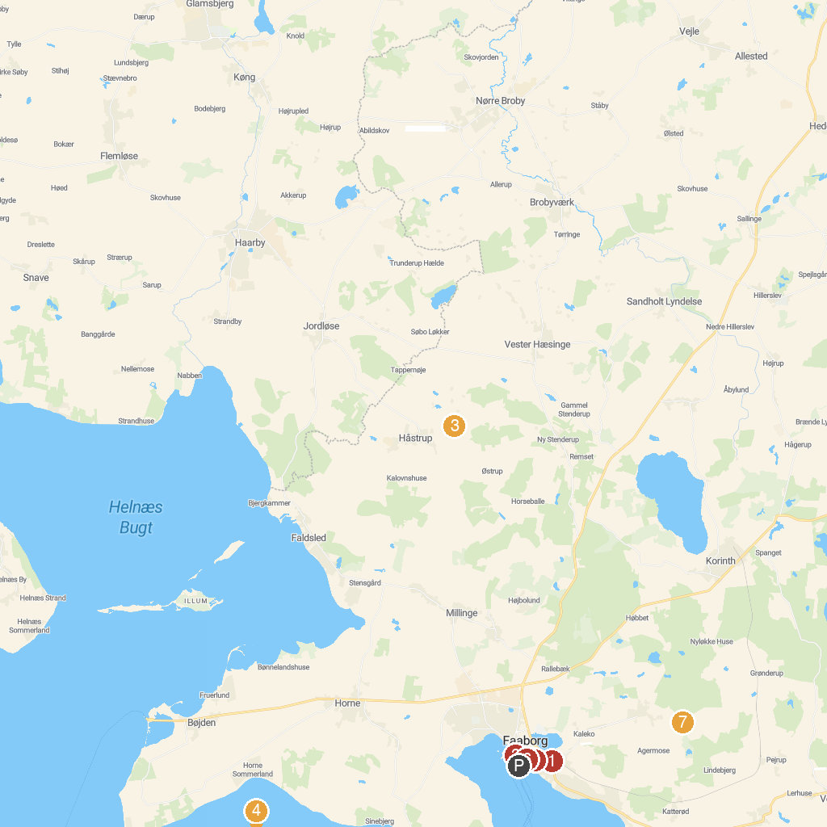
MAP KEY
1. Faaborg MiniBy | 5. Faaborg Museum
2. Øhavsmuseet | 6. Faaborg Clock Tower
3. Trebjerg, Dronningeudsigten | 7. Holstenshuus
4. The bell stone
P. Cruise port / terminal
Map © MapTiler © OpenStreetMap contributors · cruiseports.org

