Exmouth, Western Australia, Australia
Where the red outback meets a UNESCO World Heritage reef — and whale sharks cruise the same clear water you're snorkeling in. Exmouth is remote, raw, and unlike anywhere else a cruise ship calls.
⚓ Tender port — no pier · 🕒 Typical call: 8–10 hrs · 💵 Australian Dollar (AUD) · 🗣️ English · 🐠 Ningaloo Reef UNESCO site
✍️ MY DAY IN PORT (FILL IN)
Ship / Date
In port | arrive ______ · all aboard ______
Booked excursion
Notes / meeting point
GETTING ASHORE
- Docking: Tender to Exmouth Boat Harbour
- Walk to centre: ~3 km from marina (shuttle recommended)
- Best For: Snorkeling, whale sharks, reef wildlife
- Don't Miss: Turquoise Bay drift snorkel
GETTING AROUND
- 🚕 Taxi: AUD – — Local taxis serve the area; short runs around town start ~AUD , while private transfers from the tender point to hotels
TOP THINGS TO DO
- Swim with Whale Sharks — Ningaloo hosts the world's largest aggregation of whale sharks (March–July).
- Turquoise Bay Drift Snorkel — Widely voted one of Australia's best beaches.
- Cape Range National Park Tour — Red limestone gorges, kangaroos, rock wallabies, and sweeping Indian Ocean views.
- Humpback Whale Watching — June to November, thousands of humpbacks migrate past the North West Cape.
- Glass-Bottom Boat — Ningaloo Reef — See the coral and marine life without getting wet.
BEST WALKS
- Town Heritage & Emu Stroll: 1–2 km · Flat · 30–45 min — From the shuttle drop-off at the Ningaloo Centre, wander the main street to Froth Craft Brewery…
- Yardie Creek Trail: 2 km return · Easy–moderate · 1 hr · National Park entry required — A short gorge-top walk above the turquoise creek with red limestone cliffs and sightings of the…
WEATHER · DAYLIGHT · MONEY
Month | High °F | Low °F | Rainy days
May | 60 | 48 | 12
Jul | 69 | 57 | 10
Sep | 65 | 54 | 10
Daylight: May 5:25AM–8:55PM · Jul 5:18AM–9:19PM · Sep 6:49AM–7:26PM
cruiseports.org/exmouth-wa · Confirm terminal & all-aboard time with your ship

Exmouth, Western Australia, Australia — Port Map
Red = walkable sights · Amber = excursions farther out · P = cruise terminal
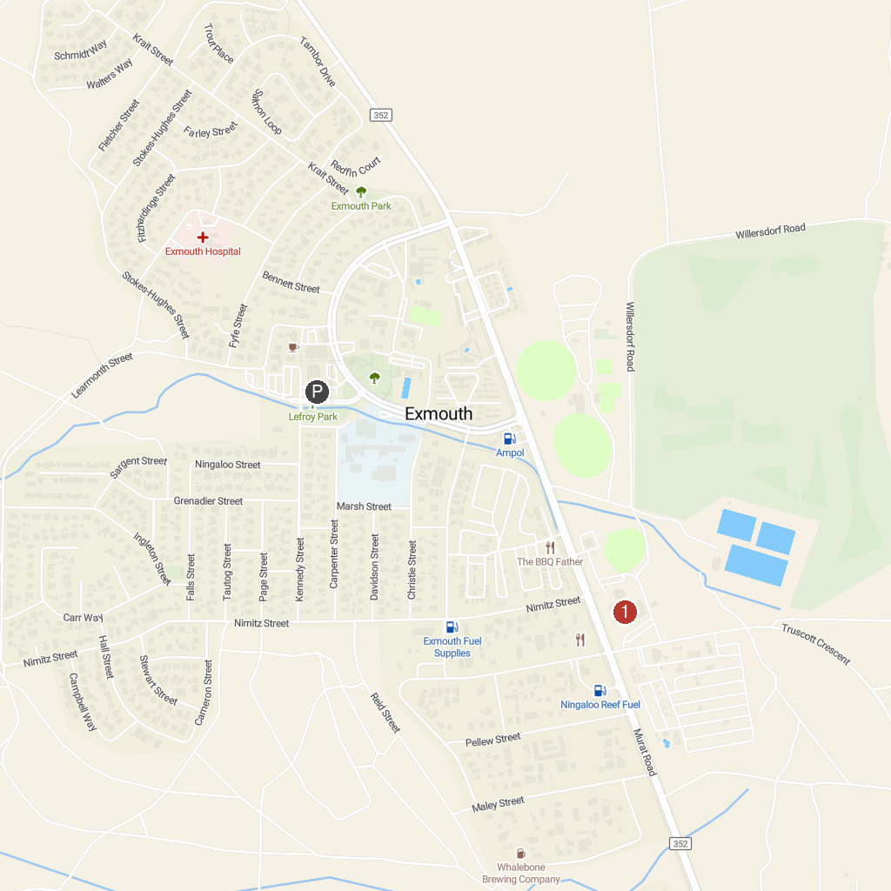
MAP KEY
1. Mauritius Beach | 4. Bundegi Beach
2. Jurabi Turtle Centre | 5. Vlamingh Head Lighthouse
3. Ningaloo Centre | 6. Dunes Beach
P. Cruise port / terminal
Map © MapTiler © OpenStreetMap contributors · cruiseports.org

