Evansville, Indiana, USA
Indiana's 'Pocket City' on the Ohio River packs a punch: the last navigable WWII landing ship in the US, elegant Victorian mansions, and a compact, walkable downtown riverfront a short shuttle ride from the marina.
⚓ Docked (pier) · 🕒 Typical call: 6-8 hrs · 🚕 Marina ~2 mi from downtown · 💵 USD · 🗣️ English · 🌊 Ohio River — no beaches
✍️ MY DAY IN PORT (FILL IN)
Ship / Date
In port | arrive ______ · all aboard ______
Booked excursion
Notes / meeting point
GETTING ASHORE
- Docking: Pier at Evansville Inland Marina (850 LST Drive) — no tendering
- Walk to center: Marina sits ~2 mi from downtown — short rideshare or shuttle, not a casual walk
- Best For: WWII history, Victorian architecture, Midwestern food culture
- Don't Miss: USS LST-325 — last operational WWII landing ship in the US
GETTING AROUND
- 🚕 Taxi: $8–$15 — Local taxis (e.g. Dave's Taxi) serve the riverfront area. Base fare ~$3 plus ~$2/mile; a short trip to downtown is typic
- 📱 Rideshare: ✅ Uber, Lyft
TOP THINGS TO DO
- USS LST-325 — WWII Landing Ship — The last fully operational, navigable WWII Landing Ship, Tank (LST) in the United States, berthed at 610 NW Riverside Drive on…
- Reitz Home Museum — Victorian Mansion — One of America's finest examples of French Second Empire architecture (1871), in the downtown Riverside Historic District.
- Evansville Museum of Arts, History & Science — Downtown riverfront museum covering Ohio River Valley history, American art, a planetarium, and a 1908 steam locomotive in the…
- Haynie's Corner Arts District — Evansville's artsy neighborhood with outdoor installations, local galleries, and a lively fountain square, just south of downtown…
- Midwestern Food Crawl — Chase Evansville's culinary quirks: the infamous fried brain sandwich at Hilltop Inn, a giant pork tenderloin sandwich, and…
BEST WALKS
- Downtown Riverfront Loop: ~1.2 miles · ~30 min · Flat & paved — From the downtown riverfront, stop at the Pagoda for a map, walk south along Riverside Drive to the…
- Victorian District Walk: ~0.8 miles · ~20 min · Flat — From the downtown riverfront, head a few blocks inland into the Riverside Historic District for…
WEATHER · DAYLIGHT · MONEY
Month | High °F | Low °F | Rainy days
May | 76 | 59 | 12
Jul | 87 | 71 | 12
Sep | 82 | 64 | 6
Daylight: May 5:39AM–7:53PM · Jul 5:40AM–8:11PM · Sep 6:32AM–6:57PM
cruiseports.org/evansville-in · Confirm terminal & all-aboard time with your ship

Evansville, Indiana, USA — Port Map
Red = walkable sights · Amber = excursions farther out · P = cruise terminal
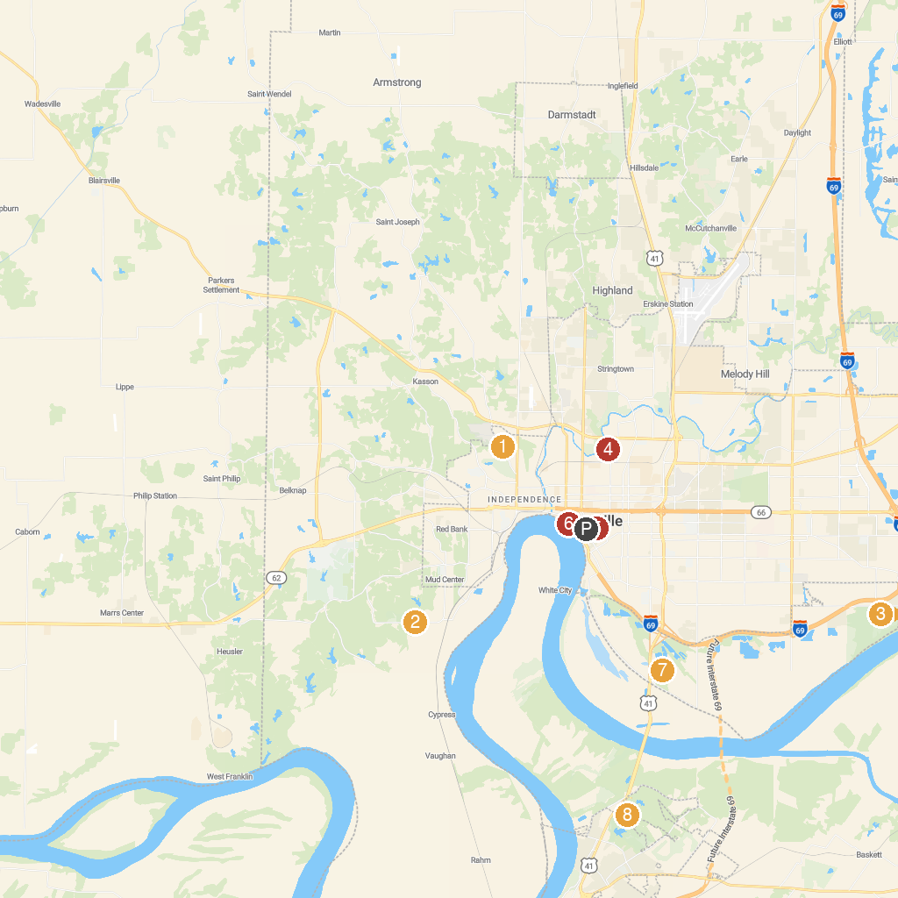
MAP KEY
1. Mesker Park Zoo | 5. Children's Museum of Evansville
2. Burdette Park | 6. USS LST-325
3. Angel Mounds State Historic Site | 7. Eagle Slough Natural Area
4. Garvin Park | 8. Audubon Museum & Nature Center
P. Cruise port / terminal
Map © MapTiler © OpenStreetMap contributors · cruiseports.org

