Étretat, Normandy, France
Monet painted them. Arsène Lupin hid secrets in them. The chalk arches and needle-rock of Étretat are among France's most dramatic coastal sights — and entirely worth the 40-minute drive from Le Havre.
⚓ Shore excursion from Le Havre (docked pier) · 🕒 Typical call: 8-10 hrs (Le Havre day) · 💶 Euro (€) · 🗣️ French · 🥾 Cliff walks + pebble beach
✍️ MY DAY IN PORT (FILL IN)
Ship / Date
In port | arrive ______ · all aboard ______
Booked excursion
Notes / meeting point
GETTING ASHORE
- Docking: Ships dock at Le Havre pier (~30 km, 40-min drive)
- Walk to cliffs: 5 min from village center to beach & cliff base
- Best For: Scenic cliff walks, Impressionist history, Norman food
- Don't Miss: Falaise d'Aval arch & the Needle at high tide viewpoint
GETTING AROUND
- 🚕 Taxi: €65–€95 — Private taxi from Le Havre cruise terminal to Étretat (~30 km, ~35 min). Minivan for 5–8 passengers runs ~€117.
- 📱 Rideshare: ✅ Uber
TOP THINGS TO DO
- Falaise d'Aval Cliff Walk — The 20-minute hike up the left cliff delivers the money shot: the elephant-trunk arch and the solitary 70 m Needle rising from…
- Les Jardins d'Étretat — A surrealist garden on top of the Falaise d'Amont where hedges are sculpted into waves and giant green faces.
- Le Clos Arsène Lupin Museum — The house where Maurice Leblanc wrote his Arsène Lupin mysteries — made famous anew by the Netflix series.
- Falaise d'Amont & Notre-Dame de la Garde — The right-hand cliff with its seafarers' chapel, Notre-Dame de la Garde (rebuilt 1950), and the soaring Nungesser & Coli aviation…
- Norman Food & Cider Lunch — Normandy means moules-frites in cream-cider sauce, Camembert-stuffed galettes, and Calvados to finish.
BEST WALKS
- Beach & Falaise d'Aval Loop: 2.5 km · 1-1.5 hrs · Moderate (steep cliff steps) — Walk the pebble boardwalk to the cliff base, climb the stepped path to the Falaise d'Aval…
- Village & Covered Market Stroll: 1 km · 30 min · Easy — A flat wander through the village: the timber-framed Vieux Marché covered market, the casino…
WEATHER · DAYLIGHT · MONEY
Month | High °F | Low °F | Rainy days
May | 60 | 51 | 11
Jul | 69 | 60 | 12
Sep | 67 | 58 | 12
Daylight: May 6:14AM–9:37PM · Jul 6:08AM–10:01PM · Sep 7:35AM–8:11PM
cruiseports.org/etretat · Confirm terminal & all-aboard time with your ship

Étretat, Normandy, France — Port Map
Red = walkable sights · Amber = excursions farther out · P = cruise terminal
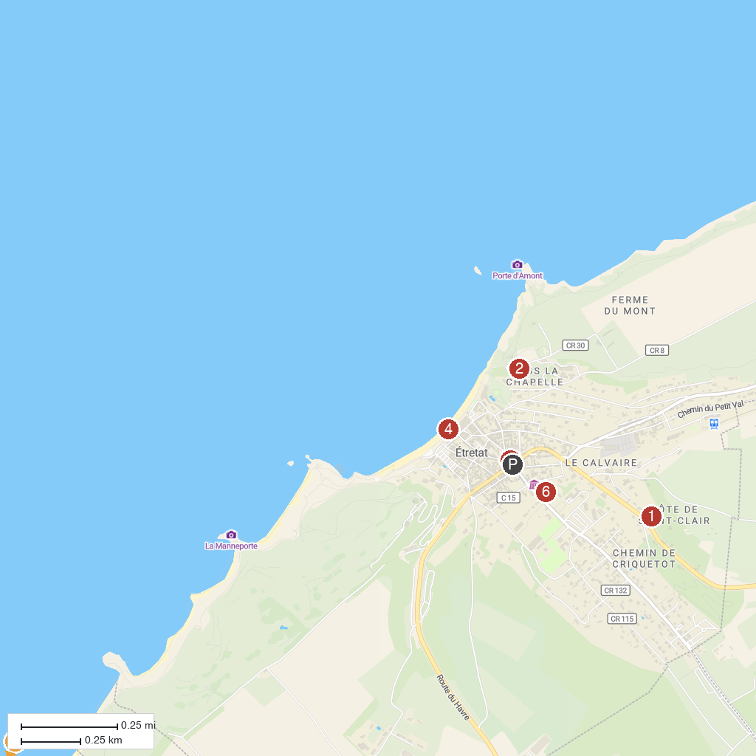
MAP KEY
1. Le Château des Aygues | 4. Plage d’Étretat
2. Jardins d'Etretat | 5. Le petit train d'Etretat
3. TIM JET | 6. Le Clos Arsene Lupin
P. Cruise port / terminal
Map © MapTiler © OpenStreetMap contributors · cruiseports.org

