Esztergom, Komárom-Esztergom, Hungary
Hungary's ancient capital rises from the Danube Bend in a sweep of Baroque domes and castle ramparts. Step ashore in Viziváros, walk to Slovakia across a graceful bridge, and climb to a basilica that lords over two countries.
⚓ Docked (riverside pier) · 🕒 Typical call: 5–8 hrs · 💵 Hungarian Forint (HUF) · 🗣️ Hungarian / English spoken in tourist areas · 🏰 River cruise port
✍️ MY DAY IN PORT (FILL IN)
Ship / Date
In port | arrive ______ · all aboard ______
Booked excursion
Notes / meeting point
GETTING ASHORE
- Docking: Pier — ships dock along the Viziváros quay; no tender required
- Walk to center: 5 min to Viziváros; 15–20 min uphill to Basilica (or short taxi)
- Best For: History, panoramic views, cross-border walks to Slovakia
- Don't Miss: Esztergom Basilica dome climb and walk across Mária Valéria Bridge
GETTING AROUND
- 🚕 Taxi: 1,150–2,000 HUF (~€3–5) — Local taxis are available near the dock. Base fare is ~700 HUF plus ~300 HUF/km; in-town distances are short so fares st
TOP THINGS TO DO
- Esztergom Basilica & Dome Climb — Hungary's largest church dominates Castle Hill with its neoclassical bulk.
- Esztergom Castle Museum — Hungary's first royal palace stands alongside the Basilica on Castle Hill.
- Christian Museum (Keresztény Múzeum) — Housed in the Primate's Palace in Viziváros, this is one of Hungary's finest art museums — a trove of medieval and Renaissance…
- Walk Across Mária Valéria Bridge to Slovakia — Stroll across the elegant 1895 bridge to Štúrovo, Slovakia for a genuinely cross-border experience.
- Viziváros Lunch & Wine Tasting — The Water Town lanes around the pier are lined with traditional Hungarian restaurants.
BEST WALKS
- Quay to Basilica Loop: 2.5 km | 45–60 min | Moderate (one steep hill) — From the riverside pier, walk through Viziváros past the Christian Museum, then climb Castle Hill…
- Border Bridge Walk: 2 km return | 30 min | Easy, flat — Head north along the embankment to the Mária Valéria Bridge, cross into Štúrovo (Slovakia) for the…
WEATHER · DAYLIGHT · MONEY
Month | High °F | Low °F | Rainy days
May | 68 | 52 | 13
Jul | 81 | 63 | 9
Sep | 72 | 56 | 9
Daylight: May 5:07AM–8:16PM · Jul 5:02AM–8:39PM · Sep 6:22AM–6:56PM
cruiseports.org/esztergom · Confirm terminal & all-aboard time with your ship

Esztergom, Komárom-Esztergom, Hungary — Port Map
Red = walkable sights · Amber = excursions farther out · P = cruise terminal
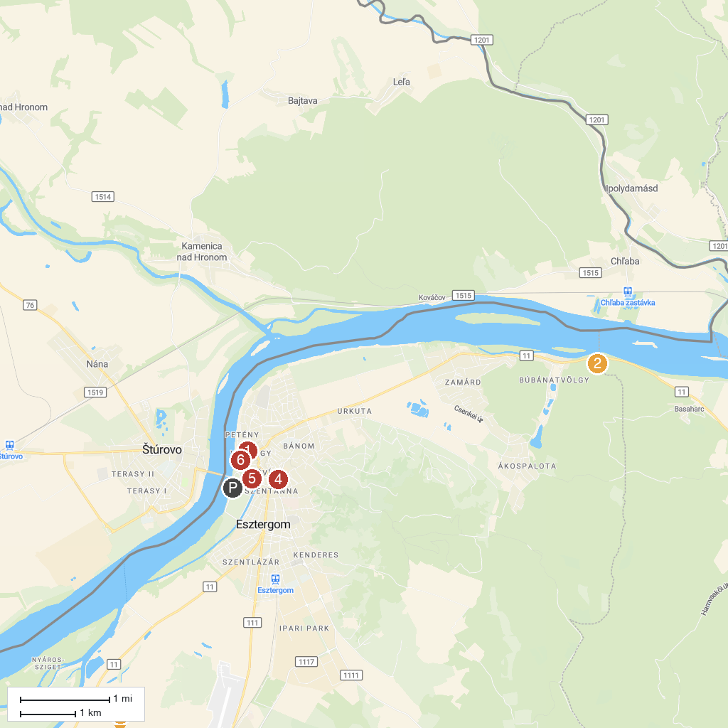
MAP KEY
1. Basilica of Esztergom | 5. Predikálószék lookout
2. Hajózástörténeti Múzeum | 6. Hungarian Environment and Water Museum
3. Hideglelős-kereszt | 7. Aqua Island Esztergom
4. Mining Museum Csolnok | 8. Christian Museum
P. Cruise port / terminal
Map © MapTiler © OpenStreetMap contributors · cruiseports.org

