Esperance, Western Australia, Australia
Home to some of Australia's whitest beaches and kangaroos that sunbathe on the sand, Esperance rewards cruise passengers who venture beyond the jetty with jaw-dropping scenery in Cape Le Grand National Park.
⚓ Tender port (no pier) · 🕒 Typical call: 7-9 hrs · 💵 Australian Dollar (AUD) · 🗣️ English
✍️ MY DAY IN PORT (FILL IN)
Ship / Date
In port | arrive ______ · all aboard ______
Booked excursion
Notes / meeting point
GETTING ASHORE
- Docking: Tender to Taylor Street Jetty — ship anchors in Esperance Bay
- Walk to centre: 2 min from tender drop-off on the foreshore
- Best For: Beaches, wildlife, nature lovers & photographers
- Don't Miss: Kangaroos on Lucky Bay beach in Cape Le Grand National Park
GETTING AROUND
- 🚕 Taxi: A–15 to town — Local taxis are available at the port. The short distance to the centre keeps fares low — expect around A–15 for the tow
TOP THINGS TO DO
- Cape Le Grand National Park & Lucky Bay — Australia's most photogenic beach, where kangaroos lounge on flour-white sand beside turquoise water.
- Frenchman Peak Hike — A 3 km return scramble up a granite dome inside Cape Le Grand, rewarded with 360° views of the national park and the Recherche…
- Great Ocean Drive Loop — A self-drive 40 km circuit past Twilight Beach, Blue Haven Beach, West Beach, and coastal lookouts — all within 15 minutes of…
- Esperance Museum & Skylab Artefacts — A small but fascinating museum covering local maritime and agricultural history — plus fragments of NASA's Skylab space station…
- Esperance Stonehenge — A full-scale replica of Stonehenge built from 2,500 tonnes of local pink granite — quirky, photogenic, and aligned to the…
BEST WALKS
- Foreshore & Jetty Stroll: 1.5 km | 20 min | Easy | Flat — Walk from the Taylor Street Jetty along the beautifully landscaped Esplanade, past the Whale Tail…
- Town Centre Loop: 2 km | 30 min | Easy | Flat — From the foreshore, head up to Dempster Street for cafes, the Esperance Museum, local shops, and a…
WEATHER · DAYLIGHT · MONEY
Month | High °F | Low °F | Rainy days
May | 66 | 55 | 8
Jul | 61 | 51 | 12
Sep | 65 | 52 | 9
Daylight: May 6:37AM–4:59PM · Jul 6:55AM–5:01PM · Sep 5:52AM–5:43PM
cruiseports.org/esperance-wa · Confirm terminal & all-aboard time with your ship

Esperance, Western Australia, Australia — Port Map
Red = walkable sights · Amber = excursions farther out · P = cruise terminal
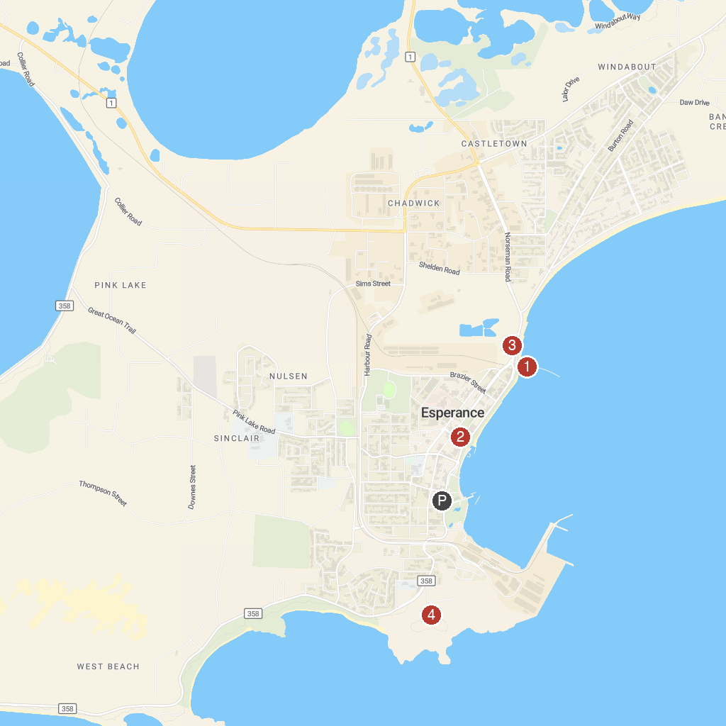
MAP KEY
1. Tanker Jetty | 3. The Cannery Arts Centre
2. Esperance Museum | 4. Rotary Lookout
P. Cruise port / terminal
Map © MapTiler © OpenStreetMap contributors · cruiseports.org

