Esna, Upper Egypt, Egypt
Step down into a 2,000-year-old temple buried under a living Egyptian town, then watch your ship squeeze through the Nile's famous lock while rowboat merchants hurl souvenirs up to the sun deck.
⚓ Docked (Nile pier) · 🕒 Typical call: 4-6 hrs · 💵 Egyptian Pound (EGP) · 🗣️ Arabic (English limited)
✍️ MY DAY IN PORT (FILL IN)
Ship / Date
In port | arrive ______ · all aboard ______
Booked excursion
Notes / meeting point
GETTING ASHORE
- Docking: Direct alongside floating pontoon on the Corniche — no tender
- Walk to Temple: ~400 m / 10 min through the souk
- Best For: Ancient temples, lock transit spectacle, authentic bazaar
- Don't Miss: The restored astronomical ceiling inside the Hypostyle Hall
GETTING AROUND
- 🚕 Taxi: EGP 20–50 — Taxis are available at the dock but have no meters; agree on the fare and currency (Egyptian Pounds) before you get in.
TOP THINGS TO DO
- Temple of Khnum — Descend 9 metres below modern street level into the only excavated part of a massive Ptolemaic–Roman temple.
- Esna Souk (El-Qaysariya Market) — The historic covered street market linking the riverfront to the temple is Esna's living heart.
- Esna Lock Transit — The Esna weir lock raises and lowers ships up to 8 metres to navigate the Nile dam.
- Wekalet El-Gedawy Caravanserai — A restored 18th-century caravanserai (merchants' inn) steps from the temple — one of few surviving examples in Upper Egypt.
- Corniche Stroll & Local Life — Walk Esna's Nile-front Corniche to watch feluccas, fishing boats, and farmers working the fertile green strip between river and…
BEST WALKS
- Pier to Temple Loop: ~1 km · 20 min · flat · easy — Leave the gangway, head into the covered souk street, reach the Temple of Khnum, descend into the…
WEATHER · DAYLIGHT · MONEY
Month | High °F | Low °F | Rainy days
May | 102 | 76 | 0
Jul | 106 | 82 | 0
Sep | 103 | 79 | 0
Daylight: May 6:05AM–7:27PM · Jul 6:09AM–7:42PM · Sep 6:35AM–6:53PM
cruiseports.org/esna · Confirm terminal & all-aboard time with your ship

Esna, Upper Egypt, Egypt — Port Map
Red = walkable sights · Amber = excursions farther out · P = cruise terminal
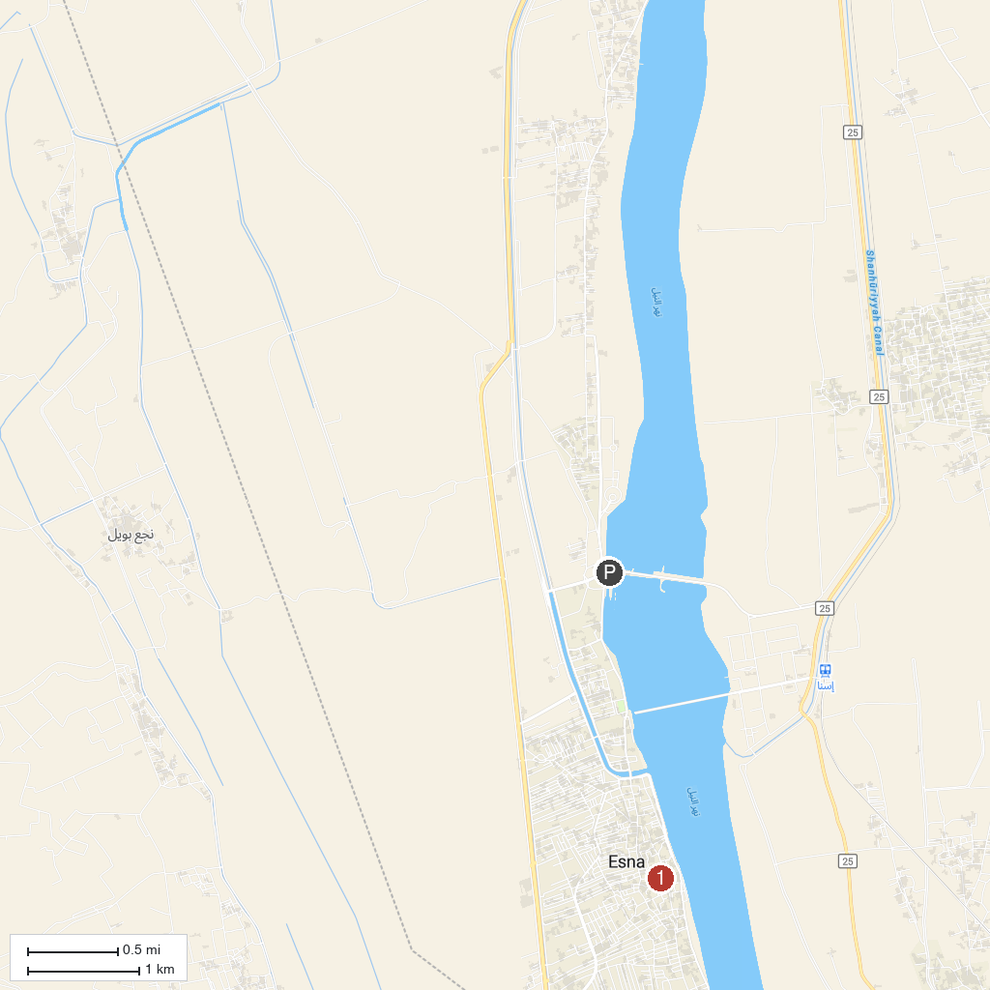
MAP KEY
1. Temple of Khnum | 2. 尼羅河水閘門
P. Cruise port / terminal
Map © MapTiler © OpenStreetMap contributors · cruiseports.org

