Eskifjörður, East Iceland, Iceland
A serene East Iceland fishing village backed by Mount Hólmatindur, Eskifjörður offers an honest taste of Icelandic life — colorful boathouses, a Victorian herring station, and the world's finest Iceland Spar calcite mine nearby.
⚓ Pier (most ships dock) · 🕒 Typical call: 6-8 hrs · 💵 ISK — cards accepted everywhere · 🗣️ Icelandic (English spoken by all)
✍️ MY DAY IN PORT (FILL IN)
Ship / Date
In port | arrive ______ · all aboard ______
Booked excursion
Notes / meeting point
GETTING ASHORE
- Docking: Pier — most cruise ships dock at the town quay; large vessels may tender
- Walk to center: 5-10 min from pier to town center; 20 min to Randulff's Sea House
- Best For: Geology, herring history, fjord scenery, authentic Icelandic village life
- Don't Miss: Randulff's Sea House restaurant and the Iceland Spar (Helgustaðanáma) mine
GETTING AROUND
- 🚕 Taxi: ~$6-15 USD — Local taxis are available but not stationed at the port. Must be pre-booked in advance through the local visitor center
- 📱 Rideshare: ❌ not available
TOP THINGS TO DO
- Randulff's Sea House & Herring Museum — Step inside this 1890 Norwegian herring station — a preserved bunkhouse where 'herring girls' lived, with a traditional…
- Helgustaðanáma Iceland Spar Mine — The world's most famous transparent calcite deposit, historically used in optics and possibly as the Viking 'sunstone' compass.
- East Iceland Maritime Museum — Housed in a restored 1816 building, this museum covers East Iceland's fishing, whaling, and shark-hunting heritage with vintage…
- Eskifjörður Geothermal Swimming Pool — The local sundlaug: outdoor lap pool, hot pots at varying temperatures, steam bath, and waterslides — all with fjord and mountain…
- East Fjords Scenic Drive & Tunnel — Drive the tunnel from Eskifjörður to neighbouring Neskaupstaður or wind through the mountain road to Seyðisfjörður — one of…
BEST WALKS
- Strandgata Shoreline Stroll: 1.5 km · Flat · 20 min one way — Walk along the main harbor road past the iconic red wooden boathouses, the Maritime Museum, and…
- Bleiksárfoss Waterfall Walk: 1 km round-trip · Easy · 20 min — A short, gentle uphill walk from the town center leads to Bleiksárfoss, a multi-tiered waterfall…
WEATHER · DAYLIGHT · MONEY
Month | High °F | Low °F | Rainy days
May | 44 | 36 | 15
Jul | 57 | 48 | 17
Sep | 52 | 43 | 17
Daylight: Sep 6:18AM–7:21PM
cruiseports.org/eskifjordur · Confirm terminal & all-aboard time with your ship

Eskifjörður, East Iceland, Iceland — Port Map
Red = walkable sights · Amber = excursions farther out · P = cruise terminal
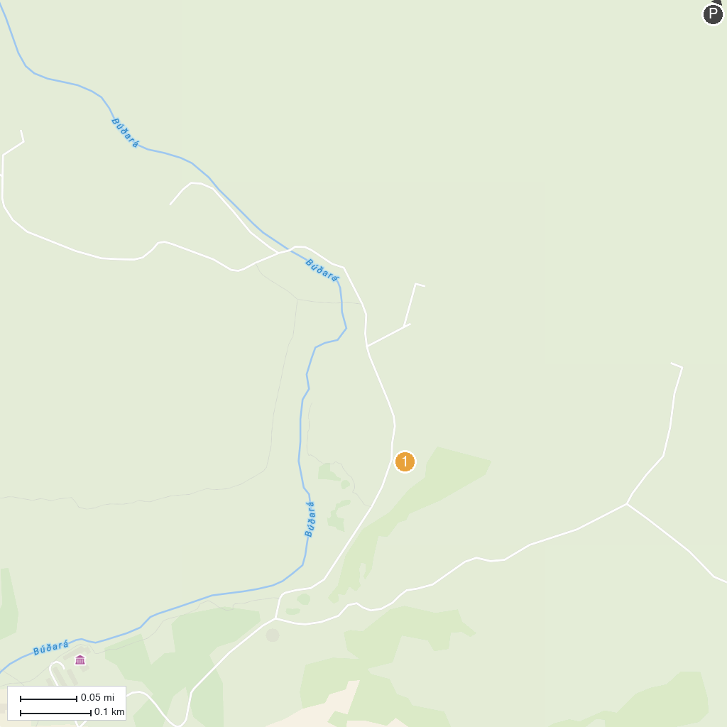
MAP KEY
1. Klifbrekku Waterfalls | 2. Búðarárfoss
P. Cruise port / terminal
Map © MapTiler © OpenStreetMap contributors · cruiseports.org

