Escanaba, Michigan, USA
"Esky" punches above its weight — a laid-back Upper Peninsula town where the walleye bite, the pasties are legendary, and a Victorian lighthouse watches over a calm, sandy bay.
⚓ Docked (North Shore Marine Terminal) · 🕒 Typical call: 6-8 hrs · 💵 USD · 🗣️ English · 🦟 Bring bug spray May–June
✍️ MY DAY IN PORT (FILL IN)
Ship / Date
In port | arrive ______ · all aboard ______
Booked excursion
Notes / meeting point
GETTING ASHORE
- Docking: Pier — North Shore Marine Terminal, Little Bay de Noc
- Walk to Center: ~1 mi (20 min) to downtown Ludington Street; shuttles common
- Best For: Great Lakes culture, U.P. cuisine, lighthouse history
- Don't Miss: Sayklly's candy shop (est. 1906) and a U.P. pasty
GETTING AROUND
- 🚕 Taxi: Flat rate within city limits — Get-a-Cab (866-438-2222) operates 24/7 in Escanaba and offers flat-rate fares within city limits. Call ahead — the city
- 📱 Rideshare: ✅ Uber, Lyft
TOP THINGS TO DO
- Sand Point Lighthouse Tour — Climb the restored lighthouse (built 1867, first lit 1868) for views over Little Bay de Noc, then tour the keeper's quarters and…
- Fayette Historic State Park — A perfectly preserved 19th-century iron-smelting ghost town perched on white limestone bluffs above Big Bay de Noc — one of the…
- U.P. Food & Culture Walk — Sample a classic Cornish-style pasty, grab Swedish pancakes at The Swedish Pantry, and pick up a box of legendary Snappy turtles…
- Ludington Park Beach — A clean, calm sandy beach in Ludington Park on Little Bay de Noc — warmer and calmer than open Lake Michigan, with a designated…
- Downtown Ludington Street Stroll — One of Michigan's longest continuous historic downtowns — boutiques, antique shops, local art galleries, and the William Bonifas…
BEST WALKS
- Ludington Park, Lighthouse & Downtown Loop: ~2 miles round trip · Flat · 45-60 min — Head south from the dock to Ludington Park, walk out to Sand Point Lighthouse and the Delta County…
- Aronson Island Nature Walk: 0.5 miles · Easy · 20 min — Cross the footbridge from Ludington Park onto Aronson Island for a peaceful stroll through wooded…
WEATHER · DAYLIGHT · MONEY
Month | High °F | Low °F | Rainy days
May | 57 | 44 | 10
Jul | 75 | 61 | 11
Sep | 67 | 56 | 9
Daylight: May 6:16AM–9:13PM · Jul 6:13AM–9:34PM · Sep 7:27AM–7:58PM
cruiseports.org/escanaba-mi · Confirm terminal & all-aboard time with your ship

Escanaba, Michigan, USA — Port Map
Red = walkable sights · Amber = excursions farther out · P = cruise terminal
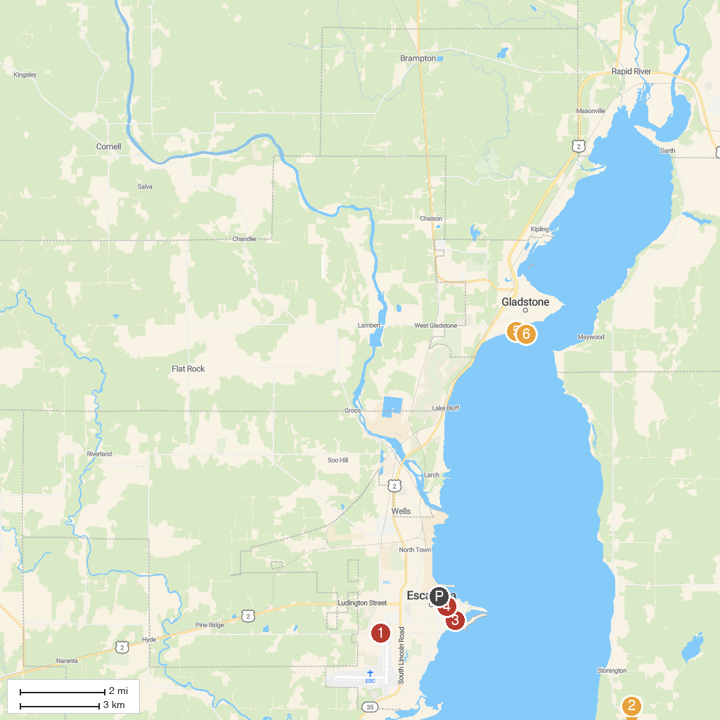
MAP KEY
1. John D. Besse Park | 4. William Bonifas Fine Arts Center
2. Peninsula Point Lighthouse | 5. Van Cleve Park & Gladstone Beach
3. Ludington Park | 6. Gladstone Lighthouse
P. Cruise port / terminal
Map © MapTiler © OpenStreetMap contributors · cruiseports.org

